Surface current field in the subpolar gyre of the North Pacific observed with surface drifters

Yutaka MICHIDA¹, Hiroyuki YORITAKA² and Toru SUZUKI³

1 Ocean Research Institute, The University of Tokyo
2 Hydrographic Department, Japan Coast Guard
3 Marine Information Research Center, Japan Hydrographic Association

Abstract
Surface drifter experiments have been carried out as part of a research programme called 'SAGE-Subarctic Gyre Experiment', which has been implemented as a 5-year project since 1997. More than 40 surface drifters were deployed in the subpolar gyre of the North Pacific Ocean within the programme. The trajectories of drifters display surface circulation in the region, particularly in the western half of the gyre, where only small number of drifters had been deployed in the previous programmes including WOCE (World Ocean Circulation Experiment). They also show a seasonal variability in the central area of the gyre that the eastward component of the mean current takes its maximum twice a year, in November-December and in February. We have estimated the Ekman depth at 44 m from the drifter tracks including not only those of SAGE but the historical archive, assuming that the effect of the Ekman current for the drogued period is different from that for the undrogued period and the difference can be determined by the relationship between the Ekman depth and drogue depth. As the estimated Ekman depth is similar to a previous estimation by analyzing ADCP data, it can be used in the calculation of the wind-driven component. We also discuss about mean geostrophic current field in the subpolar gyre of the North Pacific Ocean obtained by subtracting the Ekman component from drifter tracks with the estimated Ekman depth.

1 Introduction
The subpolar gyre in the North Pacific Ocean is one of the key areas to investigate the mechanism of the global change, recognizing its importance in the water mass formation such as North Pacific Intermediate Water (NPIW) that is thought to play an important role in the inter-decadal climate variability and global carbon cycle. In the area north of 40°N in the Pacific, however, there have been less oceanographic data available in comparison with other areas: the subtropical and tropical Pacific. In these contexts, a research project ‘Subarctic Gyre Experiment (SAGE)’ initiated according to the proposal by Japanese scientists in 1997 and has been implemented as a 5-years programme until 2002 (Michida et al., 1997).
With regard to the surface circulation in the gyre, our present knowledge is summarized in the schematic view presented by Ohtani (1991) and Nagata et al. (1992) that has been drawn by compiling the results of previous analyses on hydrographic observations. There have been few direct measurements of the surface circulation in the area. During the WOCE (World Ocean Circulation Experiment) intensive observation period (1990-1998) surface drifters to measure the distribution and variability of the surface currents were deployed less than planned and have not covered well to describe the current field. Hydrographic Department of Japan Coast Guard (JHD) has deployed ARGOS tracked surface drifters in the subpolar gyre of the North Pacific within a national research programme, Subarctic Gyre Experiment (SAGE), to complement the coverage of WOCE drifters.
The current velocity, which can be derived from trajectories of a drifter, contains not only the geostrophic component but also wind-driven component, the Ekman current, because the drifter is attached a drogue at 15 m below the sea surface that is supposed to be in the surface Ekman layer. The Ekman component is relatively big in the subpolar gyre where the geostrophic currents are weaker than in the subtropics, except for some limited regions such as Alaskan Stream. Therefore, it is essential in describing the current field in the subpolar gyre to estimate and subtract the wind-driven component from drifter-derived velocities (Michida et al., 2001).
The present study describes the trajectories of the drifters deployed by JHD in the subpolar gyre in the Pacific and seasonal changes in the velocities derived from the trajectories, in order to draw the current field in the area where we have had little information. It also estimates the wind-driven components contained in the drifter velocities, by analyzing climatological wind data and most of available drifter data including historical archive and drifters deployed in SAGE programme, and by analyzing the drifter trajectories for drogued and undrogued periods. We also discuss the seasonal changes of the surface current field drawn by drifter data.

2 Data and Data Processing
JHD has deployed 16 drifters in the first (1997-1999) and 30 in the second (2000-2001) phase of SAGE, respectively. In addition to these drifters, historical drifter data archived in WOCE Surface Velocity Programme (SVP) have been obtained from WOCE Global Data Ver. 2 (2000) and the Data Assembly Center for SVP. All the drifters including SAGE and WOCE are designed to have a drogue attached at 15 m below the sea surface according to the WOCE SVP standard. A drogue on/off sensor is installed on each drifter, with which we can tell the date and position of drogue loss.
All trajectories of drifters are plotted in Figure 1. Most of the areas of subpolar gyre are covered with drifter tracks of WOCE archive together with those deployed by JHD, although the density of data is different by places.
There are areas of good coverage in the western Pacific and along the coast of North America, while some sparse areas can be seen in the central part. It is noted that the Alaskan Stream has also been well sampled as a narrow current along south of Aleutian Islands.

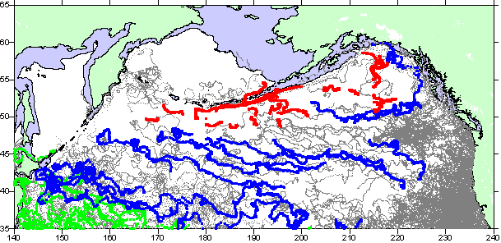
Figure 1. All trajectories of drifters deployed in SAGE progrrame (red and blue), by JHD within other programmes (green), and WOCE SVP archive (black).

The raw data of ARGOS location were processed and linearly interpolated into daily positions at 0000 UT everyday. As errors of positioning with ARGOS system should be about some 100 m, the errors in the daily mean velocity are expected approximately at 1 cm/s. We then calculated spatial mean velocities for every month, by averaging daily mean velocities of drifters in 5 °x 10°(latitude x longitude) bins.
The surface wind velocity data were extracted from ‘Mean Surface Wind Field from the ERS-AMI and ADEOS-NSCAT Microwave Scatterometers’ published a part of WOCE Global Data Version 2.0 (2000). Objectively analyzed wind fields into weekly, monthly, and 8-year climatological averages were retrieved for the area north of 30°N of the North Pacific. Then the Ekman velocities were estimated with these wind data, assuming typical calculation parameters such as the Ekman depth (or eddy viscosity) and drag coefficient.

3 Trajectories and Velocities of Drifters
Trajectories of sixteen drifters deployed in the first half of SAGE are shown with blue color in Figure 1. All of them drifted generally eastward: most of them deployed in the central or western pat of the North Pacific showed a southward trend in the dominant flow to the east, while two deployed in the Alaskan gyre visualized a part of a cyclonic circulation.
With regard to the drifting velocity, daily mean velocities computed from ARGOS positions of the drifters deployed in 1997 are plotted in Figure 2. Zonal velocities of the drifters in the central region show maximum values twice: in November – December, 1997 and February, 1998. The maximum zonal velocities are 40 – 50 cm/s for both periods.
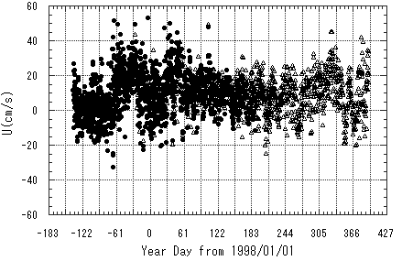
Figure 2. Zonal component of daily mean drifting velocity (cm/s) for six drifters deployed in the central region of the North Pacific in 1997. The horizontal axis is ‘year day’ starting on January 1, 1998. Solid circles (●) are for drogued period and open triangles (△) for undrogued period, respectively.
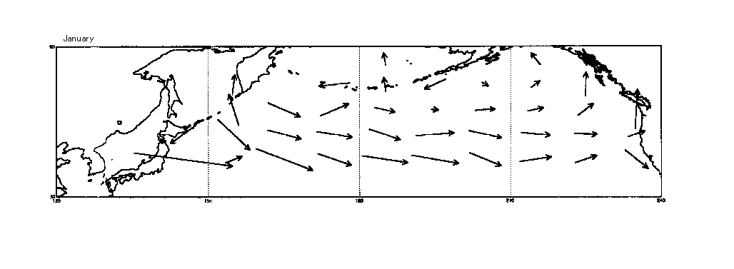
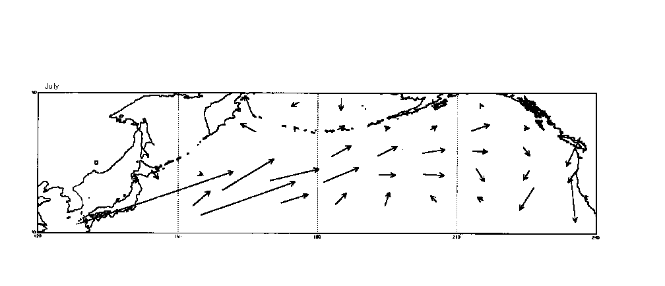
Figure 3. Distribution of the mean currents calculated for 5°x 10°bins from drifter data after correction of wind-driven currents, in January (top) and in July (bottom).
Figure. 3 shows mean current field for January and July derived from drifter data after subtraction of wind-driven component. Eastward flows are dominant in most of the bins both in winter (January) and summer (July). In summer, however, the mean current vectors have northward components along a main stream from western to eastern gyre. And associated with the changes, the bifurcation point of the eastward current at the North American coast changes meridionally by seasons: it gets north in summer and south in winter.
The Alaskan Stream can be seen in the figure of January, but not of July. This may not mean that the Alaskan Stream becomes weak or disappear in summer, because the spatial resolution of this analysis is too coarse to display such a narrow current system and there is a possibility that drifters in this study have not sampled the Stream in summer. There is a northward current, flowing toward Bering Sea from the Alaskan Stream, can be observed in a bin near the date line both in winter and summer. It is more apparent in winter.
The mean current distribution in summer seems similar to the schematic view of the surface circulation presented by Ohtani (1991). The Alaskan Gyre in winter given in Figure 3 is much bigger than that by Ohtani (1991). The Gyre in summer suggests an existence of a similar gyre to Ohtani’s map, although there is not any clear gyre in the Gulf of Alaska in summer in Figure 3.

4 Estimation of the Ekman Velocity
As seen in Figure 1, the trajectories of the drifters have southward components that seem to be induced by wind-driven current, namely the Ekman current. The drifting velocity can be thought to represent the current at 15 m depth, the depth of the drogue center, which should be well inside the Ekman layer, and contain relatively big Ekman current. There are two kinds of approaches to estimate the Ekman current (or ageostrophic current) in the drifter velocities. Ralph and Niiler (1999) have estimated ageostrophic components, by subtracting the geostrophic components calculated from the temperature structure observed with XBTs, and compared them with the surface wind field. In the present study, we take an opposite approach to that of Ralph and Niiler, i.e., we would estimate ageostrophic components by directly analyzing surface wind field and then compare them with geostrophic currents independently obtained.
The estimation of the Ekman current from the surface wind depends strongly upon two parameters, the Ekman depth and the drag coefficient, as well as the wind speed or stress. These two parameters are to be variable by oceanic and weather conditions, by time and place. Michida (1999) investigated on the Ekman depth in the adjacent seas of Japan, by analyzing the data of vertical shear observed with shipmounted ADCP data. He analyzed a large amount of ADCP data collected by JHD mainly around Japan for longer than 10 years and estimated the Ekman depth at about 40 m on average. In terms of eddy viscosity, it was estimated at 0.09 m²/s.
For the first step of our approach, we use the value of Michida’s estimation as a typical Ekman depth, a constant neutral drag coefficient of O(10⁻³) according to the previous studies, and 8-year climatology for the surface wind (Figure 3).
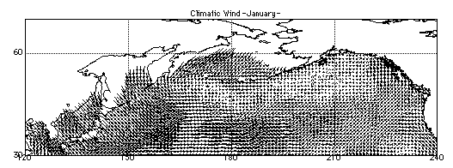
Figure 4. Climatic surface wind field in January (WOCE Global Data Version 2, 2000).

The mean meridional component of the drifting velocity in January 1998 was calculated at –2.9 cm/s (southward), from drifter tracks in that period. The Ekman current at 15 m depth calculated with the above mentioned typical values of the parameters and climatical wind field in January shown in Figure 4, is approximately 5 cm/s southward as a rough estimation. This suggests that the southward trend appeared in drifter tracks is roughly explained with the southward Ekman current generated by dominant westerly wind.

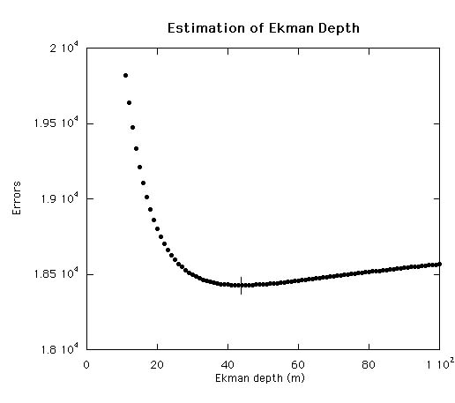
Figure 5. Velocity errors between drogued and undrogued drifters as a function of a parameter, the Ekman depth. The Ekman depth is estimated at 44 m that gives the minimum errors.

We used the Ekman depth at 40 m as a typical value in the estimation of wind-driven current. In order to examine the reasonability of the value, we estimate it by analyzing drifter data in this section. The influence of the Ekman current upon the motion of a drifter should be changed by on/off of the drogue. The Ekman current contained in the drifter motion under the same wind condition should be smaller for drogued drifters whose drag center is 15 m than undrogued ones whose drag center is quite shallow, as the amplitude of the Ekman current is expected to decay exponentially with depth if it satisfies a steady state condition. Therefore we can determine the Ekman depth so as to minimize the discrepancies in the mean velocity of drifters between drogued and undrogued drifters for the same period and area. Figure 5 shows the square velocity errors between drogued and undrogued drifters as a function of the parameter, the Ekman depth. The minimum velocity error can be obtained when the parameter (Ekman depth) is 44 m. This is an independent estimation of the previous estimation of the Ekman depth by ADCP data analysis presented by Michida (1999), and gives similar value. This implies that the Ekman depth we used in the estimation of wind-driven current in this study is a reasonable value.

5 Concluding Remarks
There has been presented just a rough estimation of the wind driven component that seems to be contained in the drifter tracks, by analyzing surface wind data with typical values for the Ekman depth and drag coefficient. A preliminary comparison shows that the southward drift of the drifters is basically due to the Ekman velocity.
As the present study suggests that the approach to the issue be effective, more extensive analysis using a wider range of parameters and surface wind data will lead to the geostrophic drifting velocity, which is to be compared with the geostrophic current field estimated by other methods such as satellite altimetry.
Seasonal mean current fields in the subpolar gyre of the North Pacific are calculated from surface drifter data after correction for wind-driven Ekman current that has been estimated by applying a steady state Ekman theory and by using climatological wind data. The mean current field shows big seasonal changes. Distribution of the mean current in summer is similar to the previous schematic view, while that in winter shows big difference displaying the Alaskan gyre with bigger horizontal scale. The result suggests that the previous map given by Ohtani (1991) may reflect more the circulation condition in summer than in winter when smaller number of observations has been available.
The Ekman depth has been examined by comparing the drifter velocities of drogued period with those of undrogued. It has been estimated at 44 m that gives the minimum error discrepancies between drogued and undrogued drifters. This concludes that the Ekman depth we used in the estimation of wind-driven component, that is 40 m according to the previous study by Michida (1999), is a reasonable value.

Acknowledgments
This study has been financially supported by Research Promotion Fund for Science and Technology, and done as a part of a research programme under the Fund, ‘Subarctic Gyre Experiment (SAGE)’. The authors express their sincere appreciation to Dr. P. P. Niiler for his leadership in the drifter experiments in WOCE and encouraging suggestion to this study.

References
Michida, Y. and H. Yoritaka (1995): Survivability of the drifters deployed by Hydrographic Department for the
period from 1988 to 1993, J. Japan Soc. Mar. Surv. Tech., 7(2), 21-28.
Michida, Y., M. Fukasawa, M. Endoh and Y. Nagata (1997) : New Research Programme, SAGE (Subarctic Gyre
Experiment in the North Pacific Ocean), P-11, Proc. 12th Symp. Okhotsk Sea & Sea Ice.
Michida, Y., H. Yoritaka and T. Suzuki (2001): Surface current field in the subpolar gyre of the North Pacific Ocean observed with surface drifters, Proc. 16th Symp. Okhotsk Sea & Sea Ice, 213-218.
Michida, Y. (1999) : Structure of the Kuroshio and the surface Ekman layer by current data analysis of shipborne ADCP, Thesis of Dr. (Sci.) U. of Tokyo, 119pp.
Nagata, Y., K. Ohtani and M. Kashiwai (1992): Subarctic Gyre in the North Pacific Ocean, Umi no Kenkyu, 1, 75-104. (in Japanese with English abstract)
Ohtani, K. (1991): To confirm again the characteristics of the Oyashio, Bull. Hokkaido Natl. Fish. Res. Inst., 55, 1-24. (in Japanese with English abstract)
Ralph, E. A. and P. P. Niiler (1999): Wind-driven currents in the tropical Pacific, J. Phys. Oceanogr., 29, 2121-2129.
WOCE Global Data Ver.2.0 (2000): WOCE International Project Office.

