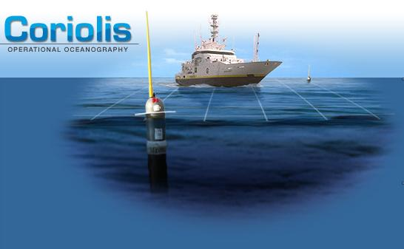
Provor : a range of profiling floats for Operational Oceanography
G. Loaec - S. Le Reste - F. Marchese - A. Billant (IFREMER)
E. Le Marchand - T. Swinamer (MARTEC - METOCEAN)
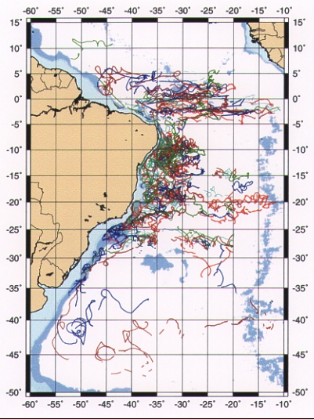
Provor : the Marvor heritage

Based on experience
gained in developing & operating
multi-cycles MARVOR floats
➔ A 7 year at sea experience
➔ ~200 MARVOR floats deployed
➔ reliable, long life

Currents at a depth of 800 m in the Antarctic Intermediate Water mass.
Nearly 100 Marvor floats have been launched during the SAMBA experiment in the Brazil Basin between 1994 and 1997 for a 5 year mission
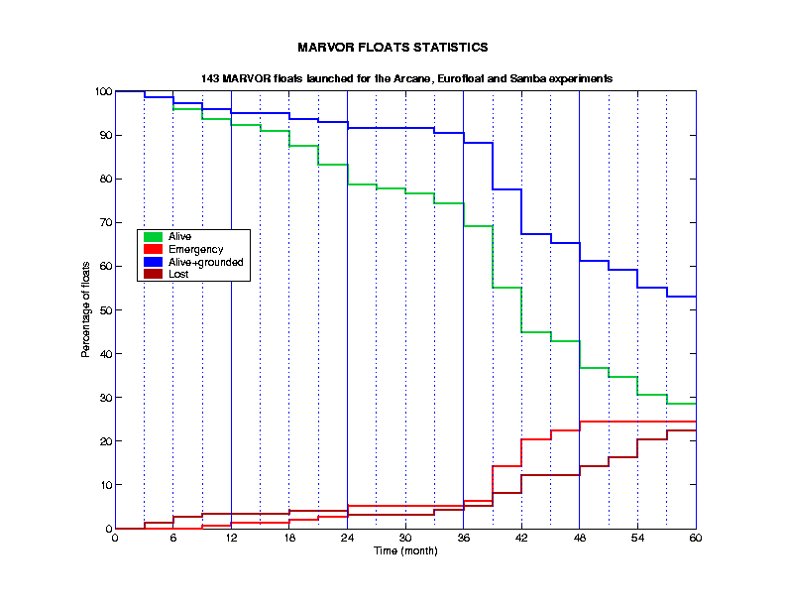

MARVOR floats statistics
143 MARVOR floats launched
for Arcane, Eurofloat, Samba experiments
MARVOR results: 65% still alive after 3 years

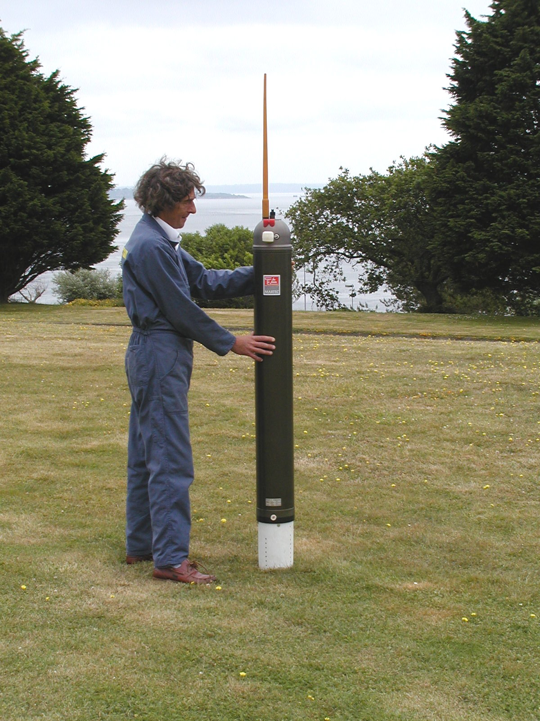
Provor - main features
- FSI or SeaBird CTD packages
- Self-ballasted, with active buoyancy control (hydraulic pump)
- Max profiling depth : 2000 m
- 100 to 150 cycles
- Possibility of data acquisition on down-profile to parking depth
- Great versatility in vertical sampling strategy (upper and deep layers with different resolution)
- ARGOS data transmission

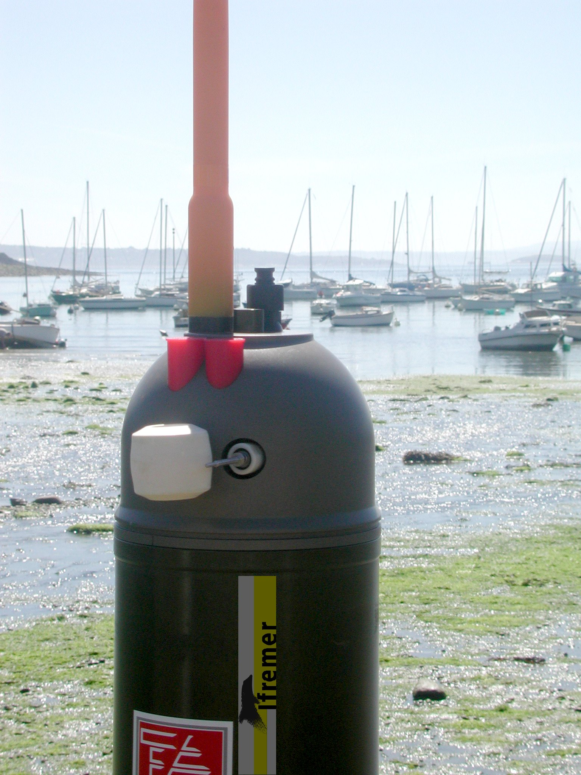
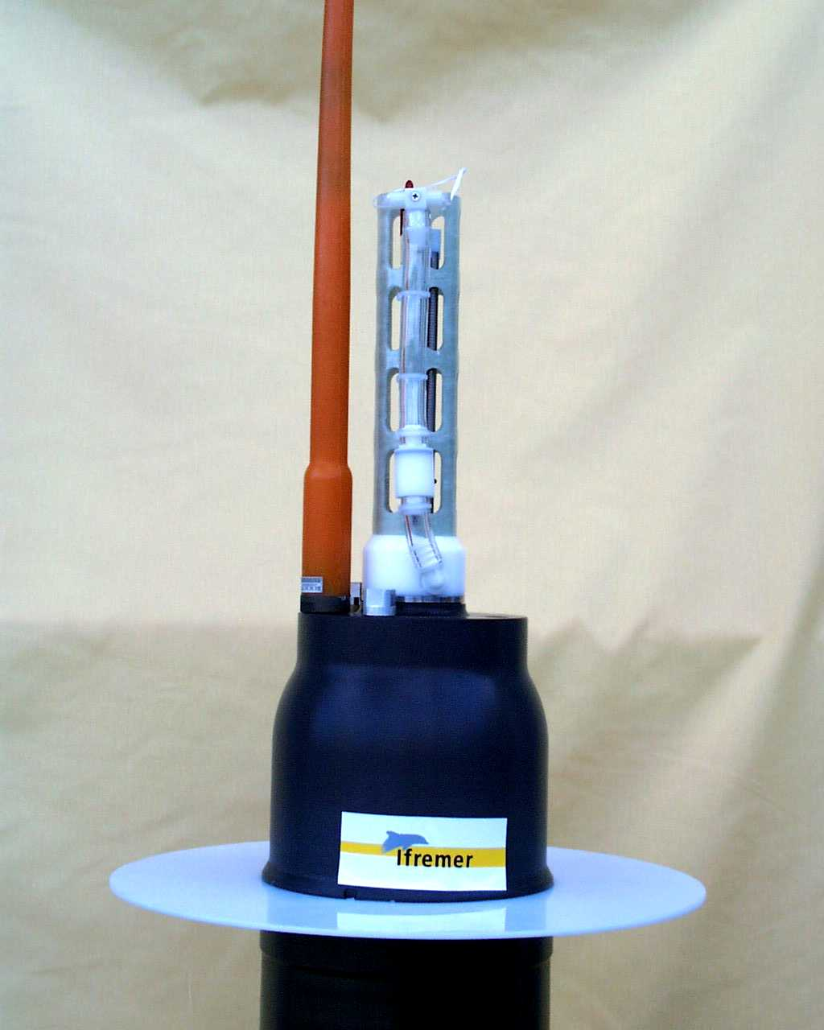
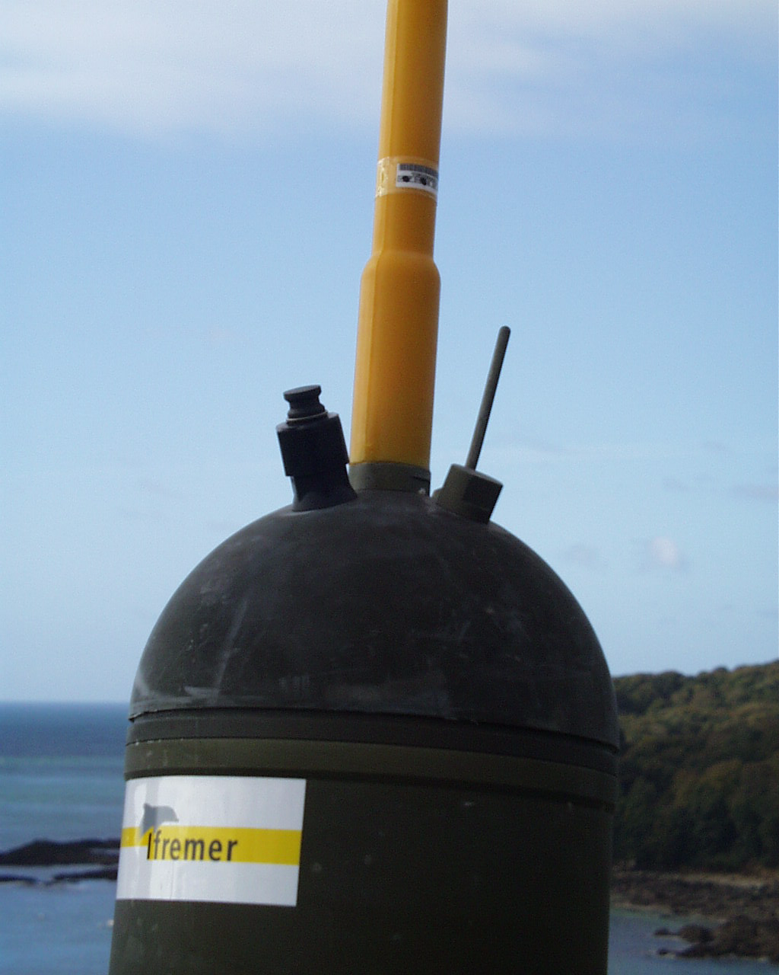
Provor CT-F2
FSI Excell
Provor-CT-S
Seabird 41 CP
Provor T
Seascan
Provor range of floats floats
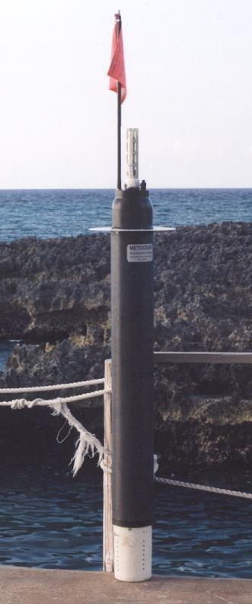
Metocean Provor CT-S
- SBE sensor

- ready to deploy (removable magnet)

- 150 cycles (36 lithium D-cells)

Sampling on down cast
Sampling on up cast
Select :
Upper and lower layers depth
Sampling interval in each
Parking depth
Timing of all actions
ARGOS parameters
Provor mission programme
Upper layer
Lower Layer
Parking Depth
Max. sampling depth ≈ 2000 m
Buoyancy control
- Transfer of oil between an internal reservoir and an external ballast
- No ballasting operation before launching
- +/- 30 dbars at depth
- About 2.3 liters of usable oil:
- emergence at the surface : >1 liter
- from surface to depth : 350 cm3 (function of difference of density)
- quality of machining : 500 cm3
Data Acquisition

- One sample every 10 seconds (1 sample per meter).
No power switching to avoid electrical noise

- From 2000 points to 100 to reduce the time at the surface
(using Argos data transmission system)

- 2 data reduction methods : chords or slices

Data reduction : chord method
. Segments between real points
. Maximum allowed error or number of points
. More points when variations are higher

69001 - Cycle 80
Data reduction : Slices Method
- 2 layers (upper and lower)

- each layer is divided into slices which height is user-defined

- all measurements which are gathered inside every slice are averaged (1 sample /meter)
Provor deployments

- On going experiments (North Atlantic)
- 1999-2000: technology experiment Pommier (5 profilers)
- 2000-2001: scientific experiment Pomme (16 profilers including 6 Provor CT-F2)
- GyroScope (funded by EU) (40 profilers - PROVOR-CT-F2)
- deployments in 2001 and 2002
- Coriolis (50 profilers - PROVOR-CT-F2)
- deployments in 2002
- Jamstec floats : 70 METOCEAN PROVOR-CT-S
- deployments in 2001 and 2002

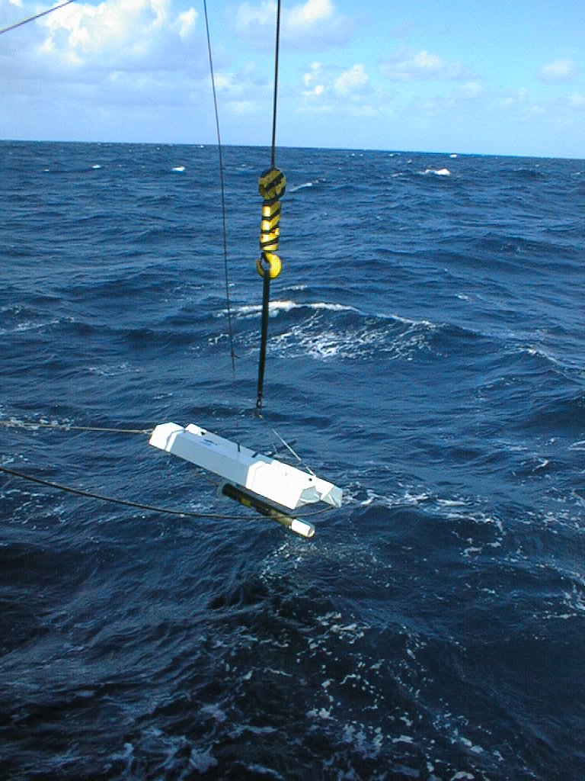
Provor float deployment
from a ship of the French
Navy near the Azores

