CORIOLIS, A FRENCH PROJECT FOR IN SITU

OPERATIONAL OCEANOGRAPHY

S. Pouliquen, A. Billant, Y. Desaubies, G. Loaec, F. Gaillard, G. Maudire

IFREMER, BP70, 29280 Plouzané, France
Sylvie.Pouliquen@ifremer.fr

ABSTRACT:
The seven French agencies concerned by ocean research are developing together a strong capability in operational oceanography based on a triad including satellite altimetry (JASON), numerical modelling with assimilation (MERCATOR), and in-situ data (CORIOLIS).
The CORIOLIS project aims to build a pre-operational structure to collect, validate and distribute ocean data (temperature/salinity profiles and current speeds) to the scientific community and modellers.

CORIOLIS aims at four goals:
- To build up a data management centre, part of the ARGO network for the GODAE experiment, able to provide quality-controlled data in real time and delay modes.
- To contribute to ARGO floats deployment mainly in the Atlantic with about 250 floats during the 2001-2003 period.
- To develop and improve profiling ARGO floats. PROVOR is a self-ballasted float, able to drift at a user-defined parking depth and then to dive to 2000m before profiling up to the surface where data are transmitted using the Argos system. More than 100 cycles can be performed during its 3-year lifetime.
- To integrate into CORIOLIS other data presently collected at sea by French agencies from surface drifting buoys, PIRATA anchored buoys, oceanographic research vessels (XBT, thermosalinograph and ADCP transmitted on a daily basis).

In 2004, recommendations will be done to transform the CORIOLIS activity into a permanent, routinely contribution to ocean measurement, in accordance with international plans that will follow the ARGO/GODAE experiment.

INTRODUCTION

The Earth’s climate is determined by the atmosphere and the ocean which transport and exchange huge amounts of heat and water. Within the climate system, the interactions are numerous and complex. The atmosphere is a transient and temperamental partner. The ocean, which reacts slowly, is the memory of the system. According to annual cycles and geographical areas, it can absorb or accumulate huge amounts of heat, water and carbon, transport it over large distances, and subsequently release it in the atmosphere.

Understanding, monitoring and forecasting ocean-circulation variability require to combine theoretical studies, in-situ measurements and numerical models. It becomes today possible, because of scientific expertise, increase in computer capabilities, numerical modelling, observation means from space and in in-situ. It is the challenge of the operational oceanography for which France raises a research program including three complementary projects:

- JASON which will provide altimetric data following Topex/Poseidon mission,
- Ocean modelling with MERCATOR which assimilates altimetric and in situ data,
- In situ measurements and data distribution with CORIOLIS.

These projects contribute to the international programs GODAE (Global Ocean Data Assimilation Experiment) for modelling aspects and ARGO for in situ measurements that will both be operational during the 2004-2005 period.

What is CORIOLIS?

CORIOLIS is a pilot project, resulting from a study conducted by the seven French organizations implied in ocean research (CNES, CNRS, IFRTP, IRD, METEO-FRANCE, SHOM and IFREMER). It is setting up a complete structure for acquisition, validation and distribution, in real and delay modes, of in-situ data over the world ocean: mainly physical parameters such temperature, salinity and speed (profiles or sections with high vertical or horizontal resolution and time series)

CORIOLIS has three phases:

- Preparation phase (2000-2002) synchronised with MERCATOR demonstration phase, which sets up the system,
- Demonstration phase (2003-2005) during which CORIOLIS will operate in an operational mode,
- Lastly, an Evaluation Phase (2004-2005), which will provide recommendations starting from this experience, on what, should be a sustainable operational structure.

The CORIOLIS project is organized in four sub-projects:

- Development of the CORIOLIS data centre,
- French contribution to ARGO deployments,
- Development of profiling floats,
- Integration of national activities related to in situ measurements
Plus a transversal component, which provides scientific support to the other projects.

- Development of a CORIOLIS data centre

The CORIOLIS data centre has been set up progressively to collect, control, distribute physical oceanography in-situ data, initially temperature and salinity profiles, and then horizontal speeds. The core of this centre is located in Brest built on the experience acquired during twenty years the Ifremer oceanographical data centre SISMER. It handles in-situ data available in real time coming from the GTS (Global Transmission System of meteorological data whose French partner is Meteo-France) and also from other sources including French floats, buoys, and research vessels. 3500 profiles (mainly temperature over the Atlantic Ocean) are now provided to MERCATOR on a weekly basis. These data are used to validate the prototype model outputs: since early 2001, MERCATOR publishes each week an ocean forecasting bulletin (http://www.mercator.com.fr). These data will then be assimilated by MERCATOR and also used in real-time by other customers, such as defence authority (SHOM) and METEO-FRANCE.

The CORIOLIS data centre also operates in delay mode for:
- Instruments and sensors monitoring,
- Re-analysis and data syntheses: gridded fields in different areas (Figure 1).
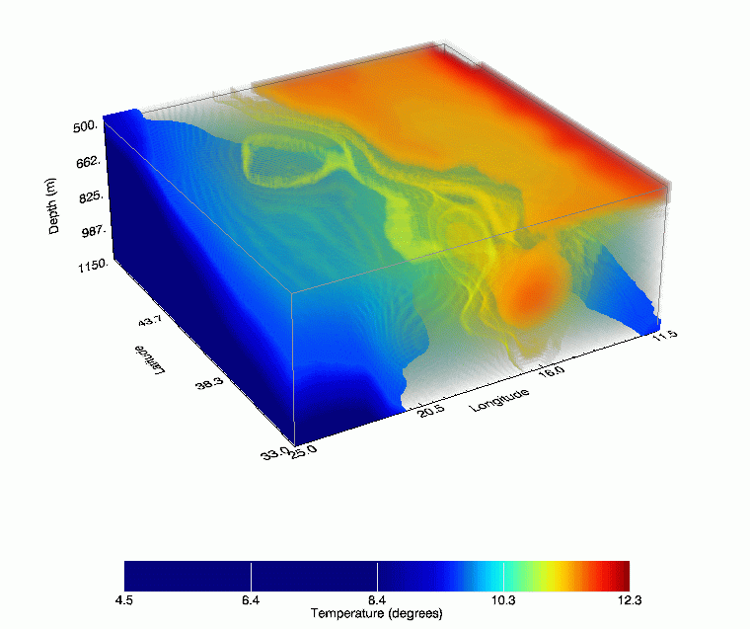

Figure1 - Example of Coriolis output: "3 D block-diagram of the thermal structure between 500 and 1200 m off Spain, in September 2000. A blob of warmer Mediterranean water is seen on the bottom right hand side of the figure. A second blob, less intense, around 43° north, is moving from the main plum heading to the open sea.

The CORIOLIS data centre already provides on-line data access within 24 hours working day to the meteorological community on GTS and on Internet to the scientific community (http://www.coriolis.eu.org). (Figures 2).

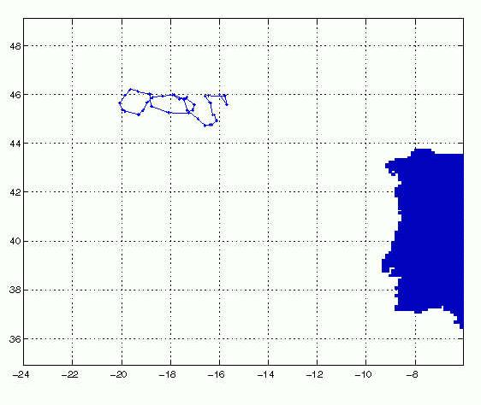
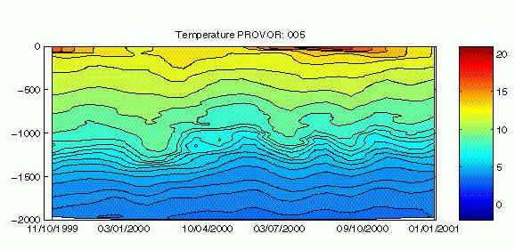
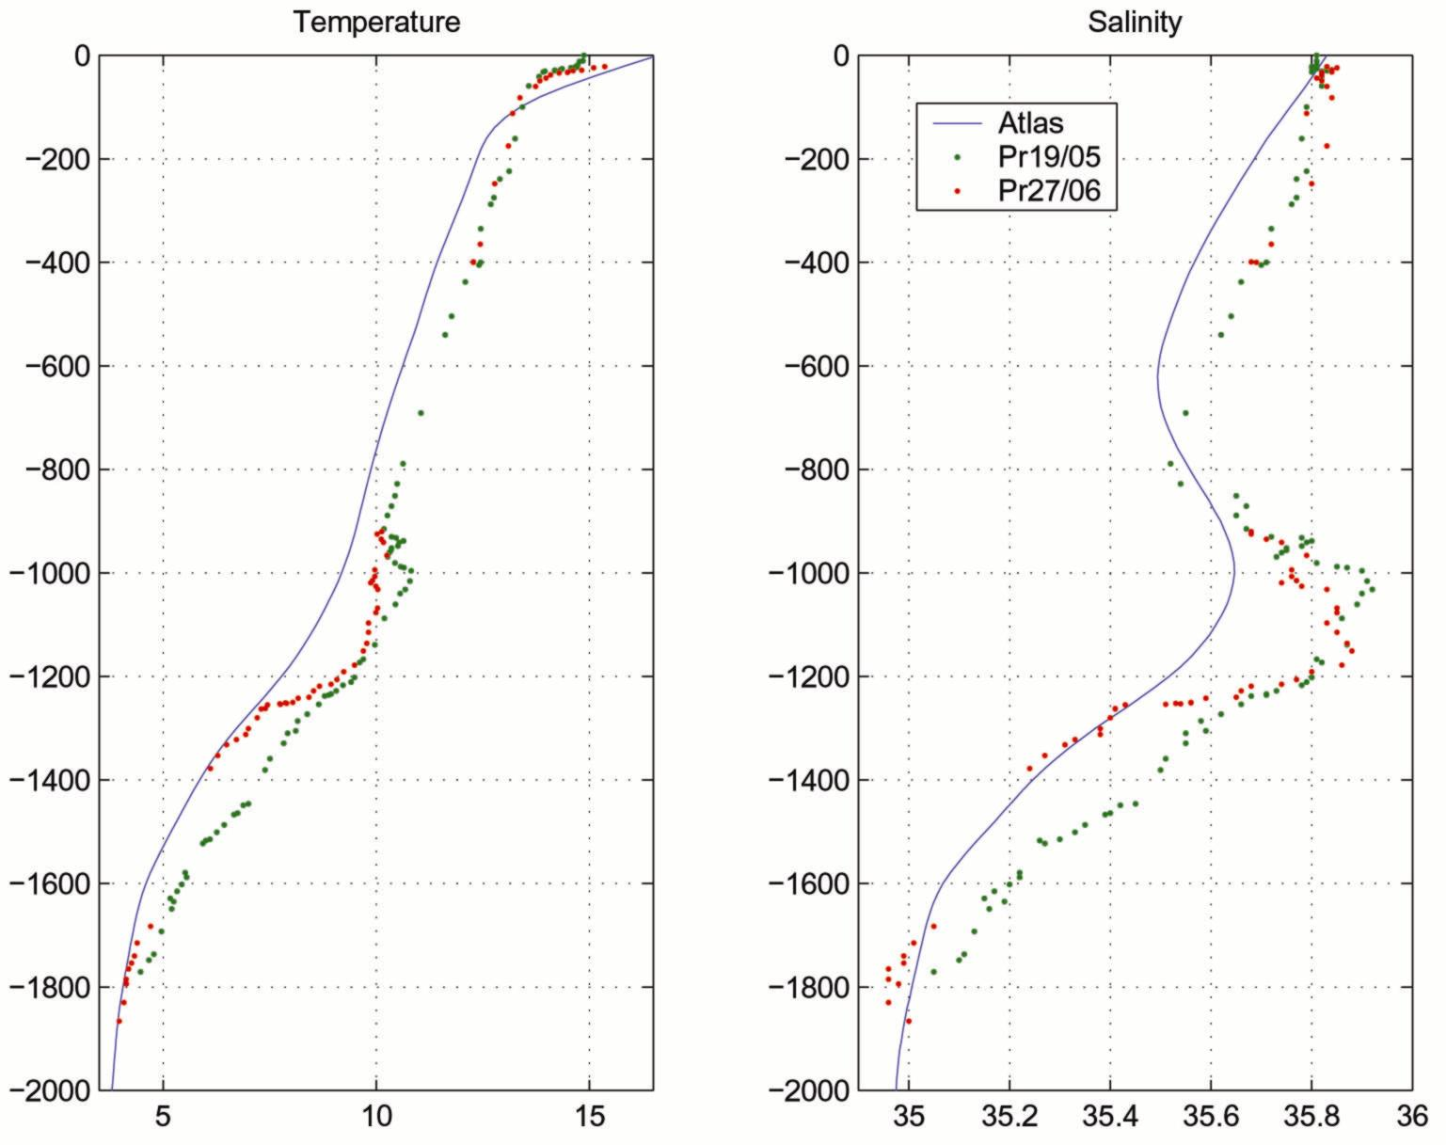
Figure 2a: trajectory and float measurements
14 months of a PROVOR trip West of Spain (blue line). Variation of temperature structure during the 14 months period; one can see the seasonal signal in surface and variability of 1000 m deep warm Mediterranean water.

Figure 2b - T/S profiles: Example of T/S profiles recorded by PROVOR, North of Spain. More than one month separate the profiles (between 19 May and 27 June). One can observe large signal fluctuation under 950 m, relating to the warmer and salter Mediterranean water. The blue curve is issued from climatology.

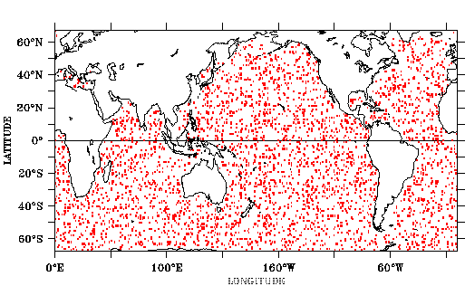The CORIOLIS data centre has also volunteered to be one of the two Argo Global Data Centres together with the US GODAE centre, providing a unique access to all the ARGO data (Figure 3). The first ARGO meeting held in Brest (3-5 October 2000) has discussed the basic principles of data exchange and distribution. Data format, quality control procedures as well as data exchange are already defined. The 2nd workshop will be held before the end of 2001 in Ottawa.

Figure 3 - ARGO network: The international ARGO program (in which France takes part) will deploy more than 3000 profiling floats according to a regular grid in the world ocean, by 2004. This new ocean observing network will give in real time an instantaneous vision of the thermal and haline structure of the 2000 m layer under the surface

- French contribution to ARGO deployments

CORIOLIS will contribute to the ARGO program (A global array of profiling floats) that aims at setting up a world network of 3000 autonomous floats to monitor the thermal and haline structure of the oceans in real time (Figure 4). The float displacement gives information on the fields speed. Such a network will provide a low-resolution sampling, at a 10-day frequency. ARGO is placed in the context of international programs on the ocean monitoring (GODAE) and on climatic variability studies (CLIVAR), and under the auspices of several agencies, such as the World Organization of the Meteorology (WMO) and the Intergovernmental Oceanographical Commission (IOC) of UNESCO. It was noticed at the G8 Foreign Affair Minister conference, in Miyazaki in July 2000, " the importance of the project ARGO, which will improve the possibility of forecasting the global change of the environment, thanks to precise oceanographical observations ". (http://www.argo.ucsd.edu)

At the international workshop held in Paris in July 2000 to define the ARGO network implementation in the Atlantic Ocean, France announced it will initially concentrate its participation in the world network by first deployments in the Atlantic Ocean, gradually from North to the South. It is thus foreseen to supply 240 profiling floats in the 2 coming years (2002 and 2003); it includes 40 floats funded by the European Commission for the demonstration project "Gyroscope" co-ordinated by the Ifremer and in partnership with nine laboratories in four countries.
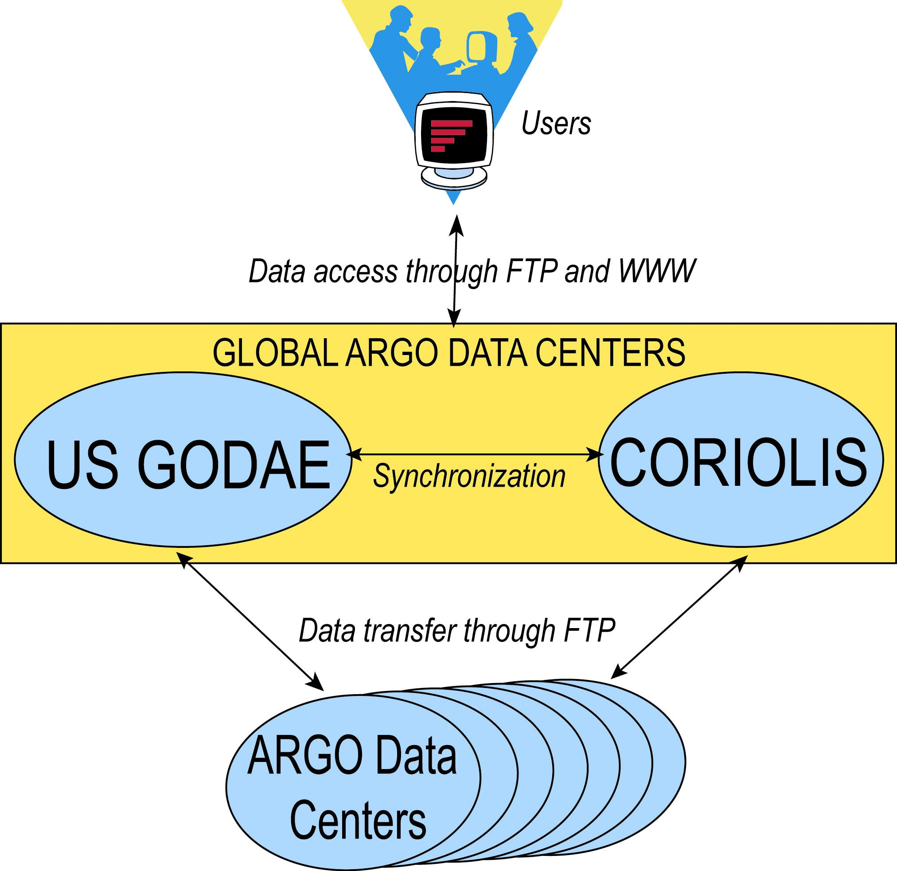

Figure 4 - ARGO data management network: The Coriolis data centre and the
US GODAE (in Monterey) are the two ARGO global data centres that will provide homogeneous access to all ARGO data acquired over the entire globe. These centres will be fed by various national data centres which will validate the data provided by the floats they deployed, using the same quality control procedures as defined by the “ARGO data management team”.

More than 30 floats PROVOR were deployed during 2000-2001, in the north-eastern Atlantic. The data are available in real time on the CORIOLIS website (http://www.coriolis.eu.org).

- Profiling floats development

3-1. PROVOR float description
Within the Coriolis framework, Ifremer has developed, through industrial partnership with the MARTEC company, a free-drifting hydrographical profiler named PROVOR based on MARVOR technology (the MARVOR drifting float is usually used for deep current studies – up to 2000m - and has been already built in nearly 200 specimens). As for the MARVOR, it doesn’t need any ballasting operation before launch.

Over more than three years, they typically drift at a user-defined parking depth for 10 days, dive to 2000 meters, come up to the surface, transmit data and then dive back for another cycle. The float volume is modified using a hydraulic system that transfers oil from an internal reservoir to an external ballast and generates enough buoyancy variation to move from the surface to 2000 meters even through high variations of sea water density (Figures 5).
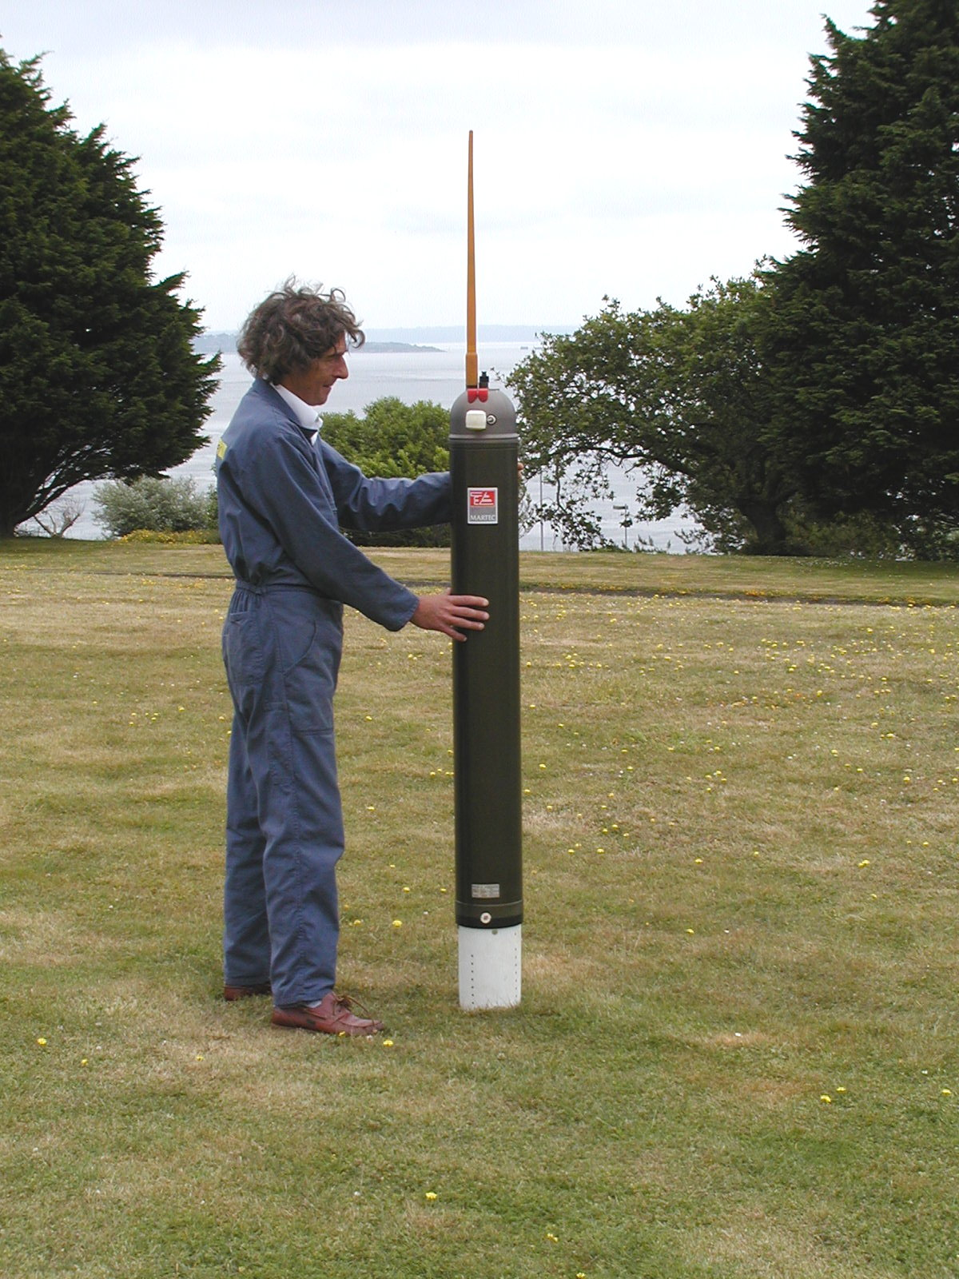
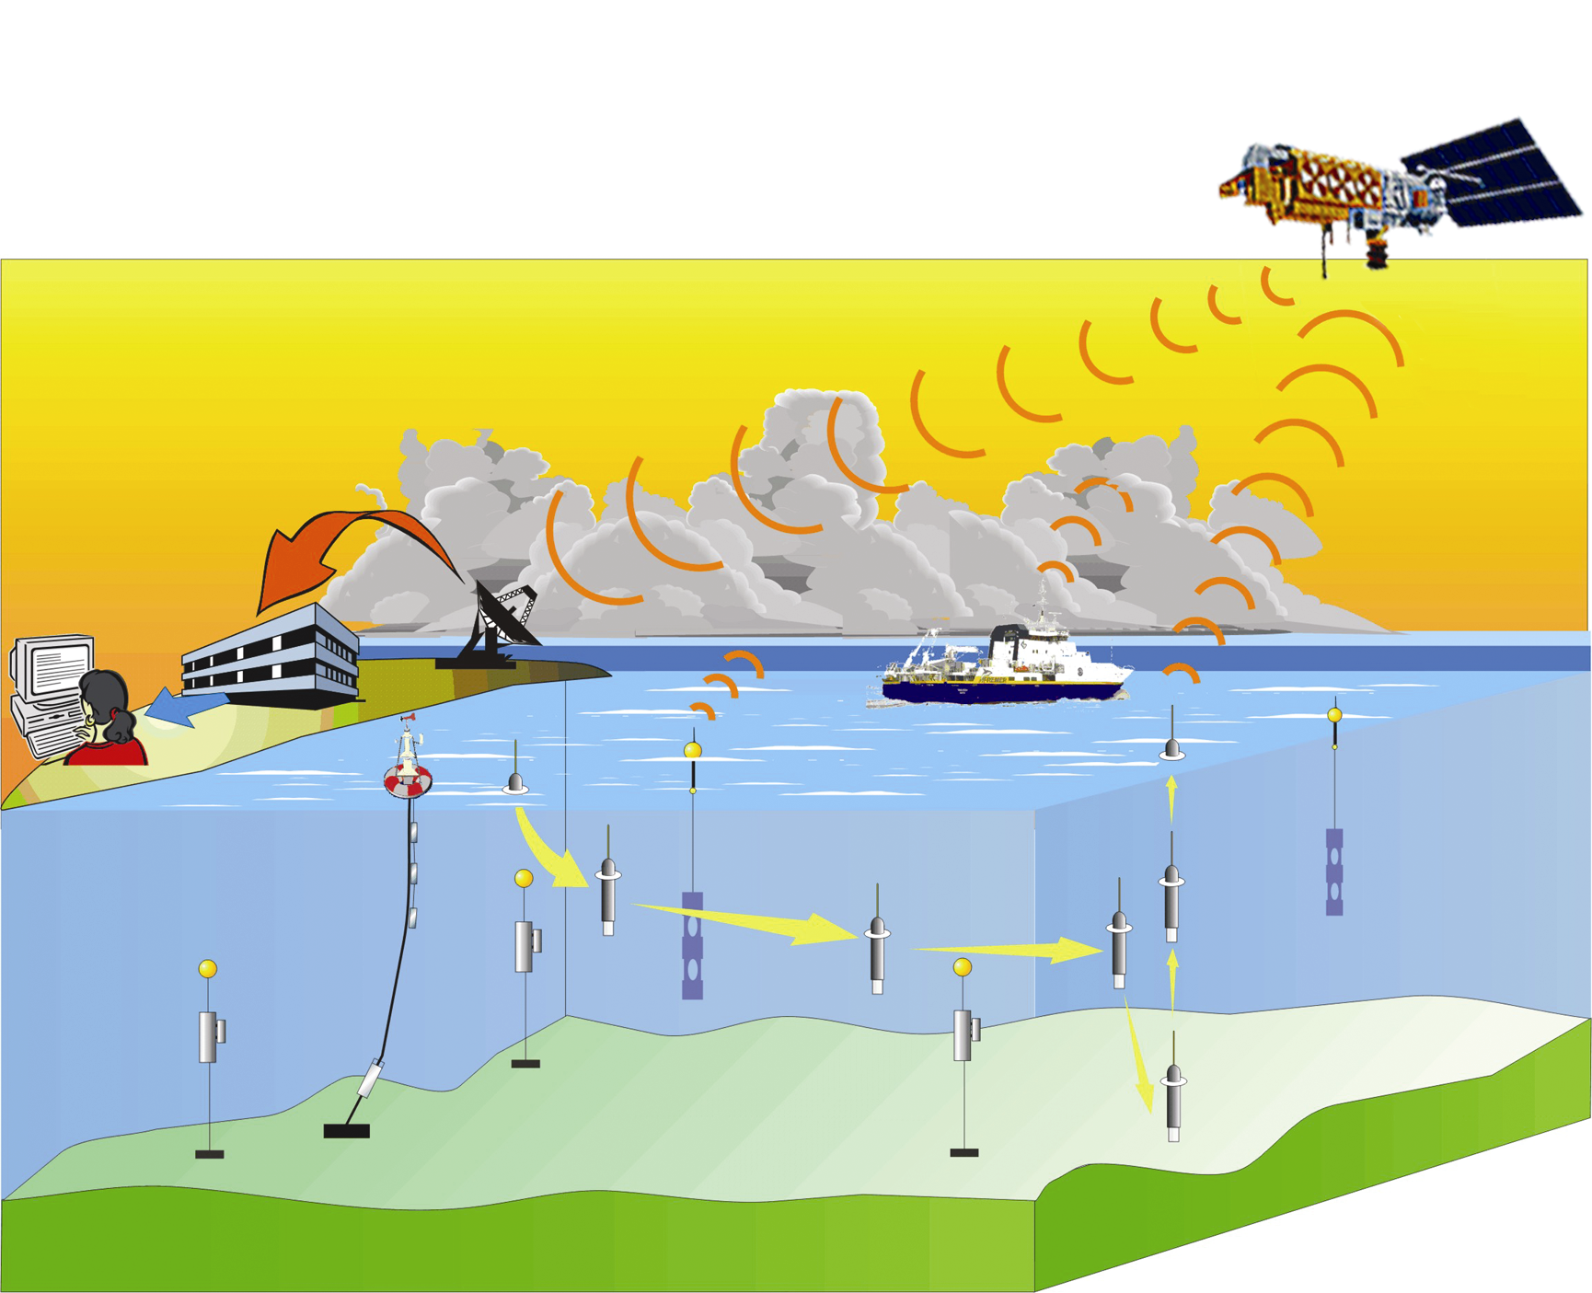
Figure 5b - profiling cycle: PROVOR is drifting into the water mass. Every ten days, it measures a Temperature and Salinity profile. After transmission of its data via the Argos satellite system, it dives for a new cycle.

Figure 5a - profiling float PROVOR

Temperature and salinity measurements are performed during the ascent and/or the descent and the sampling strategy is set before launching and parameterised at least for two user-defined layers.

3-3. Other profiling instruments
Other profiling instruments are under development, such as the expandable probes EMMA, able to pop up from the ocean bottom at a given time. These instruments (Temperature version) will measure profiles "at the fixed location", and over the entire water column, giving an Eulerian vision complementary to the Lagrangian one provided by drifting floats. Data will be transmitted through the Argos transmission system. First prototypes will be tested at sea beginning of 2002.

4. Integration of national activities related to in situ measurements

Many in situ measurements necessary for operational oceanography are made regularly by the French agencies involved in CORIOLIS: SHOM (XBT, hydrographical cruises), Ifremer (4 large research vessels), IFRTP (one large research vessel cruising in Indian and Antarctic oceans), IRD (TOGA XBT lines and thermosalinometers), Meteo-France (drifters and several anchored buoys), CNRS (floats). But data are not always transmitted in real time to data centres.
CORIOLIS aims to organize the systematic collection in real time of such in-situ measurements made either in routine or within the framework of specific research, in order to meet the operational oceanography needs. It harmonises reduction, control and calibration processes to cope with operational constraints.

Conclusion

The CORIOLIS project implementation by the French agencies in charge of oceanography, will contribute to the ocean observing system, providing world coverage of the oceans in real time. CORIOLIS a multi-disciplinary pilot project is involved in new autonomous instruments development with up-to-date transmission capability, in float deployment in the Atlantic Ocean then world and in data collection, processing and distribution to users (public authorities, scientific community, industry sector,).
It aims to be sustained when the world programs, to which it refer to, will have drawn their assessment for the coming years. One will then witness an evolution similar to the one observed in meteorology field twenty years ago: the deep-sea oceanography will go from science to operational for the benefit of the world population on a sustainable base. Nevertheless it will then be necessary to assume the recurring cost of such a program.

