An Update to Data Quality Control Techniques
Used by the National Data Buoy Center

by

David B. Gilhousen
Meteorologist, NDBC Operations Branch
Leader, Data Products Team

and

Eric A. Meindl
Chief, NDBC Operations Branch

ABSTRACT

The National Data Buoy Center (NDBC) has supplied marine weather observations to its parent organization, the United States’ (U.S.) National Weather Service (NWS), for approximately 25 years. The primary uses of these data are operational in nature, such as determining whether short-fused warnings or advisories need to be issued, verifying the accuracy of existing marine products, and providing input to operational numerical models. These real-time needs require a fast, reliable data quality control system to facilitate sound operational decision-making by marine forecasters. This paper presents a brief overview of NDBC’s data quality system.

1. INTRODUCTION

The National Data Buoy Center (NDBC) is a component of the United States’ (U.S.) National Oceanic and Atmospheric Administration (NOAA), National Weather Service (NWS). NDBC is the U.S. focal point for moored buoy and automated environmental monitoring system operation and technology development.

NDBC operates and maintains approximately 70 moored buoy and 55 fixed Coastal-Marine Automated Network (C-MAN) stations. They are located in the coastal and open oceans that surround the U.S., as well as the Gulf of Mexico and Great Lakes. Wind, barometric pressure, air and sea surface temperature, relative humidity and sea state are sampled at least every hour.

The data are transmitted via assigned communications channels through NOAA Geostationary Operational Environmental Satellites (GOES), processed at the NWS Telecommunications Gateway (NWSTG) every five minutes, and reach NWS operational forecasters within minutes.

Measurements taken by NDBC automated weather stations primarily benefit operational marine forecasters of NWS. The critical niche occupied is in the very short term (less than 3 hours) that is the usual limit of effective marine warnings and advisories. According to the most recent poll of NWS forecasters taken in 1995, NDBC observations were the basis of nearly half of all warning and advisory actions. While Doppler radar and satellite technologies have been deployed since then, continuing close contact with Weather Forecast Office (WFO) personnel indicate the marine observations remain very important. In addition, relatively recent development of Internet, along with real-time telephone access to the data through which observations are posted in real-time, have provided a powerful tool for mariners themselves to make final decisions before casting off. As of September 2001, there were an average of 5 million to 6 million page visits per month to NDBC’s web page.

Since operational warning decisions are often made based on this data, NDBC expends an unusual level of effort and resources to make sure the observations accurately represent the marine environment. This makes the system unique. NDBC’s data quality system consists of three parts: real-time automated checks that are executed every 5 minutes while data are being received; near real time checks that blend automated flags and graphical tools that facilitate manual inspection within 24 hours; and delayed manual verification prior to archival each month when data are between 30 and 60 days old. Most of this paper will provide a description of the real-time automated checks.

2. CONTEXT OF REAL-TIME QUALITY CONTROL

Before delving into the details, the proper place of these algorithms in the data quality control process needs to be understood. They form the last line of defense in preventing degraded data from reaching the public. Many other important measures precede them. New sensors are tested in environmental chambers before field evaluations. When the onboard software is modified, it is regression tested to make sure the output agrees with previously accepted values. Measurements from new sensors, buoy hulls, or onboard systems, called payloads, are compared with measurements from standard configurations (Gilhousen, 1987). All sensors are calibrated before every deployment, and site surveys are conducted to ensure proper exposure of the anemometers at new C-MAN stations. Servicing technicians remain at the station until several hours of acceptable transmissions make it through the satellite.

The historical role of the real-time data validation algorithms was in removing the large, “gross” errors (Gilhousen, 1988). These errors are typically caused by such things as satellite transmission problems, power system degradation, and broken cable connections. What these algorithms detect is virtually certain to be wrong. Although these checks have done a poorer job of detecting errors due to sensor degradation, modified algorithms are expected to perform much better (Gilhousen, 1998).

3. EXISTING DATA VALIDATION TECHNIQUES

The validation methods used in 1997 will be presented before the modifications are described. The validation occurs via software running at the NWSTG that encodes the observations into World Meteorological Organization (WMO) or NWS-approved codes. Measurements of sea level pressure, air temperature, sea surface temperature, dew point temperature, wind speed, wind direction, wind gust, wave height, average wave period, and dominant wave period are validated, if measured. If any measurement fails these checks, it will not be released, and measurements from a backup sensor, if it exists, will be examined. All NDBC stations have two anemometers; all buoys have two barometers; and a few buoys have two air temperature sensors.

Several transmission checks are accomplished before the data are validated. Any message with a single parity error is not transmitted. The wave portion of the message is transmitted in binary at the end of the transmission. If this message is shorter than expected, contains checksum errors, or has an improper synch character, no waves are encoded.

The simplest of the data checks, the range check, ensures all measurements fall within established upper and lower limits. A different set of limits is used in each of 29 climatologically similar areas.

The second check is the time-continuity check. The formula for performing the time-continuity check is:
(1)
$M=0\text{.}\text{58}σ\sqrt{τ}$ ,

where M is the maximum allowable difference,  is the standard deviation of each measurement, and ☺ is the time difference in hours since the last acceptable observation. ☺ is never greater than 3 hours despite the actual time difference. For information on how this formula was derived, see National Data Buoy Center (2001).

In practice, using station-specific values of the standard deviation of measured variables is not necessary. The general values in use are listed in Table 1. As with the general range limits, departing from the general values of σ is necessary for some stations. For example, since water temperatures at stations close to the Gulf Stream can change abruptly, ^{WTMP} for several east coast stations was increased to 12.1 C.

TABLE 1. Standard deviations used for the time-continuity check
Measurement | ☞
Sea Level Pressure | 21.0 hPa
Air Temperature | 11.0 C
Water Temperature | 8.6 C
Wind Speed | 25.0 m/s
Wave Height | 6.0 m
Dominant Wave Period | 31.0 s
Average Wave Period | 31.0 s
Relative Humidity | 20.0%

Four exemptions to the time-continuity test exist. These exemptions are based on the very rapid changes that occur in wind, pressure, temperature, and wave height during the passage of tropical and severe extratropical cyclones. First, air pressure measurements that fail the time-continuity check are released if both the previous and current pressures are less than 1000 hPa. Second, wind speed measurements are released if both the previous and current pressures are less than 995 hPa. Third, air temperature measurements are released if either the wind speed exceeds 7 m/s or the wind direction change is greater than 40. Finally, wave height measurements are released if the current wind speed is equal to or greater than 15 m/s. Even with these contingencies in place, analysts can elect to disable the range- and time-continuity checks for limited periods during hurricanes.

Finally, internal-consistency checks are:

• If the battery voltage is less than 10.5 volts, pressure is not released. This precludes the chance of transmitting bad pressures from a failing station operating on minimum power.

• The significant wave height, average, and dominant wave periods are set to zero if the significant wave height is less than 0.15 m. Without this, unrepresentatively large wave periods could be transmitted from an essentially flat, “signal-less” spectrum.

• If the dew point exceeds the air temperature by less than 1.1 C, the dew point is set equal to the air temperature. If the dew point exceeds the air temperature by more than 1.1 C, the dew point is not encoded. This approach is taken because a reading slightly more than 100 percent (Breaker et al., 1997) is normal for the hygrometers used by NDBC.

• If the ratio of gust-to-mean wind speed is greater than 4 or less than 1, neither the wind speed nor gust is transmitted.

4. VALIDATION CHANGES FOR BETTER QUALITY CONTROL

Several changes were made in early 1998 that will help further reduce the chance of degraded data being transmitted (Gilhousen, 1998):

- The consequences of a parity error were made less inhibiting. Under the new system, only the measurement where the error is located is not transmitted. Previously, the entire message was not transmitted. One significant observation that never was transmitted was from station 42020 in the western Gulf of Mexico during the formative stages of the March 1993 Superstorm (Gilhousen, 1994).

• If a measurement fails either the range or time-continuity check for two consecutive observations, the measurement is not transmitted until it is manually reviewed at NDBC.

• A check was installed to ensure that consecutive 10-minute wind direction averages, on stations equipped with “continuous winds,” agree with the standard 8-minute average wind direction. More specifically, the 10-minute average wind direction that overlaps the standard one must agree within 25 of the standard if the wind speeds exceed 2.5 m/s.

• A procedure was installed to determine if measurements from duplicate sensors are in reasonable agreement. If the measurements fail this determination, the software transmits the measurement from the sensor that exhibits better time continuity. This sensor is then chosen for all subsequent reports until it is manually reviewed. If the measurements from duplicate sensors are within the tolerances listed in Table 2, they are judged to be in reasonable agreement. This procedure is designed to detect significant sensor failures automatically and switch to a backup sensor, if one exists and is transmitting reasonable values.

TABLE 2. Tolerances used to validate duplicate measurements
Measurement | Tolerance
Wind Speed | 1.5 m/s
Wind Direction | 25 provided speed > 2.5 m/s
Sea Level Pressure | 1.0 hPa

Figure 1 is a time-series plot of a wind speed failure. Under the older procedure, almost 24 hours of degraded data were transmitted before data analysts at NDBC detected a wind speed failure and manually switched to the other sensor. With this new procedure, the software would automatically transmit speeds from the second sensor beginning at 1500 UTC, on March 1, 1996.

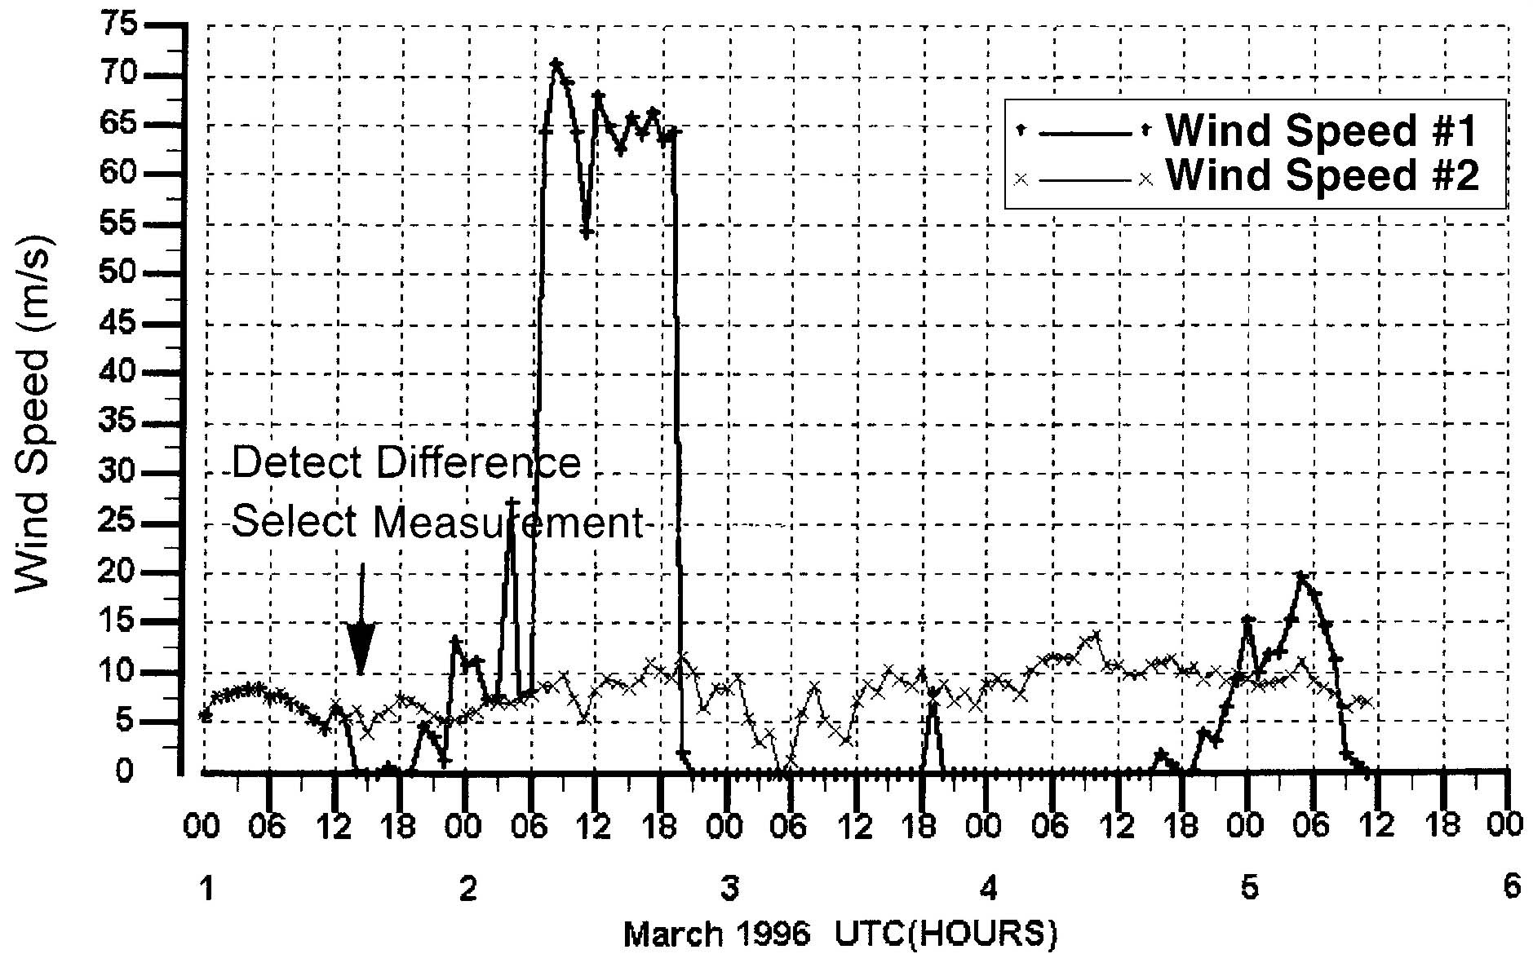

We estimate the number of degraded measurements transmitted are estimated to fall from approximately 40 to 15 each month. Excluding spectral wave measurements, about 800,000 measurements are transmitted each month.

5. VALIDATION CHANGES TO INCREASE DATA

Several aspects of the real-time quality control system were judged overly restrictive. The following improvements will result in additional data being transmitted:

- The ability to transmit wind speeds from one anemometer and the wind directions from another was enabled. This circumstance can result from a cracked propeller or worn bearings on one anemometer and a faulty compass associated with the other. At any given time in NDBC’s network of 120 stations, this situation happens at one or two stations.

• The range check will be made less powerful because on a few, rare instances, it caused valid, but extreme, data to be withheld from transmission. More specifically, a measurement has to fail a time-continuity check for the previous observation before it can be deleted because of a range check.

• The real-time processing was installed on two UNIX workstations running simultaneously. This provides automatic backup capability without the need for manual intervention if a workstation fails or the processing on it crashes.

One other improvement concerns the timeliness of the validation. The validation is now done every 5 minutes instead of every 15 minutes. This means that NWS field offices are more likely to receive the observations before NOAA Weather Radio cut-off times.

6. NON REAL-TIME QUALITY CONTROL

NDBC supplements the real-time algorithms with an extensive, after-the-fact validation effort. The effort is a “manual-machine” mix that involves a different set of algorithms and a review of computer graphics. The checks are designed to alert the analyst to suspicious data that indicates a potential payload, system, or sensor problem. Sample checks include those that ensure consistency between the high frequency wave energy with the wind speed; another that compares the wind direction with the wave direction; and others that compare observations with NCEP Aviation Model analysis fields. The manual review is typically accomplished within 24 hours of observation time. The Handbook of Automated Data Quality Control Checks and Procedures the National Data Buoy Center (2001) provides the algorithms and their use. Before monthly archival, analysts review all data via time-series plots to ensure that all degraded data were removed.

This system also changed significantly in the last two years with the addition of several new algorithms. Extensive manual review of printouts has been replaced by greater reliance on algorithms and reviews of computer graphics. When either a real-time algorithm, or an “after-the-fact” one indicates the possibility of degraded data, an intelligent assistant produces pre-done graphics that are most likely to help the analyst diagnose the event. These changes have served to make data validation more efficient and less labor intensive.

7. CONCLUSION

Many changes were made in the last four years to the processing and quality control software for NDBC stations. The changes increase the overall amount of data while decreasing the chance of degraded measurements being transmitted or archived.

REFERENCES

Breaker, L.C., Gilhousen, D.B., and Burroughs, L.D., 1997: Preliminary results from long-term measurements of atmospheric moisture in the marine boundary layer, J. Atmos Oceanic Technol., Vol. 15, pp. 661-676.

Gilhousen, D.B., 1987: A field evaluation of NDBC moored buoy winds, J. Atmos. Oceanic Technol., Vol. 4, pp. 94-104.

Gilhousen, David B. Improved real-time quality control of NDBC measurements, Preprints of the 10th Symposium on Meteorological Observations and Instrumentation, Phoenix, AZ, 11-16 January 1998, pp. 363-366.

Gilhousen, David B., 1994: The value of NDBC observations during March 1993's “Storm of the Century,” Weather and Forecasting, Vol. 9, pp. 255-264.

Gilhousen, David B. Quality control of meteorological data from automated marine stations, Proceedings of Fourth Internal Conference on Interactive Information and Processing Systems for Meteorology, Oceanography, and Hydrology, Anaheim, CA, Jan. 31 - Feb. 5, 1988, pp. 248-253.

National Data Buoy Center, Handbook of automated data quality control checks and procedures of the National Data Buoy Center, 2001.

