DEVELOPMENT OF A HIGH ACCURACY TEMPERATURE SENSOR
Simon Skey¹, Mark Blaseckie¹, Reo Phillips¹ and Val Swail²

¹Axys Technologies Inc., Sidney, BC, CANADA
²Meteorological Service of Canada, Downsview, ON, CANADA
s

- Abstract

The Global Climate Observing System has determined that the required accuracy of sea surface temperature measurements for use in analysis of climate change and variability is 0.1°C. Recent work (Skey et al., 2000) has shown that the stated accuracies for the NDBC buoys is ±1°C, and the Canadian ODAS buoys was ±1°C for the ZENO payload and is ±0.5°C for the Watchman payload; however, the measured accuracies for the Canadian buoys is actually much better, at about ±0.2°C, although with some offset, drift and non-linearity, and is sensor specific. The goal of this project was to develop a stable sensor which would provide accuracies better than ±0.1°C

This paper describes the development of the new High Accuracy Temperature Sensor (HATS) by Axys Technologies Inc. for the Meteorological Service of Canada. Initial laboratory testing of the sensor was carried out at the Institute of Ocean Sciences, Sidney, B.C., and at Axys. The results of these tests showed that the HATS temperature measurements agreed to within ±0.06°C of the IOS calibration tank. The data also showed that the errors were only the result of a linear offset for each sensor, and that therefore with a constant linear offset correction, each sensor was corrected to better than ±0.02°C.

Following the laboratory testing, the sensors were deployed in two 3m-discus hulls, one an experimental buoy in Saanich Inlet, the other an operational buoy at Halibut Bank off Vancouver Island, for extended field-testing. The results of the first period of field-testing are also described.

.

2.0 DEVELOPMENT OF A HIGH ACCURACY TEMPERATURE SENSOR (HATS)

Recently YSI has developed highly accurate YSI Precision™ thermistors as well as a YSI 4800LC Thermistor Linearizing Circuit™ (TLC) that converts the non-linear response of the thermistors to a linear digital output. The development of HATS took advantage of these developments at YSI and used a 46000 series super stable glass thermistor in conjunction with the YSI 4800LC. HATS provides a digital serial output thus eliminating the ±0.15°C errors associated with the 12 bit A/D converter in the Watchman. The design was confident that with the combination of this, the improved thermistor and the TLC, an accuracy of ± 0.05°C could be achieved.

  - Custom Circuit Board

AXYS designed a small custom circuit board to provide the necessary 5VDC power input to the Thermistor Linearizing Circuit, from the standard ODAS buoy power of 12VDC. In addition AXYS added a RS485 driver to this circuit board so that the HATS can accommodate both RS232 and RS485. RS232 is only effective over relatively short cable runs. The addition of the RS485 interface enables the HATS sensor to be located much further away from the data processor.

Typical values for serial port asynchronous communications are as indicated in the following table:

Interface | Max no. of devices | Max cable run (feet) | Max Speed  (bps)
RS-232 | 2 | 50 – 100 | 20 – 115K
RS-485 | 32 | 4,000 | 10M

Table 2.1
Communication Parameters
Ref: Axelson 1998

2.2 Interchangeability and Accuracy

The thermistor, the YSI 4800LC and the small custom circuit board are all housed within the temperature bolt. Because of this, it is not necessary to allow for the interchangeability of thermistor and TLC, resulting in a cost saving for the thermistors. It also means that the design provides a basic 0.1°C sensor if the calibration coefficients are not used, but where the coefficients can be stored in a data logger and operated on by a data processor (e.g., Watchman), the accuracy can be brought to the required 0.05°C.

Figure 2.1 Drawing of Sea Surface Temperature Sensor as presently installed in ODAS buoys.

Figure 2.2 Drawing of High Accuracy Temperature Sensor for installation into ODAS buoys.

2.3 Construction

The High Accuracy Temperature sensor (HATS) is manufactured by potting the thermistor, the TLC and the custom circuit board with a heat sink compound into the threaded end of a machined hollowed ¾” stainless steel bolt. This is a slightly longer bolt than the standard ODAS temperature sensor bolt. See Figures 2.1 and 2.2 for drawings of the sensors, and Figure 2.3 for a photograph of the finished HAT sensor. Two metres of AXYS water block cable extends from the back of the bolt and terminates in a male Bulgin 6-pin connector. The six pins provide an analog output, RS485 and RS232 outputs, power and ground (see Figure 2.3)

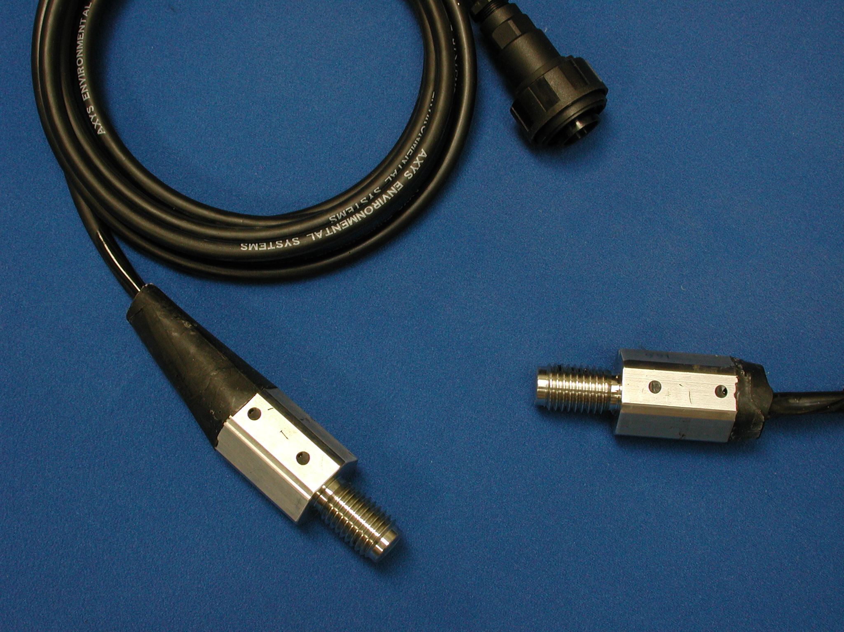

Figure 2.3 Photograph of Completed High Accuracy Temperature Sensor with water block cable and Bulgin connector.

2.4 Specifications Summary

TLC 4800LC - 004 – B &
Thermistor 46033
Range -10° to + 50° C.
Resolution 0.01°C
Accuracy without calibration coefficients 0. 1°C
Accuracy with calibration coefficients 0.05°C
Drift (operating temperature < 70☹ C) <0.01°C over 5 years

2.5 Prototype Sensors

Four prototype sensors were built into the modified ODAS temperature bolt at AXYS (see Figures 2.1 and 2.2). Three of these sensors used thermistors that had a temperature range of 0 to 100°C. These sensors are identified as a 46036 type and have AXYS serial numbers 166, 167 and 168 respectively. The fourth prototype sensor (with a –10°C to +50°C thermistor which is identified as a 46033 type) has the AXYS serial number 169, and was tested in the second IOS tests. The thermistor used in SN 169 gives more accuracy near 0°C.

3.0 TESTING AND VERIFICATION

Three sets of calibration and verification tests were carried out. Two sets at the Institute of Ocean Sciences and the other at AXYS. The first set of tests at IOS were plagued with problems related to noise, and although the results showed that the sensors were on the right track, the data were not sufficiently accurate to demonstrate that the required specifications had been achieved. Thus further electronics work and testing at AXYS took place before the second set of testing at IOS.

The sensors were tested in their operational configuration, with the following interface cable, allowing the RS232, RS485 and analog outputs to be measured.

Figure 3.1 Interface Configuration Used During Testing.

3.1 Initial Testing at Institute of Ocean Sciences

Only three of the four prototype sensors (S/N 166, 167 and 168) were used for the initial testing and verification using the CTD calibration test tank at IOS. Because of the short cable runs (<50 feet) the RS232 communications circuit were used. The RS485 communications were not used but were tested using a RS485 test jig. These tests were successfully accomplished.

Prototype sensor SN 168 did not perform well during the tests. When this sensor was dismantled later for investigation a faulty solder joint was discovered. Since the sensor had been potted, it was destroyed during the process of fault investigation.

The initial testing of the HATS was performed at IOS. The temperature was set to profile from +35°C down to –1°C, with a 15 minute dwell at 35°, 30°, 25°, 20°, 15°, 10°, 5°, 0° and –1°. At the initial set-up for this testing, it was noted that the noise level of the sensor readings was high (temperature fluctuations of 0.05 to 0.10°C from sample to sample, approximately every 1.3 seconds). This noise was the result of an external influence, since the time constant for the SS bolt assembly was such that the amount of the temperature fluctuations was not realistic over a period of one second in a relatively stable temperature bath. The test computer and power supply were moved to an alternate location, which did reduce the noise level by a factor of 2. Although the noise could not be removed altogether, the test was continued. The analysis of the data from this test confirmed that there was a significant amount of induced noise, but that when the temperatures were averaged over 10 minutes, the average values were very close to that of the bath (within 0.1°C).

Following the results of this testing, the sensors were brought back to AXYS for further electronics testing. This testing did not show that there was any problem with the electronics, however a small change was made to the power supply circuit in an attempt to reduce the effect of potential noise coming from the power supply

3.2 Testing at AXYS

The two units were placed in an insulated water bath alongside a Seabird SBE 37-SI (Serial Interface) MicroCAT Conductivity and Temperature Monitor. Data from the SBE 37-SI was set to output every 10 seconds and was logged by a terminal program during the test. The SBE 37-SI was the control for the test. The SBE 37-SI measures a temperature range of –5° to +35°C with a resolution of 0.0001°C and an accuracy of 0.002°C. The latest calibration certificate of the SBE37 is included in Appendix D. The water was cooled to near 0°C by placing ice in the water bath, and a submersible water pump was used to circulate the water. The heat generated from this pump was used as a means to heat the water. The bath was sealed and allowed to heat with time. The test ran for 48 hours which resulted in a temperature profile from near 0°C to 42°C. (Figure 3.3).

For data acquisition, the two sensors were interfaced to two RS232 communications ports of a portable computer. A common 12V gel cell battery powered the sensors and the computer. Data was collected sequentially through each port and displayed on the computer screen at about a one-second interval (1 Hz). Data from each unit was stored every 10 seconds (0.1 Hz) onto computer disk. Each data point was date and time stamped.

During the set up for the tests there was no evidence that there was any noise due to the power supply. It was concluded that the noise discovered in the first set of IOS tests must have had something to do with the particular set up at IOS and was not a function of the sensors themselves.

Figure 3.2 Profile of Calibration Bath Temperatures for Duration of Test.

Figure 3.2 shows that the entire temperature profile increased at a very stable rate during the test. Data from the SBE 37-SI and the two prototype sensors were synchronized for statistical analysis such that only sensor values that were taken within 5 seconds of SBE values were used as coinciding values.

We define the difference between the SBE 37-SI and the prototype sensor as an offset. A positive offset indicates that the SBE value is higher than the prototype sensor. Table 3.1 shows statistical averages of temperatures, average temperature offsets from the SBE 37-SI temperature, and standard deviation of temperature offsets at temperatures near 0°C, 1°C, 5°C, 10°C, 15°C, 20°C, 25°C, 30°C, and 40°C.

SBE37  Temp  Average | SN 166  Temp  Average | SN 166  Offset  Average | SN 166  Offset  Std Dev | SN 167  Temp  Average | SN 167  Offset  Average | SN 167  Offset  Std Dev
0.044 | 0.022 | -0.022 | 0.007 | -0.011 | -0.055 | 0.008
0.961 | 0.912 | -0.049 | 0.011 | 0.877 | -0.084 | 0.011
4.769 | 4.706 | -0.063 | 0.008 | 4.686 | -0.082 | 0.007
9.918 | 9.869 | -0.049 | 0.009 | 9.842 | -0.075 | 0.009
14.929 | 14.881 | -0.049 | 0.006 | 14.867 | -0.062 | 0.008
20.107 | 20.075 | -0.032 | 0.008 | 20.052 | -0.055 | 0.006
24.976 | 24.953 | -0.023 | 0.005 | 24.935 | -0.040 | 0.005
30.010 | 30.001 | -0.009 | 0.006 | 29.981 | -0.028 | 0.005
40.001 | 40.003 | 0.002 | 0.004 | 39.997 | -0.005 | 0.005
Table 3.1.
Average Temperatures, Offsets and Offset Standard Deviations

These data show that for the duration of the test the prototype sensor temperature offsets were typically less than 0.060°C, ranging from 0.002 at 40°C to -0.084 at 1°C. The standard deviation of the offsets, which demonstrates the stability of temperature measurements, were typically less than 0.010 ranging from 0.005 at 40°C to 0.011 at 1°C.

Figures 3.3 and 3.4 show graphs of offsets over the test temperatures from near 0°C to 42°C for the prototype sensors s/n166 and s/n167 respectively. These demonstrate the small variation of the offset and the stability of temperature measurements.

Figure 3.3. Observed temperature offsets for Prototype Sensor S/N 166 from 0°C to 42°C.

Figure 3.4. Observed temperature offsets for Prototype Sensor S/N 167 from 0°C to 42°C.

3.3 Further Testing at IOS.

Following these successful tests at AXYS, a further set of tests was carried out at IOS. For these second set of tests at IOS the fourth prototype sensor (SN 169) was included, as well as an SST bolt and an air temperature sensor of the type that are presently used in the Canadian ODAS buoy network.

The three HATS sensors (SN 166, 167 & 169), the air temperature probe and the SST bolt were monitored and logged by a Watchman 100 to remove the ambient noise induced by the power supplies at IOS. The complete logging system was powered by an external battery pack. The tests were run over a period of three days with temperature set points of ten minute durations at each of 0°, 5°, 10°, 15°, 20° and 25°C. The results of these tests showed that without the noise influence, the HATS temperature measurements agreed to within 0.06°C of the IOS calibration tank. The data also showed that the errors were only the result of a linear offset for each sensor, and that therefore with a constant linear offset correction, each sensor was corrected to better than ±0.02°C of the IOS calibration tank. The following charts show the temperature comparisons between the HATS sensors values and the IOS calibration tank values before and after the offset was applied.

Figure 3.5. HATS Temperature Plots.

With the following offsets applied, it can be seen that the corrected temperatures agree within 0.018°C of the IOS calibration tank:

Hats Sensor | HATS166 | HATS167 | HATS169
Offset Applied | 0.02 | 0.05 | -0.02

Table 3.2
HATS Offsets

Figure 3.6 Corrected HATS Plots.

At the same time as the HATS sensors were tested, a SST bolt and Air temperature probe as used on the EC weather buoys was also tested. As suspected, these sensors disagreed with the IOS calibration tank by as much as 0.12°C. The following chart shows the offset of these two sensors from the IOS calibration tank.

Figure 3.7 SST and Air Probe Temperature Plots

.

With the following third order polynomial coefficients (empirically determined) applied to the SST bolt and the Air temperature probe:

T_{c} = aT_{r}³ + b T_{r}²+cT_{r}+d
Where T_{r} = Raw Temp., T_{r} = Corrected Temp

Table 3.3
SST and Air Probe Temperature Corrections
.

Sensor | SST | AIR Probe
a | -0.00004 | -0.00004
b | 0.0011 | 0.001
c | 0.0040 | 0.0057
d | -0.1229 | -0.1256

Figure 3.8 Corrected SST and Air Probe Plots

It can be seen that the corrected SST temperatures agree within 0.01°C and the corrected Air Probe temperatures agree within 0.04°C of the IOS calibration tank.

The following table summarizes the data obtained from the second test performed at IOS with the calibration tank.

IOS Tank Temp | Air Probe Offset | Air Probe  Corrected Offset | SST Offset | SST  Corrected Offset | HATS 166 Offset | HATS  166 Corrected Offset | HATS 167 Offset | HATS  167 Corrected Offset | HATS 169 Offset | HATS  169 Corrected Offset
0.043 | -0.12 | 0.00 | -0.12 | 0.00 | 0.03 | 0.00 | 0.07 | 0.02 | -0.03 | 0.00
4.917 | -0.09 | -0.01 | -0.08 | -0.01 | 0.03 | 0.01 | 0.06 | 0.01 | -0.02 | 0.00
9.905 | -0.01 | 0.00 | -0.01 | 0.00 | 0.03 | 0.00 | 0.06 | 0.00 | -0.01 | 0.01
14.899 | 0.03 | -0.01 | 0.05 | 0.00 | 0.03 | 0.00 | 0.05 | -0.01 | -0.03 | 0.00
19.827 | 0.05 | -0.03 | 0.06 | -0.01 | 0.02 | -0.01 | 0.05 | 0.00 | -0.02 | 0.00
24.849 | 0.00 | -0.04 | 0.02 | 0.00 | 0.01 | -0.02 | 0.04 | -0.02 | -0.02 | 0.00

Table 3.4
Summary Data (NOTE: all values in °C)

3.4 Field Testing

Test 1 - Empty 3M Hull testing (not done)

Place three new HAT sensors into the hull as outlined below:

- One, as is, attached to the hull via the normal bolt mount.
- One attached to the hull by a second normal bolt mount, but covered with insulation,
- One suspended in the chamber approximately 4” from the bottom directly overhead of the two mounted into the hull.

Also have one ambient air temperature sensor.

With the sensors mounted as described above, heat the inside chamber up to ~40°C (measured from the hanging sensor) and record the values from the three sensors. Ensure sufficient time to reach equilibrium (@4-6 hours) and perform the same test for values of 30°C, 20°C and 10°C. By suitable temperature modeling the effects of the internal chamber temperature on the SST measurements can be determined.

Test 2 – Eco-Buoy (Patricia Bay) and Halibut Bank

The Field-testing is taking place on two of Environment Canada’s 3-metre discus buoy on the Southern BC Coast. Figure 3.9 shows their location.

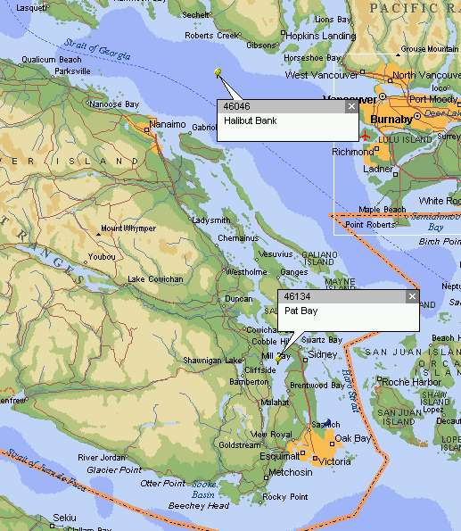

Figure 3.9
Field Testing Locations

These two location were selected for their ease of access and because they both were fitted with Seabird SBE 37-SI sensors which provided a high accuracy SST measurement.

The first sensor was installed on the Pat Bay Buoy on October 2nd, 2001. Both the hardware and software modifications were done with the buoy remaining in the water. Since the standard SST measurement sensor had a foam-insulating cup installed, a foam-insulating cup was also installed on the HATS sensor. Figure 3.10 shows the foamed installation.

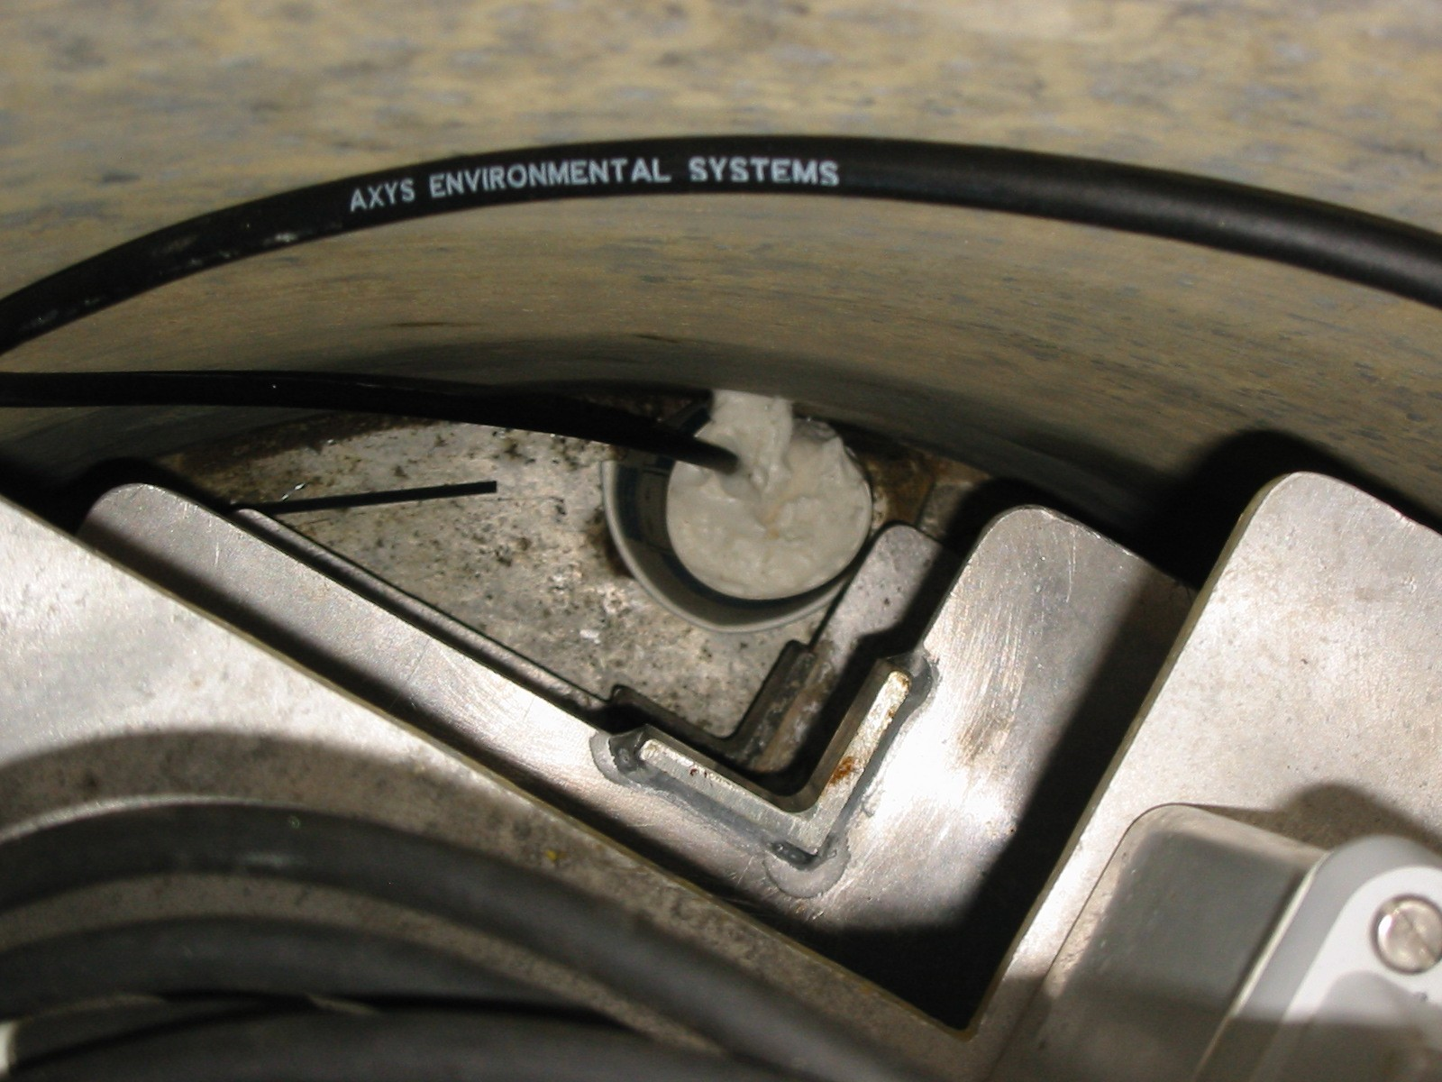

Figure 3.10
HATS Sensor With Foamed Cup Installed

Figure 3.11 shows a graph of the standard SST sensor, the Seabird sensor and the newly installed HATS sensor

Figure 3.11
SST, Seabird and HATS Sensors

There is generally good agreement between the three sensors although there are periods of time where the Seabird measurement is .3°C away from the standard SST and HATS measurements.

To attempt to determine the cause of this difference, the Air Temperature measure was compared with the three SST sensors. There did not appear to be any direct cause, although this difference warrants further investigation. Figure 3.12 shows this data.
Figure 3.12
Standard SST, Seabird, HATS and Air Temperature

Figure 3.13 shows the difference between the HATS sensor data and the Seabird data. This difference is typically less that 0.2°C
Figure 3.13
HATS sensor data minus Seabird sensor data

On October 5th, 2001 the second sensor was installed in the Halibut Bank Buoy at 46146. At that time, it was discovered that there had been a breach of the watertight integrity of one of the cable junction boxes and the water quality instrumentation, including the Seabird sensor were removed from the buoy for repair.

There is not data to date to compare the original SST sensor and the HATS sensor with the Seabird sensor. Figure 3.14 shows the intercomparison data between the HATS data and the standard SST measurement while figure 3.15 difference between the HATS sensor and the standard SST sensor with a 24 running average.

Figure 3.14
HATS sensor and Standard SST

Figure 3.15
HATS sensor minus Standard SST sensor with 24 hour running average

4.0 CONCLUSIONS:

The offsets of the Prototype Sensors varied about 0.02 to 0.03°C between units and typically less than 0.06°C from the control measurements. The standard deviation of the offsets were typically less than 0.010°C over the range of test temperatures. Therefore without correction for offsets the expected accuracy of the Prototype Sensors are in the order of ±0.060°C. With correction for offset the expected accuracy of the Prototype Sensors should approach ±0.020°C.

These results indicate that the quoted specification accuracy of ±0.05°C with a resolution of 0.01°C has been achieved.

To help determine the cause of the between the various sensors the ambient air temperature in the buoy should be monitored and reported.

5.0 REFERENCES

1998. Axelson, J. Serial Port Complete. Programming and Circuits for RS232 and RS485 Links and Networks. ISBN 0-9650819-2-3.

2000. Skey, S., J. Gower, M. Blaseckie and V. Swail. Sea Surface Temperature Measurement From ODAS Buoys. Proc. Data Buoy Cooperation Panel Technical Workshop, Victoria, B.C., October 2000

6.0 ACKNOWLEDGEMENTS:

AXYS Environmental Systems would like to acknowledge the important contributions to this program from the following:

- Val Swail, Research Meteorologist, Climate Research Branch- MSC, Downsview - Scientific Authority

- Institute of Ocean Science (IOS) Instrument Calibration Group

Funding for this development was provided by:

Climate Change Action Fund

