SSAS: A Salinity Sensor for Autonomous Systems

Gary Williams, Gary Lagerloef, John Gunn¹, Raymond W. Schmidt
Clearwater Instrumentation, Inc., 304 Pleasant St., Watertown, MA 02472

Abstract
NASA’s Earth Science Enterprise identifies sea-surface salinity as critical for climate predictions, long-term climate variability research, model assimilation, flux closure, hydrologic budgets, and coastal dynamics. Sea-Surface Salinity Sensor for Autonomous Systems will provide accurate in situ surface salinity to validate observations from space. SSAS will be low-cost and long-lived sensor for surface drifters that are now deployed in large numbers. In this development program we designed and deployed an SSAS with a salinity sensor pod that extends sensor life by completely enclosing it when not sampling, thus limiting exposure to biofouling precursors and increasing antifoulant efficacy. SSAS transmits information by satellite. Further studies will concentrate on the evaluations and long-term studies needed to identify the best low-cost salinity sensor and antifoulant; develop SSAS calibration procedures; and proof the enclosure system for long period operational deployments. Proof will be accomplished through short-term tethered deployments, longer-term ocean deployments with recovery, and by 2003 operational deployments in the Tropical Pacific and for observing freshwater mixing across the Amazon plume in the Tropical Atlantic.

The Challenge: Long-term Salinity Measurements at the Sea Surface
Any sensor must be stable for extended periods to be useful in long, unattended deployments at sea. Conductivity sensors present greater challenges in this regard because at a minimum they need to preserve geometric stability of the sensor and its immediate environment and keep pristine surfaces to maintain calibration. However biofouling can be especially aggressive at the sea surface and quickly degrade calibration. Other requirements we seek to achieve for SSAS are low power requirements for equipment longevity and low cost to encourage widespread use.
Salinity is an extensive property of seawater that is always measured indirectly, and most frequently through its relation to the conductivity dissolved salts impart to seawater. Most commonly conductivity is measure directly with conductance cells or by inductance. Salinity also can be measured through its effect on sound velocity and density. In Table 1 lists three salinity sensors and their accuracies.
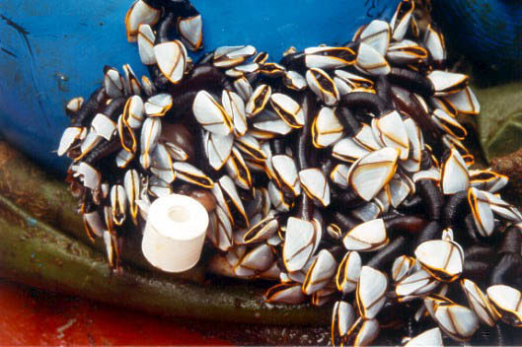
Figure 1 Barnacle surrounding a toroidal inductive salinity sensor.

Table 1 Seawater salinity related sensors
Manufacturer | Model | Sensor | Range, mmho/cm m/s | Accuracy | Temperature Range, C | Temperature Accuracy | Salinity Accuracy 5 C, 31 PSU
Falmouth Scientific | OEM C-T | Inductive | 0 = C < 64 | +/-0.025 | -5 < T < 35 | +/-0.05 | 0.075
Applied Microsystems | Conductivity Smart Sensor | Direct | 0 < C < 65 | +/-0.01 | -2 < T < 38 | +/-.005 | 0.016
Applied Microsystems | Sound Velocity Smart Sensor | Sound Velocity | 1400 < SV < 1550 | +/-0.06 | -2 < T < 38 | +/-.005 | 0.065

Current State of Antifouling Technology.
The application of antifoulants can inhibit fouling on salinity sensors for limited times. Commonly applied antifoulants are copper based coatings, titanium containing coatings, irritants (e.g. pepper oil), and tributyl tin (TBT). In the case of inductive sensors, the antifoulant can be applied directly to the surface of the encapsulated toroidal coil. We used this technique on the sensor attached to the drifter buoy in Figure 1. In that case the sensor remained unaffected for the period of the deployment, but the sphere to which it was attached fouled quickly and to the extent that sensor calibration drifted because barnacles grew into the sampling volume surrounding the sensor. Some conductivity sensors that measure the current flow between electrodes in enclosed cells use TBT-impregnated plastic tubing at the entrances to leach antifoulant that keeps organisms from growing inside.
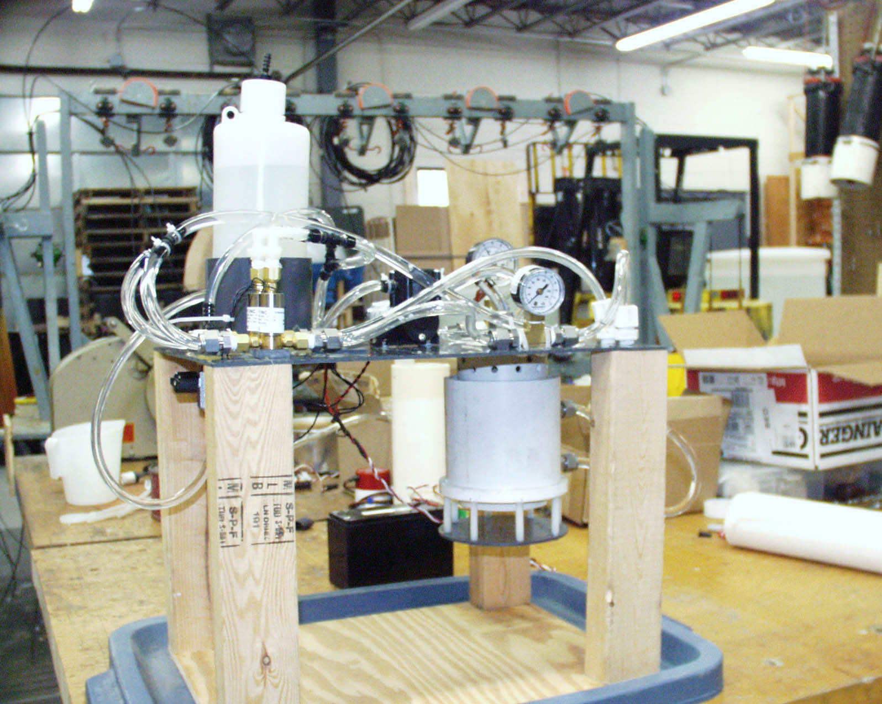
Figure 2 SSAS prototype in "open" mode.

SSAS Antifouling Technology
SSAS encloses a sensor in a pod, which can be opened to expose the sensor to seawater when a sample is required. Enclosing the sensor protects it from the continual flow of water carrying organisms looking for a place to settle, and nutrients for growing organisms. The inside of the pod provides surfaces for attaching antifoulant leeching bodies or for applying antifoulant coatings. The low velocity of water flowing past the sensor leads to higher concentration of antifoulant at the surface, and inside the volume contained by the pod thereby increasing the efficacy of the antifoulant.
An SSAS sensor pod consists of two concentric cylinders, an inner one which is securely attached to the float hull and on which slides downward an outer sleeve capped by a copper plate mounted on plastic standoffs so that ambient seawater can have access to the enclosed sensor (Figures 2 and 3). The outer sleeve is moved by a novel seawater hydraulic system in which the actuating system is contained within the cylinder parts. Consequently, there are no exterior hoses. Opening and closing is accomplished by an efficient electric pump which provides pressure and solenoid valves to direct the flow. Since the working hydraulic fluid is seawater, there is no possibility of contamination. The interior of the sensor pod provides several possibilities for the installation of antifouling treatments, besides the copper plate at the exterior of the outer sleeve. An SSAS prototype has been implemented with three sensor pods, which permit the intercomparison of a variety of sensors and antifouling treatments.

Salinity Sensors

This SSAS instrument has allowed us to compare and contrast the three sensors. One of the sensors installed in the SSAS is an FSI OEM C-T inductive conductivity sensor that employs a toroidal coil as the sensing element. A second sensor is an AML conductivity sensor that measures seawater conductance between electrodes. The third sensor is an AML sound velocity sensor.

Table 1 Seawater salinity related sensors shows the manufactures’ specifications of accuracy for the sensors installed in SSAS. The prices of these sensors range from least expensive for the FSI inductive sensor to most expensive for the AML sensors. We have estimated the accuracy of salinity measurements for the sensors from the accuracy claims of the manufacturers. Accuracy of the salinity measurements decreases with temperature, so a worst-case value is presented in the table where the sensor with the greatest accuracy, at +/- 0.16 PSU (conditions 32 PSU and 5 C), is the more expensive AML C-T Smart Sensor, while the less expensive FSI OEM C-T is least accurate, +/- 0.075 PSU (same conditions). These worst-case values assume that errors in measuring temperature and conductivity, or sound velocity, affect the calculation of salinity in the same sense so as to be additive, rather than canceling. All of the sensors are installed into the bases of the SSAS sensor pod by screwing their threaded base into a plastic block attached firmly to the SSAS hull. We expect that an inductive system will be lowest in cost because inductive sensors are available from other vendors in addition to FSI (e.g. Honeywell 5000TC Series Toriodal (Electrodeless) Conductivity Sensors).

FSI inductive conductivity sensor
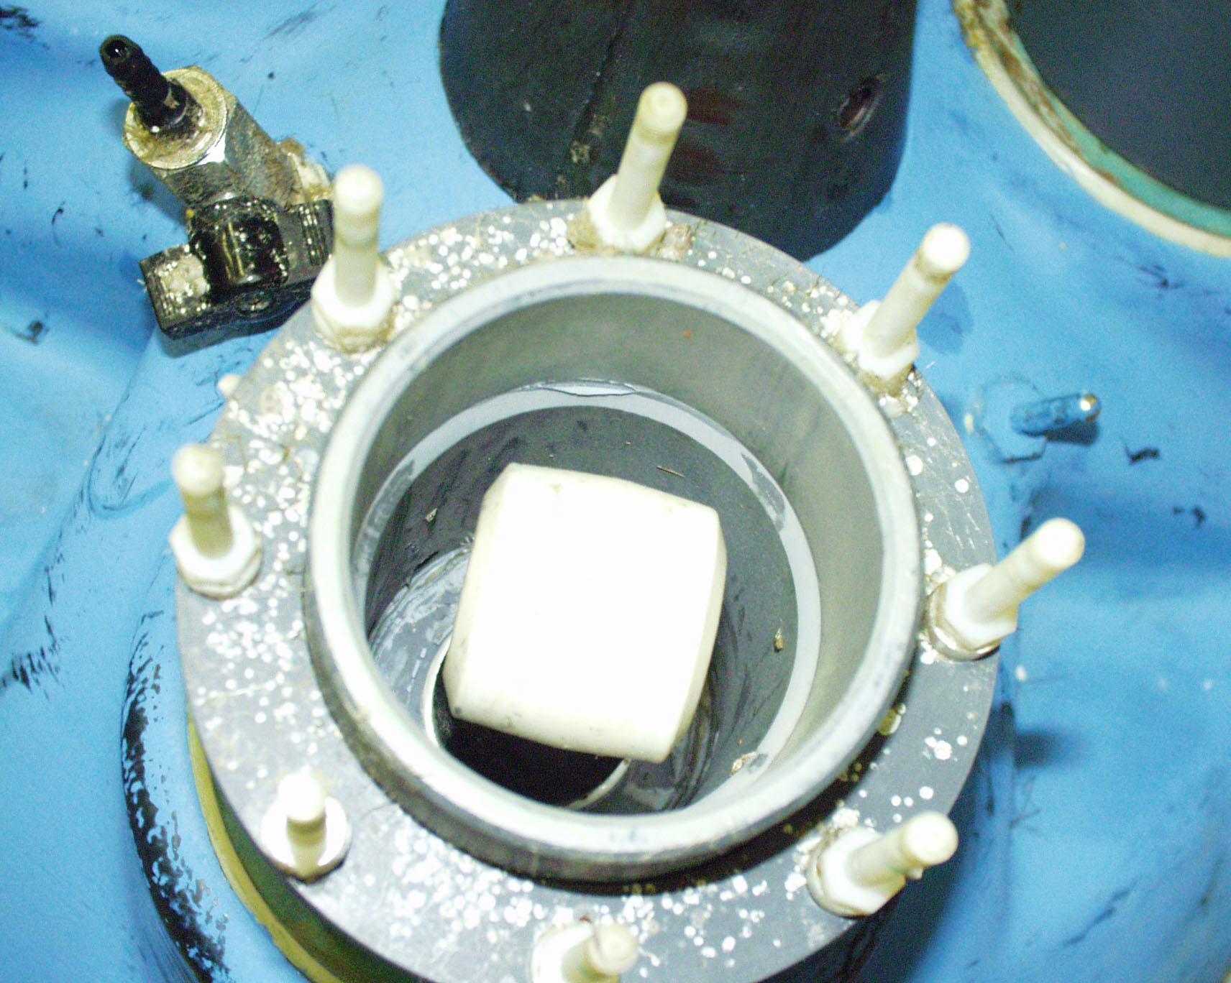
Figure FSI conductivity probe.

We use the FSI OEM C-T, an inductive conductivity sensor (Figure 3). A toroidal coil is used to induce a current in a volume of seawater around the coil. The strength of the induced current is proportional to the conductivity of seawater which can be related to the seawater’s salinity. The advantages of inductive technology are that the sensor can be made robust and that there are several industrial sources of probes. The disadvantages are that the accuracy of the technique depends upon the stability of the probe's dimensions and the cleanliness of the probe and the seawater into which the magnetic field extends (approximately 15 cm from the center of the toroid for the FSI device). The latter demands that an application such as SSAS recalibrate the sensor to take into account field distortions and confinement which is inherent to SSAS design that places the probe into a confined space. FSI claims stability of +/-.005 mmho/cm and +/-.05 C per month for its sensor.

AML conductivity sensor
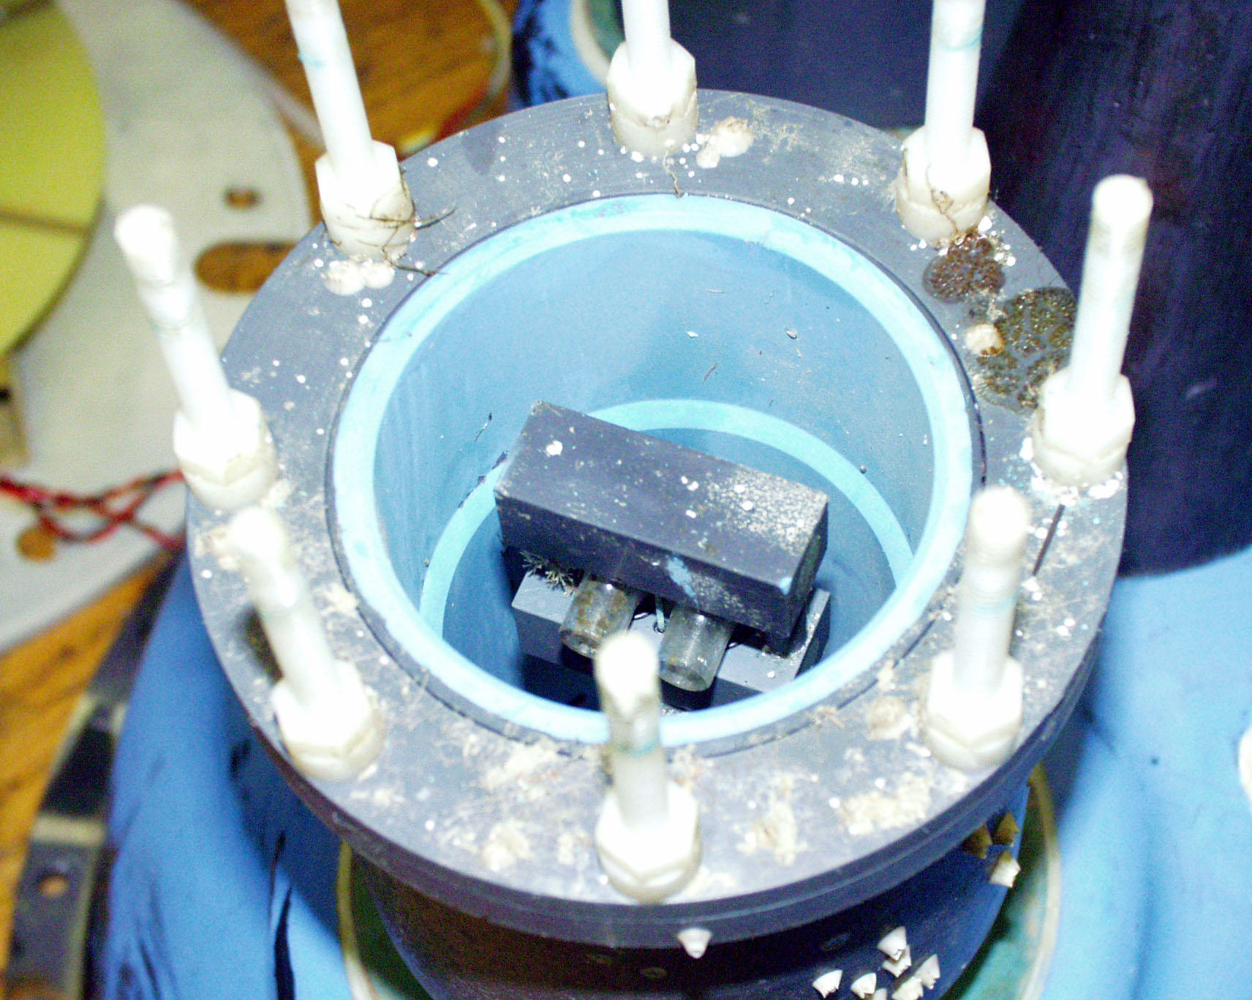
Figure 3 AML direct conductivity.

The AML Conductivity Smart Sensor utilizes platinized four-electrode glass cell to measure seawater conductivity as indicated by the flow of current between the electrodes (Figure 4). The advantages are that the seawater sample is very small and contained in a glass cell so that it can be installed into an SSAS pod without the necessity of recalibration. The glass cell can be protected from biofouling by allowing seawater to access the cell through short lengths of TBT-infused tubing. The disadvantages are the glass cell is fragile and the technology is employed in very limited disciplines so that there are no high volume commercial sources. Similar sensors are available from other manufacturers of C-T equipment.

AML sound velocity sensor
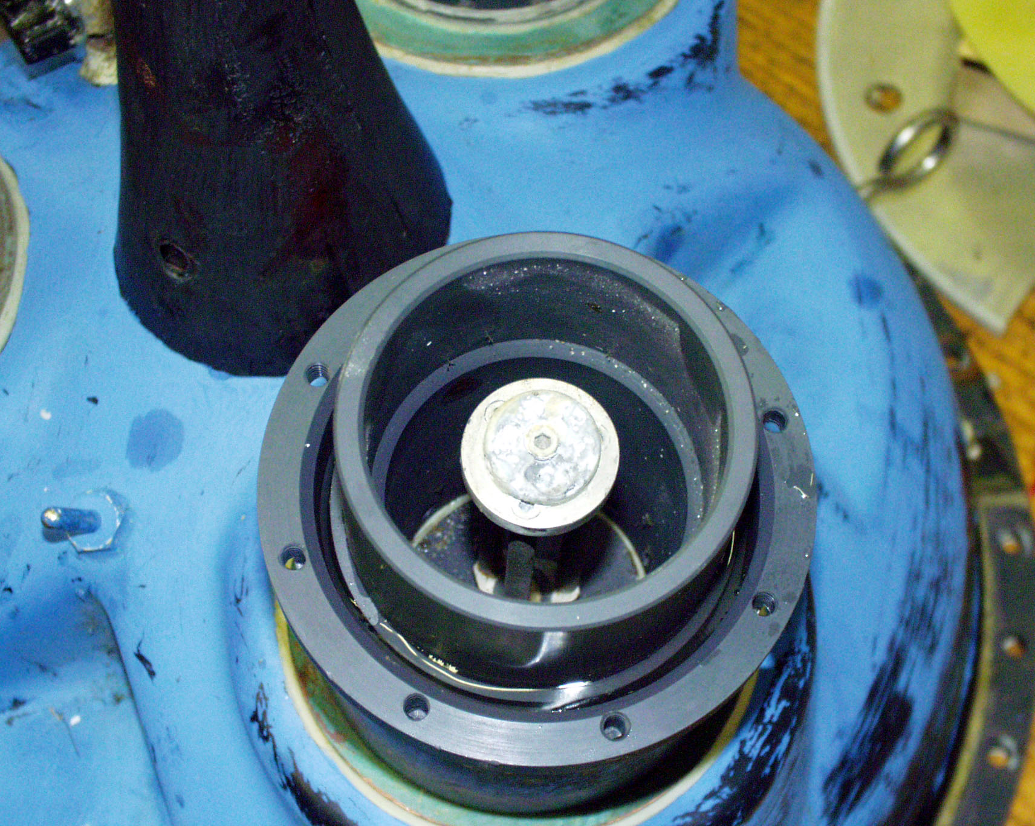
Figure AML sound velocity sensor.

The AML Sound Velocity sensor was chosen as an alternative to measuring salinity by its effect on the conductivity of seawater (Figure 5). The dependence of salinity on the density and hence sound velocity is such that a sensor of the type made by AML should be able to measure salinity to better than +/-.065 PSU. Sound velocity is measured by the time of travel of a pulse between and transducer and reflector plate. The main advantage of the sound velocity transducer is that it should be relatively unaffected by marine growth. Its main disadvantage is its costs and the potential for bias caused by motion of the sensor relative to seawater caused by passing waves. Because the SSAS sensor pod encloses the sound velocity probe and effectively carries a sample with it as SSAS responds to a passing wave, this relative velocity effect may be minimal.

SSAS Field Experiment at WHOI
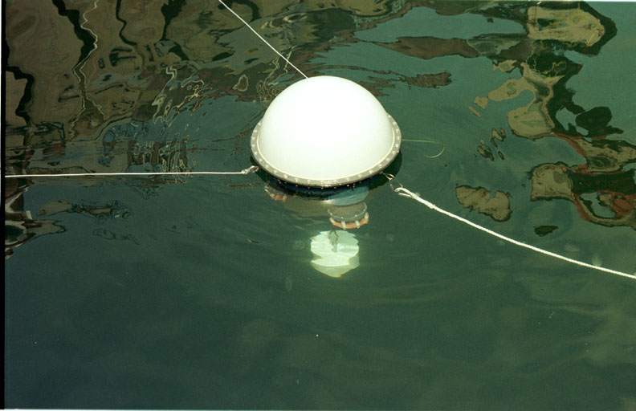
Figure 4 SSAS tethered to WHOI dock.

An SSAS with three sensors was tethered to the dock at the WHOI saltwater well from July 18 through August 20, 2001. The saltwater well receives flow directly from Woods Hole, which continually bathed the instrument in coastal seawater. The ambient water was heavy with suspended matter from nearby salt marshes; the environment proved to promote rapid biofouling. Conductivity and sound velocity data were transmitted over the Argos satellite data collection system to Clearwater where it was evaluated daily then emailed to the SSAS team members.
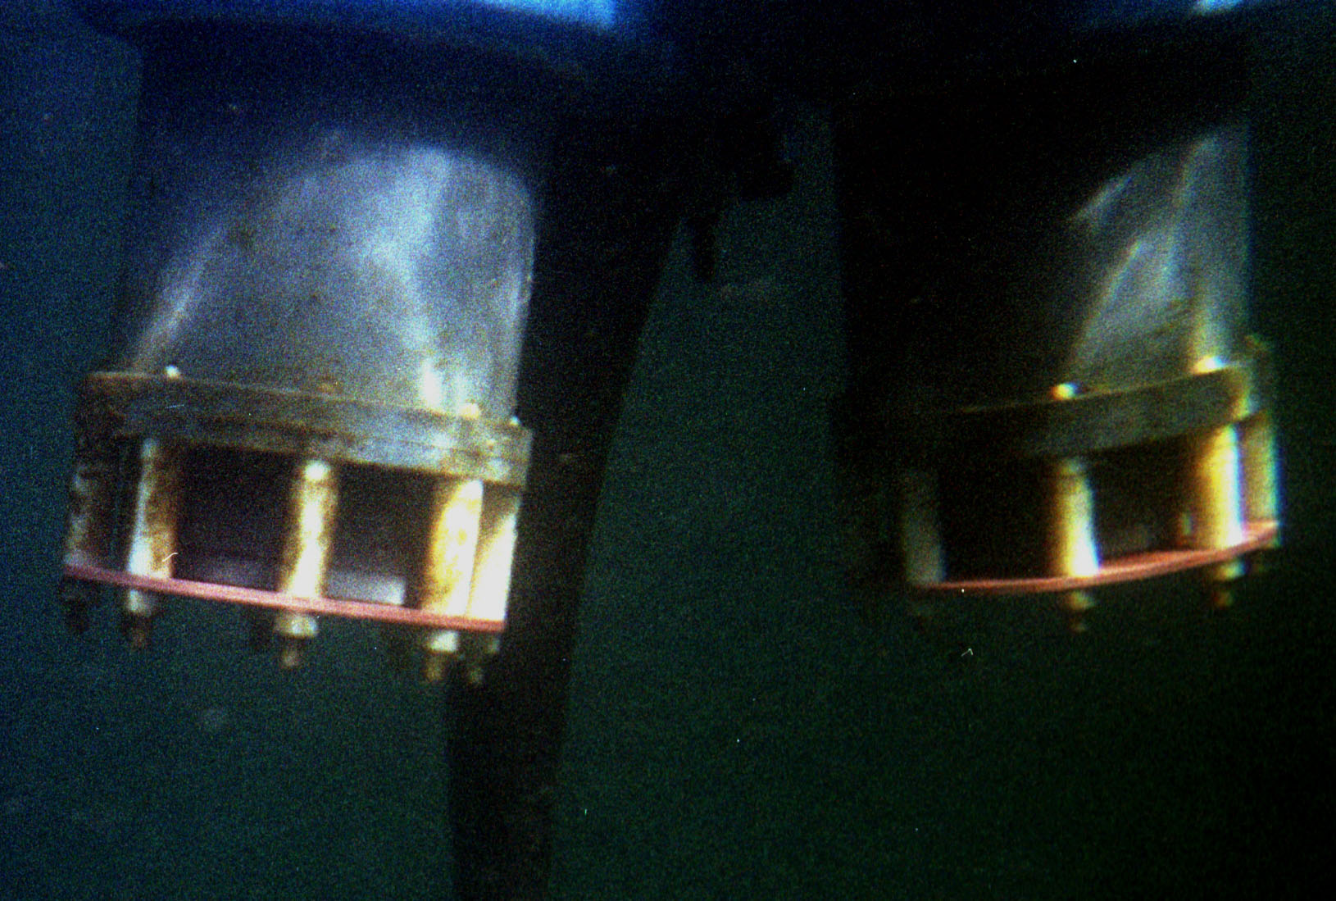
Figure 7 SSAS closed.

Figures 7 and 8 show pictures of sensor pods on an SSAS float moored in the Woods Hole seawater well. In Figure 7 the pod is closed and the inner fixed cylinder, visible behind the white plastic standoffs, is closed off from ambient seawater by a copper plate at the lower end of the outer sleeve. The outer sleeve is retracted with its upper end seated against the hull. In Figure 8 the outer sleeve has lowered approximately 4 cm and exposed the sensor pod volume to free exchange with the ambient seawater.

SSAS Results: Fouling
Figures 7 and 8 give an indication of the aggressive nature of bio-fouling in the WHOI saltwater well environment. The underwater hull parts of SSAS were painted with commercially available boat bottom paint while the sensor pods are untreated on their exterior surfaces. Since SSAS had been in the water only ten days when these pictures were taken, it is not surprising that the bottom paint is clean. However, there does appear to be the start of some growth on the unprotected parts of the sensor housing including the standoffs holding the copper cap plate. This plate shows no accumulation of growth. The extent of fouling at the end of the deployment can be judged by examining Figure 9.
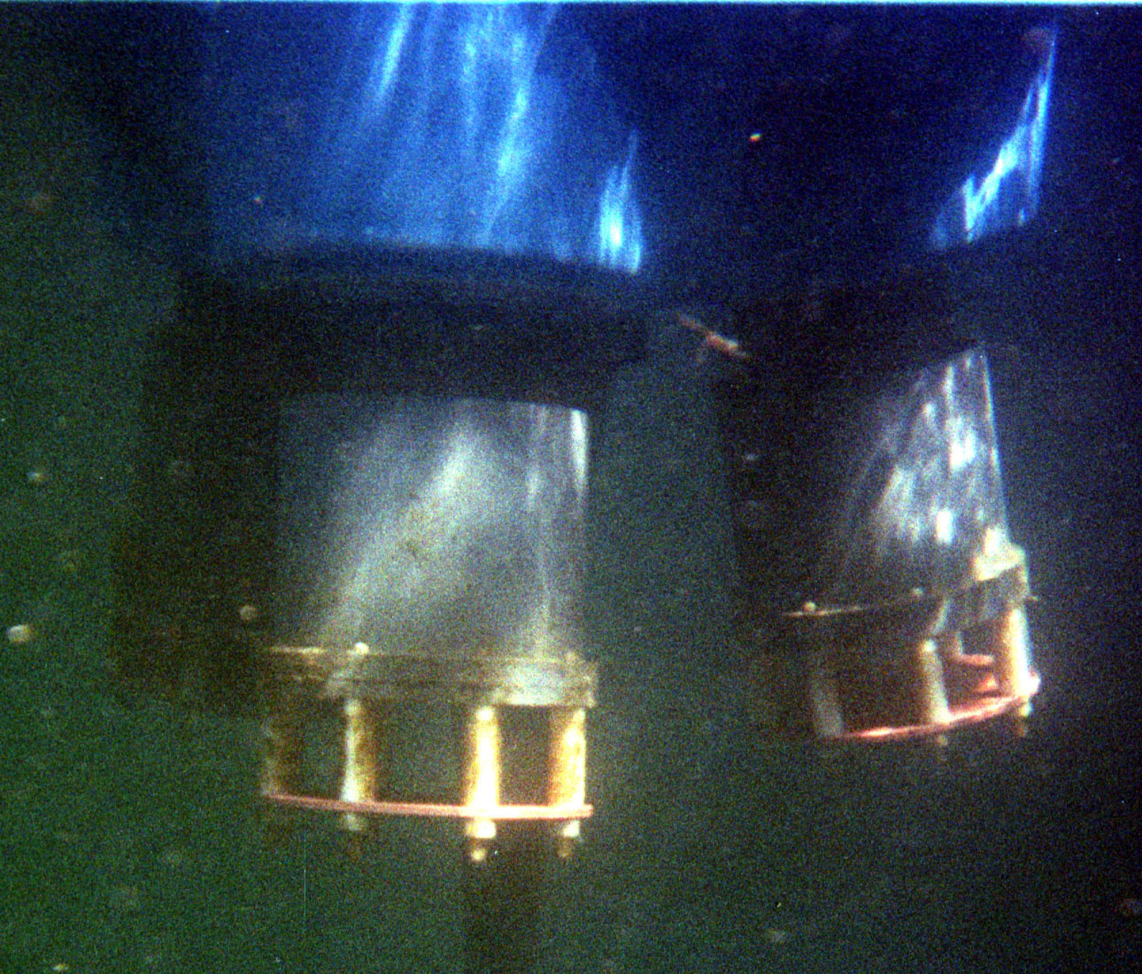
Figure 8 SSAS open.

SSAS Results: Salinity Sensor Performance
The different sensor packages on the SSAS were evaluated by comparison to six coincident water samples collected by WHOI (temperature and salinity) from July 25-27 during the buoy salt water well test and by comparison to each other. The raw data from all three sensor modules (FSI, AML Sound velocity and AML Conductivity) is displayed in Figure 11.
The figure’s four panels depict the measured temperature, conductivity and sound velocity as well as a calculated salinity. The FSI temperature has an offset of 0.89ºC when compared to the WHOI calibration values. The other two temperature series don’t show a noticeable offset and, in fact, are almost indistinguishable from each on the plotted scale. The AML conductivity sensor has obvious problems as can be seen in the second panel. It’s values were considerably different from the FSI conductivity, which are more in line with expected values, and show a major jump in the middle of the time series from an unknown cause. The scale in this figure doesn’t allow comparison of the small-scale fluctuations in both series but these were quite similar over short time scales, if the obvious major offsets were neglected. We will discuss this aspect of the data later. When salinity is calculated from the uncorrected raw values, the expected large difference between the AML conductivity sensor and the rest of the data is evident. The other sensor packages produce data close to the calibration values. Thus the sensor packages do require some additional individual calibration to produce accurate data. This may be due to variability in the manufacture of the sensor packages or perhaps the readings have been affected by the installation on the buoy and the proximity of the mounting and protective hardware.
In order to calculate salinity from the sound velocity a simple look-up table was computed so salinity could be assigned for a given temperature and sound velocity. Resolution of the table allowed determination of the salinity to .01 units. The calculation of salinity shown in Figure 11 is considered sub-optimal because of the calibration offsets in the raw data and the quality problems in the AML conductivity sensor. Some modifications to the data were necessarily to evaluate the sensor performance. First, the calibration offset for the FSI temperature sensor was applied, to align all the temperature time series. This was done by interpolating raw values to the times of the WHOI calibrations and calculating a mean offset, 0.89ºC, and subtracting this to align the data with the other curves. Once this was done a new FSI salinity time series was calculated. This resulted in a reduction of the offset from the interpolated salinity values by approximately half (salinity offset reduced from 1.10 to 0.48, the FSI sensor reading low). The calibration offsets discussed here are the mean of all the offsets from the six calibration values. The salinity calculated from the AML sound velocity sensor also showed an offset of 0.62, calculated in a similar manner, with the SV sensor values reading high.
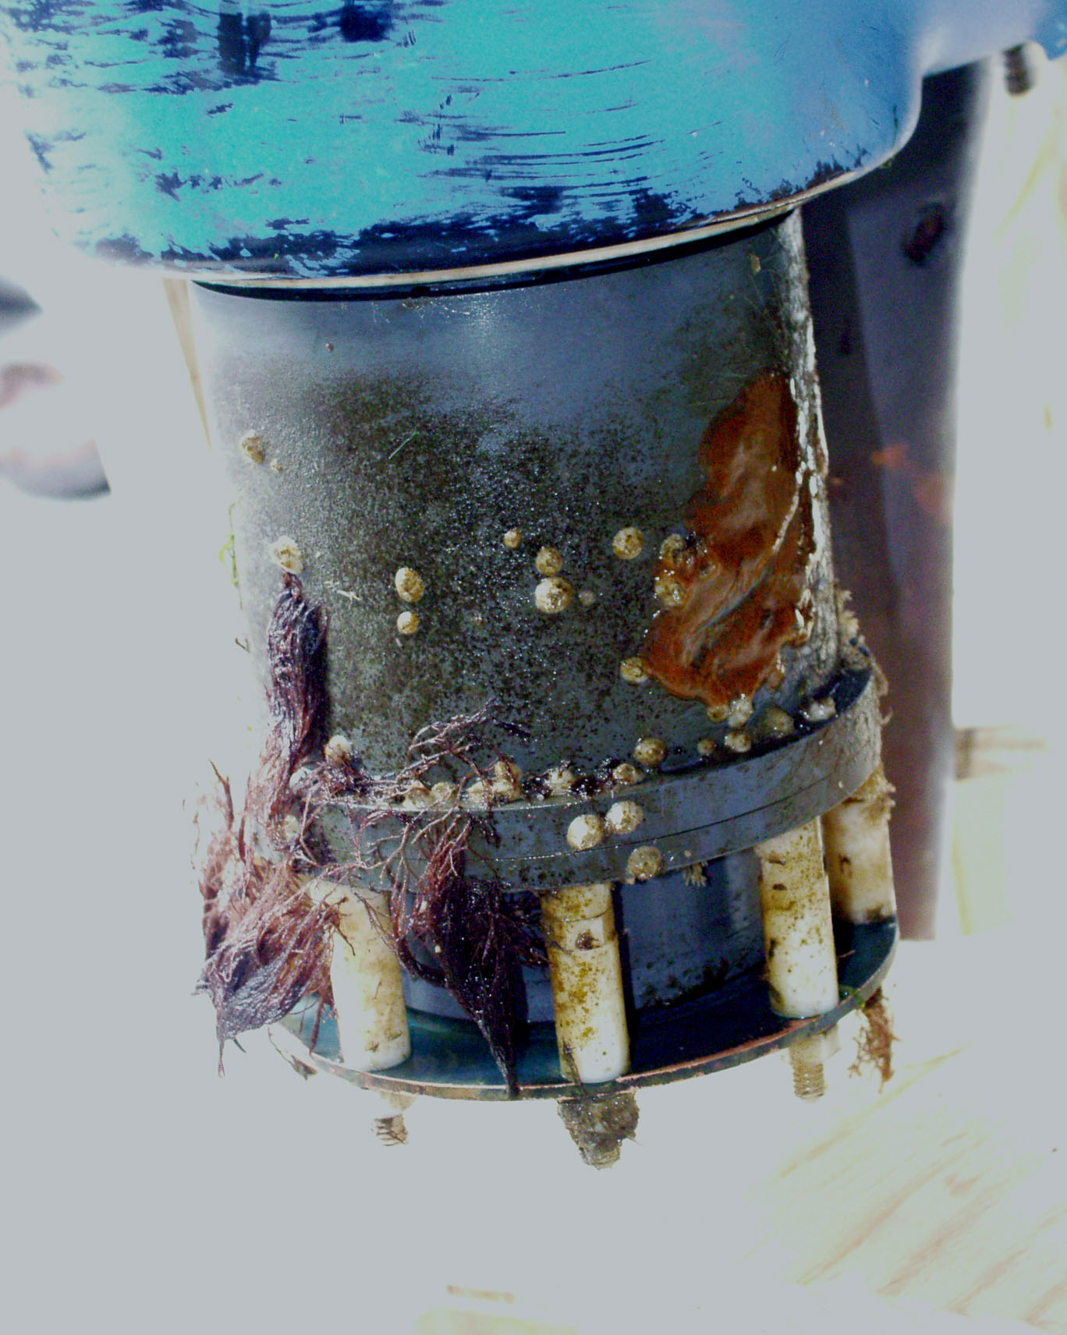
Figure 9 Fouled SSAS pod.

The AML conductivity sensor data presented its own unique set of problems. No efforts were made to directly compare this sensor’s data to the calibration values. Instead, other changes were made. First, the gross offset from the rest of the salinity data was estimated by aligning the data graphically. Different gross offsets we’re chosen for data on each side of the jump to align the time series. Then a linear decreasing trend was removed from the data to align its slope visually with the other two time series. Obvious spikes were removed from the data, replaced with interpolated values, and the obviously low salinity values from the predeployment period were removed. The resulting curves are shown in Figure 12.
Remarkably, the short-term variability in all three time series is similar, indicating that all three-sensor packages show some promise in this application. Although the level of manipulation required for the AML conductivity package indicates substantial effort would be required to bring this sensor up to the quality of the other two. A cross correlation between the various time series showed that the FSI and AML SV sensors agreed the best (max corr=0.75), the FSI - AML C was second best (0.69) and the AML SV – AML C comparison was the worst at 0.46.

Power budgets
One of the significant design issues for all oceanographic surface drifters is power consumption. The proposed innovation raises substantial issues in this area, with which we have made considerable progress. Power consumption in a standard drifter is largely due to the Argos transmitter. The SSAS power budget also includes requirements to operate sensor pods, sensors, ClearSat-3.0, and GPS engine. The prototype SSAS described in this report contains three sensor pods, which provides the ability to compare three sensors and antifouling treatments. In later development SSAS instrumentation could deploy as many as three pods or only a single sensor pod in large scale equipment tests. The SSAS power budget is presented in Table 2. SSAS prototype power supplies depend upon alkaline battery pack which can provide approximately 50 Ah. The SSAS prototype float hull can contain three such packs making available 150 Ah, which could be sufficient to run three sensors for 1 year, two sensors for 1.2, and one sensor for 1.5 years. An ideal solution would provide for the possibility of varied sampling rates, and additional sensors, e.g. optical. Fortunately, solar power provides us with that possibility.

Solar Power Augmentation
We believe that solar power represents the most promising way to augment power needs for SSAS. Solar radiation incident on the upper atmosphere is quite abundant, providing approximately 1000 watts per square meter. Of course, this is not all available as there are many factors such as atmospheric absorption, weather, angle of incidence, etc, that must be taken into account in determining the available power. Furthermore, the hours of sunlight are greatly reduced during the winter at locations far from the equator.
These considerations lead us to determine that a hybrid system consisting of a standard alkaline battery pack plus a solar power unit is best for our use: the standard alkaline battery pack runs the instrument during the darker months far from the equator, and the solar unit (solar cells and rechargeable battery) runs the device the remainder of the time. (This additionally helps with the problem of storage: most rechargeable batteries will loose their charge if stored for a few months, particularly at high temperatures: this situation can easily arise in oceanographic work, and in that case the alkaline battery pack could run the instrument while the solar unit recharges.) The processor monitors the available light and state of charge of the rechargeable battery, and can cancel sampling for a short period of time if necessary. The system then can have an indefinite lifetime, a great advantage, particularly when one considers the cost of procuring and deploying any drifter. This system would require batteries, solar modules (a solar module is a group of solar cells wired together), and special casing.

Rechargeable Batteries
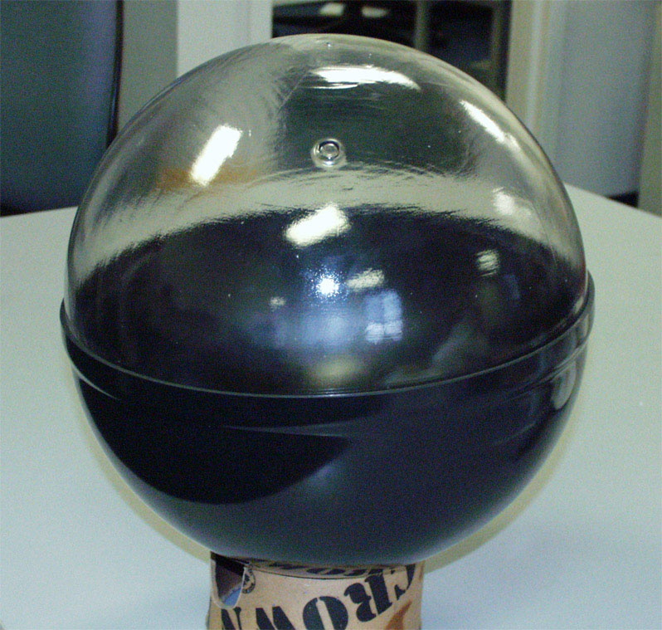
Figure 10 Clear plastic top for surface float.

We have been testing small, inexpensive rechargeable lead-acid batteries (about 1/5th the size of a standard battery pack) that have a capacity of 7.2 Amp hours. Lead-acid cells have the advantages of 1) low cost and 2) ease of maintenance. (That is, they can be charged and discharged at a wide variety of rates, and the state of their charge can be determined just by measuring the output voltage unlike other types of rechargeable batteries). Even this minimal battery capacity would be able to power the the current version of SSAS (consumption of about 157 amp-hours/year) drifter for over two weeks.
However, lead-acid batteries and other popular rechargeable batteries such as Nickel-Cadmium are not environmentally compatible with marine use. This undesirable attribute is leading us to consider other batteries, such as Nickel-Metal Hydride and Lithium-Ion.

Transparent hull top
Clearwater has had clear plastic tops fabricated to fit our standard drifters (Figure 10). These tops are made with a plastic that is rated for outdoor use and will stand up to ultraviolet light present in solar radiation. We have tested these and found that they reduce the amount of power available from solar modules by only 15%.

Solar modules
We have investigated a variety of solar modules for this application. The criteria are
- Non-interference with Argos transmitter RF
- Durability
- Output voltage compatible with our battery systems
- Easy installation
- Readily available
- Efficiency
- Cost
We have determined that Iowa Thin Film Technologies has modules well-suited for our application. The modules themselves are made of a flexible material and are easily handled, can be placed in any orientation, and mounted easily. They may, for example, be mounted against the inside of a clear plastic sphere, or overlaid on the ground plane of the Argos transmitter antenna. We have been able to test these with our antenna system and determined that they will not interfere. Unlike many solar modules, these modules are very durable and cannot easily be damaged by dropping or handling. Furthermore the cells are available in a variety of configurations, including a 12-volt version that would be ideal for this application. They are readily available and reasonably priced (a 3” by 10” module would be under $16 in production quantities.) We have found that the modules charge our 12 volts lead-acid portable batteries with no requirement for charging circuitry. . Their only disadvantage is that they are not quite as efficient as crystalline cells, however we have not found crystalline cells that are competitive in these other ways.
We can roughly calculate the power requirements as follows: our Phase I device consumes 157 amp-hours per year, or about 430 milliamp-hours per day. After taking into account environmental factors limiting the amount of available sunlight (Section 6.1), the average daily amount of insolation available in September or March for our location of about 42 degrees North is the equivalent of approximately 5 hours of direct sun (e.g. see
http://www.wattsun.com/resources/insolation_maps/flat_plate.html,
the web site for the National Renewable Energy Laboratory, U.S. Department of Energy). Our solar modules need to provide approximately 430 milliamp-hours from the 5 hours of available sunlight, which means a rate of 430ma/5hours or 86 milliamps would be sufficient.
While we have not finalized any design, four of the 3” by 10” modules mentioned above can easily be mounted atop the ground plane of the Argos antenna. Each of the four modules can produce 50 milliamps charging current, for a theoretical maximum of 200 ma in full sun, if the sun is directly overhead. This is reduced by about 15% by our clear plastic tops, giving us a theoretical maximum of 170 ma with the sun directly overhead, but reduced also by the sin of 48 degrees, (the height of the sun at solar noon at the equinox), giving us a theoretical maximum current of 126 milliamps, substantially more than the 86 milliamps we calculated as necessary.
We do not claim that these calculations are a design or a proof, but they do demonstrate that a modest system of four small solar modules should generally provide more than enough power to operate the entire drifter for at least six months of the year. They can also provide a substantial amount of power during the darker months. Our fieldwork during Phase II, coupled with data on weather patterns, will enable us to determine the capacity of the alkaline as well as the rechargeable batteries for the design.

Further Testing and Sea Trials.

Next Steps, 2002:
- Further test closing system (ongoing in our saltwater tank)
- Establish and implement thorough calibration procedures for salinity sensors
- Deploy several drifters to test sensors, antifoulants, and sensor pods
- Evaluate results and prepare equipment designs for second phase tests.
- Complete solar cell implementation

Extended Sea Trials 2003
- Make approximately 40 SSAS which will be available for installation on WOCE drifters
- Partnering with DBCP participants to test final SSAS technology designs, ideally in the Tropical Pacific and in the Amazon River plume, or other areas offering interesting applications for surface salinity measurements.
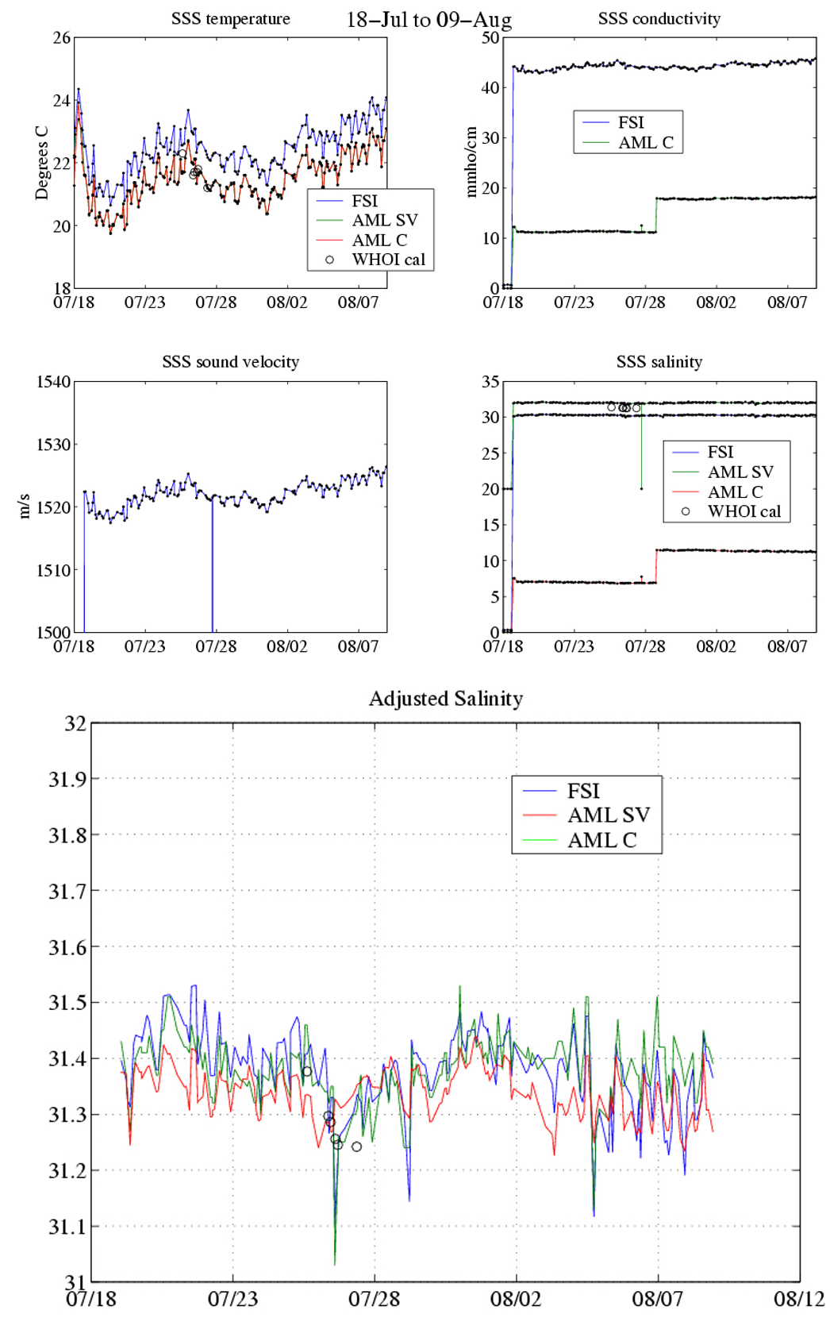
Figures 11 (top four) and 12 (bottom).

Acknowledgments
- Clearwater Instrumentation is grateful for the financial support of a NASA SBIR through Contract Number NAS5-01016, and the support of John Moisan and encouragement of Chet Koblinsky.
- We have been ably supported by our partners Earth and Space Research especially Gary Lagerloef and John Gunn.
- We have been assisted in the development of our approach through many discussions with Peter Niiler (SIO) and Ray Schmidt (WHOI.)

Earth and Space Research, 1910 Fairview Ave., Seattle, WA 98102-3620 esr.org
Woods Hole Oceanographic Institution, Woods Hole, MA 02543

