NEW DEVELOPMENTS FOR THE DATA BUOY SYSTEM IN INDIA

K.Premkumar Programme Director ,
National Data Buoy Programme,National Institute of Ocean Technology,
NIOT Campus,Chennai.

NATIONAL DATA BUOY PROGRAMME OF INDIA:

The Department of Ocean Development, Government of India has established a National Data Buoy Programme (NDBP) at National Institute of Ocean Technology (NIOT), Chennai. Under this programme, twelve moored data buoys have been deployed from August’97 to February ’98 at a sea depth of 20m to 4500m and spread over the Exclusive Economic Zone (EEZ) of India in Bay of Bengal and Arabian sea.

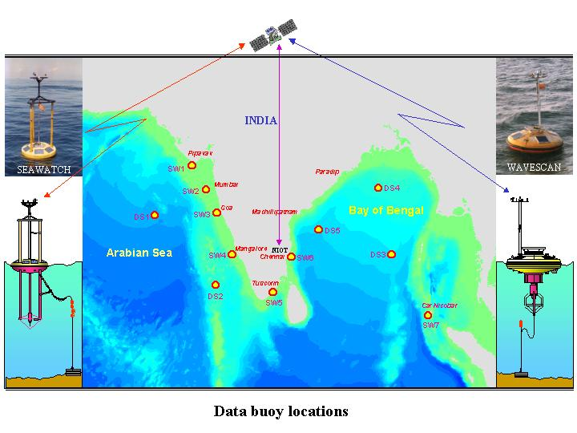
The data buoys are fitted with sensors to measure air pressure, air temperature, wind speed and direction, wave height and direction, current speed and direction, sea surface temperature and salinity. All these instruments, have the accuracy as per WMO standard. Besides, the data buoys are fitted with global positioning system, satellite transceiver, beacon light and radar reflector. Few of the data buoys are equipped with water quality sensors such as Dissolved Oxygen, Radioactivity, Turbidity, Hydrocarbon, Chlorophyll-A and Opti sensors. The data collected from the data buoys are transmitted through INMARSAT-C to the shore station having two way communication facilities.

DATA COMMUNICATION SYSTEM:

Utilisation of the data transmission through INMARSAT‘C’ increases the operational expenditures for the programme. It has been therefore considered to utilize the Indian satellite for data transmission from data buoys. The specification considered for transmission are detailed below :

Transmitter:

Data rate : 300 b/s (1/2 rate)

Data format and burst format : same as INSAT MSS Type C
Reporting system.

Modulation : BPSK

Transmit Freq : Carrier in the band 402.750 MHz ± 100Khz

Output power : 5W/10W.

Antenna and Polarization : Omni, RHCP

Satellite:

Transponder : DRT of INSAT 2B

Down link freq. : 4506.05 MHz ± 100KHz

Hub:

Receive frequency : 4505MHz (nominal)

G/T of Receive station (3m) : 17db/K

Output IF frequency band : 70MHz (nominal)

Demodulator : Burst demodulator, interfaced at 70 MHz If and same as being used Hub station of INSAT MSS-Type C.

Network Manager : As in MSS Type C system but with software modification to interface with existing operational processing system of NIOT.
BENCH TEST RESULTS:

The bench test has been carried out and has been found that 98% data recovery is feasible with every pocket of data transfer. When 3 consecutive data pocket transfer is made, 100% data recovery has been achieved.
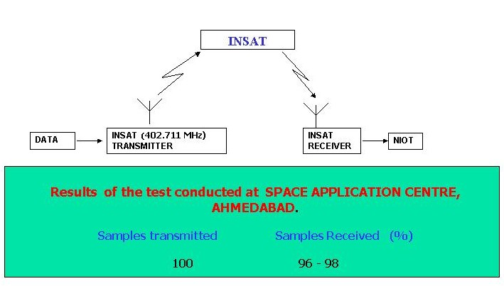

It is hoped that INSAT based data transmission would be incorporated in Indian data buoys in the year 2002. Currently, INSAT can support 1900 platforms and can cover the Indian ocean region.

OTHER BUOY SYSTEM :

In order to make the buoy system cost effective, actions have been initiated to develop local sources for buoy electronics, solar power system and mooring ropes for buoy system. The bench test/field trials for above components have been found satisfactory. The system will find place in the Indian buoy system in the year 2002. More technical information will be provided in the eighteenth session of DBCP.

