Evaluation of drifter
Longevity, drogue and SST sensor performance
in the last two decades

Mayra C. Pazos
Drifter Data Assembly Center
NOAA/AOML
Miami, Florida, USA
E-mail: Mayra.Pazos@noaa.gov
www.aoml.noaa.gov/phod/dac/dacdata.html

Abstract

Satellite tracked free drifting surface drifters have been deployed by the oceanographic community since the 1970’s for both research and operational purposes. The Global Drifter Program (GDP) database holds data from these drifters since 1979.
During the last 10 years, significant improvements have been made to the internationally coordinated surface drifter program. Drifter design, and drogue types have been standardized. Major changes and enhancements have been made to drogue design and instrumentation that have increased the average life of drifters and sensors.

Background Information

Since 1979 AOML has been involved in the deployment, data collection and quality control of satellite tracked drifting buoys. Different buoy designs, drogue and sensor types, and various transmission schemes were used to develop dependable, affordable and long lasting buoys that would provide high quality data. This evolved in what we know today as the SVP drifter. (Figure 1.)

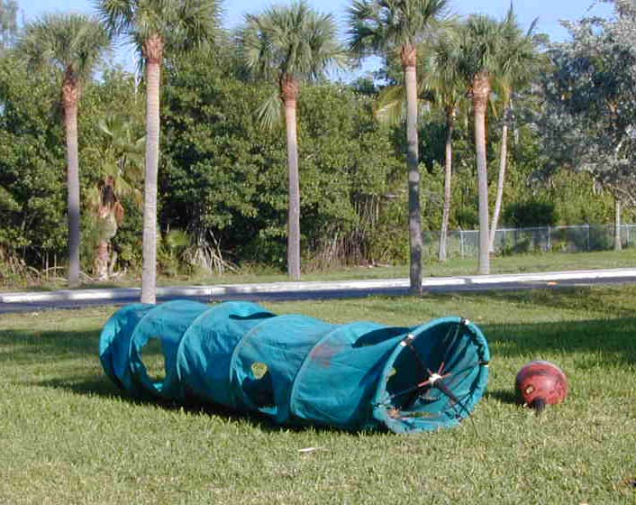
Figure 1. SVP Drifter

Deployments and Failures

A total of 739 buoys were deployed in the period fro 1979 – 1989. There are no accurate records of buoy failures at deployment during the first 10 years.
6582 drifters were deployed between 1990-2002 and a total of 271 (4.1%) failed on deployment. (Failed on deployment is defined as not transmitting, at all or transmitting data for less than 3 days).

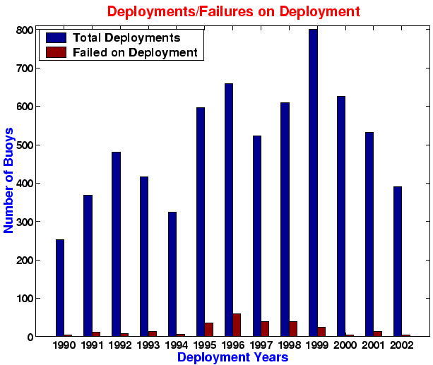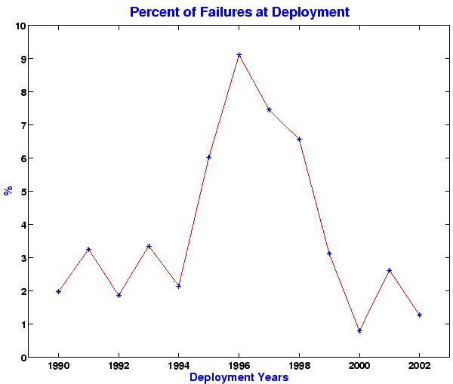

Figure 2. Deployments and Failures on Deployments

Procedure for defining mean life of drifters

- Buoys were separated into 2 groups by deployment year
Group 1: 1979 – 1989
Group 2: 1990 – 1999
- Only buoys that stopped transmitting or are still alive were considered, (grounded or recovered buoys were excluded.)
- Mean of transmitter, drogue and SST sensor lives were computed for each year.
- Total mean life, drogue and SST were computed for each decade.

Some Facts

- A total of 37 drifters lasted more than 6 years.
19 SVP – 18 SVPB (equipped with Barometric Pressure sensor)
6 drifters transmitted continuously, 31 were on one third duty cycle.
17 stopped, 20 alive as of 30-Sep-2002
- Longest transmitter and SST life was of 8 years and 2 months, an SVP, with continuous cycle.
- Longest drogue life was of 5 years, 6 months, and SVP, with 24 hours on, and 48 hours off duty cycle.

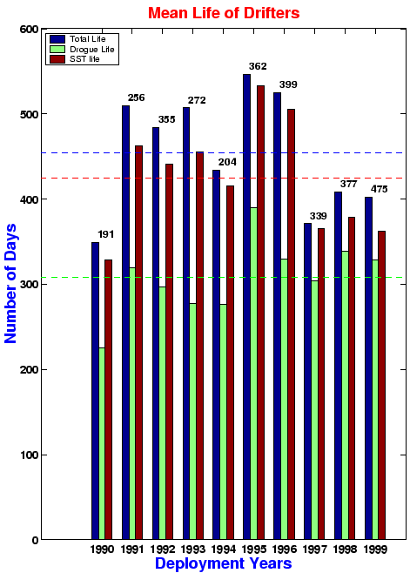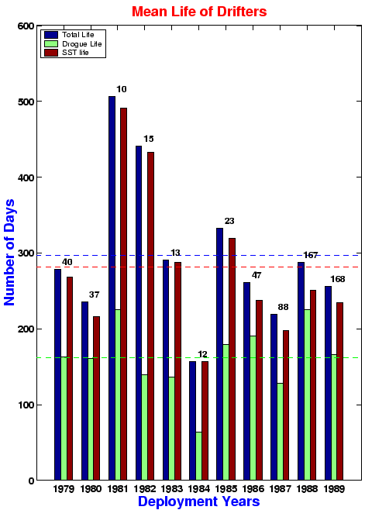

Figure 3. Comparison of buoy performance between two decades. The number on top of each set of bars indicate the number of buoys used for each year’s mean.

Conclusions

- Mean transmitter life of buoys in the last decade improved from 296 to 453 days.
- Mean SST and drogue sensor life increased:
  - SST increased from 281 to 424 days
  - Drogue increased from 161 to 308 days
- The number of deployments per year has increased, while the average of buoys failing on deployment has stayed at about 2%. (Except for years 1995-1998).
- In general:
Longer lasting buoys = More data => Better science

