REAL TIME DATA COMMUNICATION THROUGH INDIAN SATELLITES
FOR BUOYS OPERATING IN INDIAN OCEAN REGION AND THE
EXPANSION OF INDIAN MOORED BUOY NETWORK

K. PREMKUMAR – PROGRAMME DIRECTOR
NATIONAL DATA BUOY PROGRAMME
NATIONAL INSTITUTE OF OCEAN TECHNOLOGY, CHENNAI

Systematic time-series meteorological and oceanographic observations are necessary to improve oceanographic services and predictive capability of short and long-term climatic changes. Time series observations are also necessary to increase the understanding on ocean dynamics and its variations. The conventional methods being used for oceanographic measurements, at discrete time and space intervals through ships are found to be expensive and time consuming. Some of the important ocean parameters commonly required are waves, winds, currents, air temperature, pressure, etc. These are required for carrying out the basic research, developmental activities in the coastal / ocean areas and to study ocean process.
Keeping in view of the above requirements, Government of India, Department of Ocean Development has implemented the National Data Buoy Programme through National Institute of Ocean Technology (NIOT), Chennai. To begin with, 12 data buoys have been deployed in Indian seas. As the time series of Meteorological and Oceanographic data from these data buoys have evinced keen interest to Indian Meteorologists and Oceanographers, the network is poised for greater expansion in coming years.
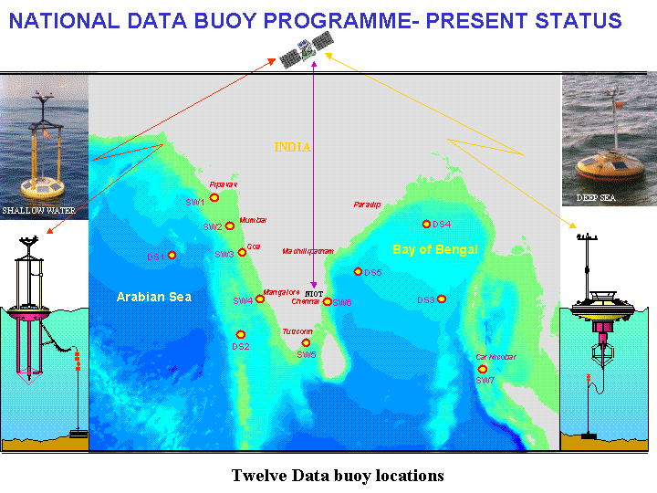
Fig. 1: Twelve Data Buoy Locations
Currently the data buoys are deployed in Indian seas under this programme utilizing the services of INMARSAT C Satellite for data communication. The data buoys transmit the acquired data in synoptic hours at 3 hour intervals to the shore station established at NIOT Chennai. As there are uncertainties prevailing on geostationary satellites availability for real time data communication and also high costing involved for data transmission, it has been necessitated to explore the possibility of utilizing the Indian satellite for data communication from ocean platforms.
Indian Space Research Organization (ISRO):
The Indian Space Research Organization (ISRO) under Department of Space (DOS) builds and operates the Indian National Satellite (INSAT) and Indian Remote Sensing (IRS) series of satellites providing self-reliant space based services for India in tele-communication, broadcasting and remote sensing. ISRO has developed Polar Satellite Launch Vehicle (PSLV) and developed Geo Synchronous Launch Vehicle (GSLV).
Space Application Centre (SAC):
The Space Application Centre (SAC) Ahmedabad, part of ISRO setup, conducts space applications research and development in satellite communication and remote sensing, design and build communication, remote sensing and meteorological satellite payloads and satellite communication earth station equipment.
INSAT System:
The Indian National Satellite System (INSAT) is a multi-purpose operational satellite system for domestic telecommunications, meteorological observations and data relay nationwide direct satellite television broadcasting and radio, television programme distribution. The system is a joint venture of Department of Space (DOS), Department of Telecommunications (DOT), India Meteorological Department (IMD), All India Radio (AIR) and Doordarshan.
The INSAT system, established in 1983 with the successful deployment of INSAT-1B and served at present by the last of the first generation INSAT-1D launched in 1991 and the two second generation satellites, INSAT-2A and INSAT-2B are providing important operational services to the nation. INSAT-2 series of satellites are more advanced and possess one and a half times the capacity of INSAT-1 satellites. INSAT-3A with DRT will be launched in end of 2002.

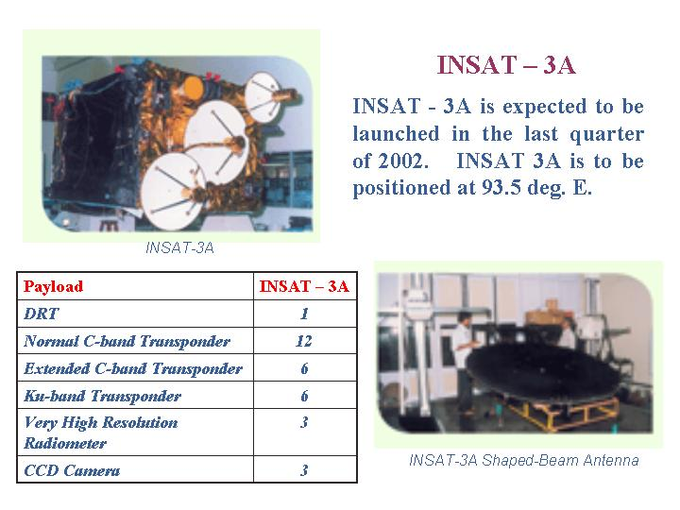
Fig. 2: INSAT-3A Specifications
METSAT:
Indian’s first exclusive meteorological satellite, METSAT, was successfully launched on September 18, 2002 by India’s Polar Satellites Launch Vehicle, PSLV-C4. It supports the India Meteorological Department by providing meteorological services from geostationary orbit, including Cyclone Warning Dissemination Services, Meteorological Data Collection and Weather Imagery on a continuous basis.


Mission | Weather
Launch Date | 12 September 2002
Launch Mass | 1055 kg (2325 lbm)
Launch Vehicle | PSLV
Mission Orbit | Geo Synchronous  Orbit, 74ºE
Design Life | 5 years, goal 7 years
Power (EOL) | 0.550 kW
Pay loads | VHRR, DRT

Fig. 3 METSAT and its specifications
The meteorological payload on METSAT comprises a 3-band VHRR instrument for providing imageries in visible, thermal IR and water vapour bands and a weather Data Relay Transponder (DRT). The satellite will collect data about wind speed, moisture content (and) temperature which can be analysed and be utilized to predict the weather, particularly cyclones more accurately.

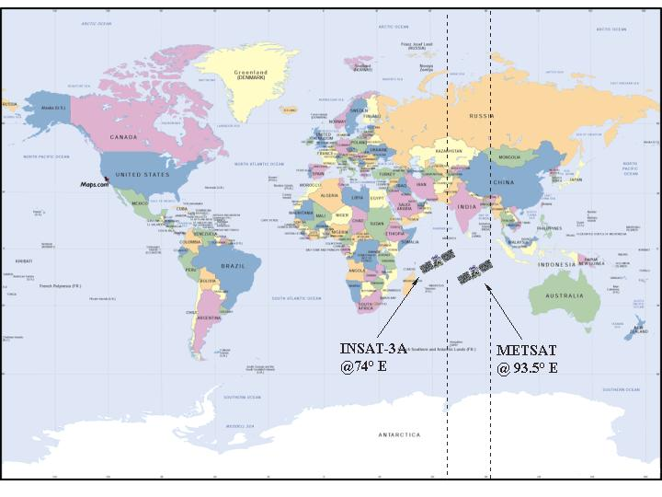
Fig.4: Coverage of INSAT & METSAT
Considering the availability of data communication facilities onboard METSAT and near future launching of INSAT 3A, NIOT in close cooperation with SAC, Ahmedabad, developed the INSAT transmitter for data communication from data buoys to shore station. The INSAT DRT uplink and down link specification with 5W transmitter power and 10W transmitter power are given below
Table 1. Uplink and Downlink specifications of INSAT DRT

 | 5W Tx Power | 10W Tx Power |  |  | 5W Tx Power | 10W Tx Power
Up link frequency | 402.75 Mhz | 402.75 Mhz |  | Down link freq | 4505 Mhz | 4505 Mhz
Max. Slant range | 41130 K | 41130 K |  | Down link path loss | 197.0 db | 197.0 db
Uplink path loss | 177 dB | 177 dB |  | Satellite EIRP | -4 DBW | -1 DBW
Tx Power (5W) | 7 DBw | 10 DBw |  | Link Margin | 2.5dB | 2.5 dB
Net antenna gain  (including cable loss) | -3dBi | -3 dBi |  | G/T of earth station (3m) | 17 dB/K | 17 dB/K
Tx EIR | 4 dBw | 7 dBw |  | Down link C/No | 44.6 dBHz | 47.6 dBHz
Satellite G/T | -19.0 dB/K  EIRP-path loss+ G/T+k | -19.0 dB/K |  | Total C / No | 36.5 dBHz | 39.5 dBHz
Uplink C/No. | 36.6 dBHz | 36.6 dBHz |  | Required C/No | 34dBHz | 34dBHz

Bench & Site Tests:
The test and data communication through the INSAT transmitter has been conducted at SAC and found that the system is satisfactory. Thereafter the site test with actual buoy system has been conducted at NIOT for data communication and found that data transfer through INSAT has been found perfect.

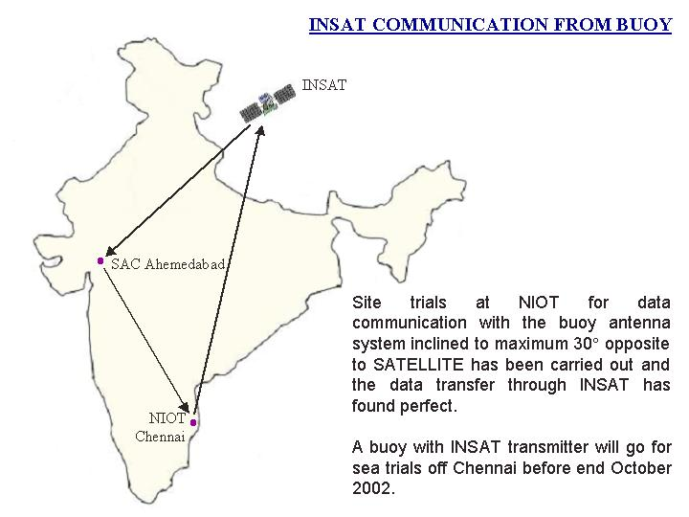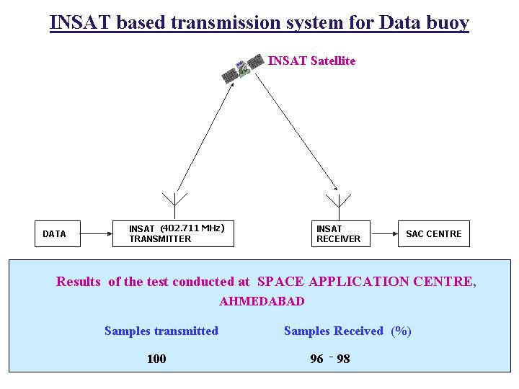
Fig. 5: INSAT based transmission system for Data Buoy
Future Plans:
With the success of the data communication through Indian Satellite NIOT in close contact with SAC are making efforts to make the data buoys with INSAT transmitter for data communication from data buoys to shore station. The buoys with INSAT transmitter will be deployed in Indian seas before March 2003. With this new type of data communication the estimated buoy network in Indian seas should go to 20 nos. by 2003 and is expected to be a boon to produce low cost buoys for Indian Ocean region as INSAT 3A and METSAT cover Indian ocean fully.

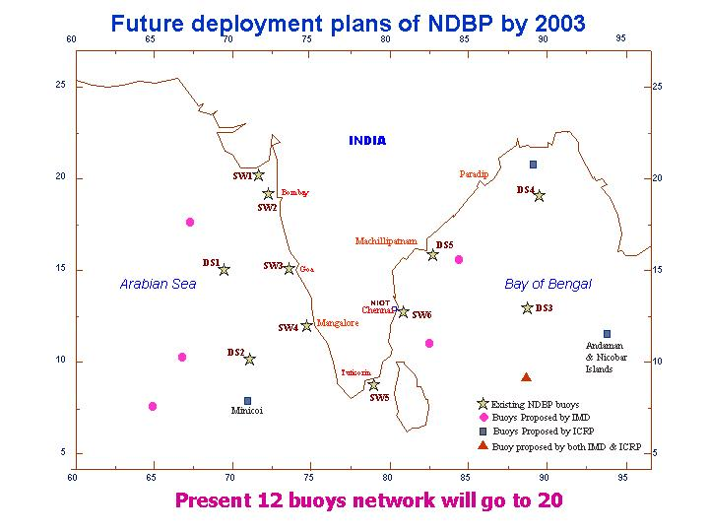

Fig. 6: Proposed location map of 20 data buoy network
Acknowledgement:
The author gratefully acknowledges the Space Application Centre (SAC) Ahmedabad, for providing the information of INSAT system.

