Drifter monitoring of Black Sea in 2001/2002

V.N. Eremeev*, E. Horton**, V.S. Motyzhev*, S.V. Motyzhev*, P.- M. Poulain***,
S.G. Poyarkov****, S.V. Stanichny*, A.G. Zatsepin****
*Marine Hydrophysical Institute NASU, 99011, Kapitanskaya, 2, Sevastopol, Ukraine
**Naval Oceanographic Office, 1002 Balch Boulevard, Stennis Space Center, MS39522-5001, USA
*** Department of Oceanography, Naval Postgraduate School, Monterey, CA 93943-5000, USA
**** P.P.Shirshov Institute of Oceanol., RAS, 117997, Nakhimovsky, 36, Moscow, Russia

Beginning with October 2001 the pilot drifter experiment “Black Sea-2001/2003” has been begun in Black Sea (BS). The participants of experiment were: Marine Hydrophysical Institute (MHI) NASU, Ukraine; Naval Oceanographic Office, USA; Department of Oceanography, Naval Postgraduate School, Monterey, USA; P.P.Shirshov Institute of Oceanology, Russia. The new organizations: Istituto Nazionale di Oceanografia e di Geofisica Sperimentale (OGS, Trieste), Italy and Institute of Marine Sciences / Middle East Technical University, Turkey have become the participants of experiment in 2002. The goal of experiment was the investigation of problems for creation of long-live drifter network in BS for the reasons of operational oceanography and hydrometeorology. The total quantity of 35 Lagrangian meteorological drifters was deployed from October 2001 to October 2002 (Fig.1).

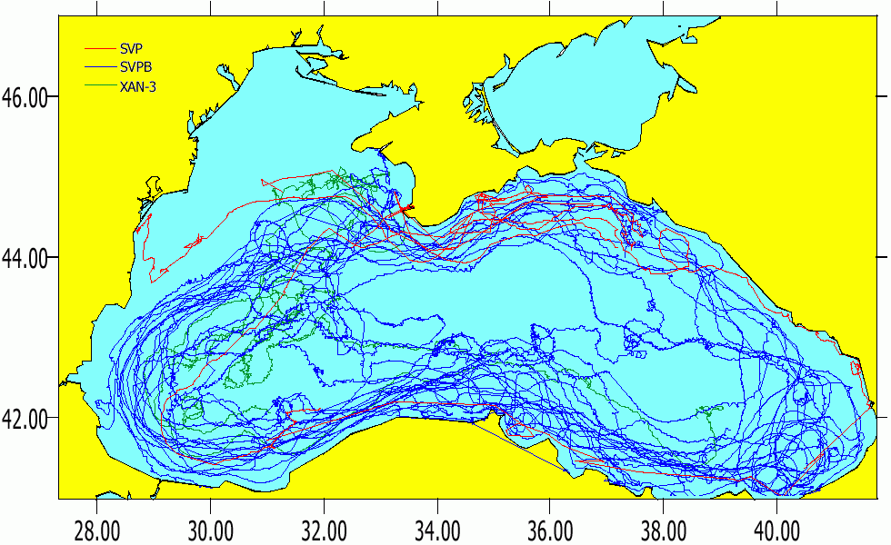
Figure 1. Total view of 35 drifter’s tracks in Black Sea from October 2001 to October 2002

All buoys got the WMO numbers before the deployments and data of them were being distributed via ARGOS and Global Telecommunication System (GTS) among the users over the world. The main areas for investigation were:
- Creation of network with space-temporary resolution according to the GOOS requests
- Acquisition, processing and distribution of data
- Data using for the operational oceanography
- Data using for the operational hydrometeorology
- Investigations according to the plans of DBCP (Data Buoy Cooperation Panel) of IOC and WMO Evaluation Group.
External meteorological users had the operational access to data via WMO's network. External oceanographic users had the access to data via MHI after the checking of control sum and removal of wrong data. The operational WEB site (http://doga.ogs.trieste.it/~drifter) with tracks of buoys was opened by Dr. Pierre Poulain (OGS, Italy).

Buoys were deployed by three blocks. The first block of 10 buoys was deployed in October 2001. It included 6 SVP-B (Marlin, Ukraine) and 4 SVP (SIO, USA). Mean lifetime for the period from October 1, 2001 to October 1, 2002 was for SVPB - 103 days and for SVP - 128 days. Deployment the second block of 18 buoys was done in December 2001. It contained 8 SVP-B (Marlin, Ukraine) and 10 XAN-3 (Metocean, Canada). Mean lifetime was for SVPB - 138 days, for XAN-3 – 85 days. Mean lifetime for XAN's termistor string was 47 days. Deployment the third block of 7 buoys was done in April 2002. It included 7 SVPB (Marlin, Ukraine). Mean lifetime for SVPB was 140 days. The information in a whole about the operation of buoys during experiment is below in Table 1.

Table 1. Statistics for buoy lifetime
Buoy | Quantity | Lifetime | Fast failure | Ashore | Vandal. | Stop trans. | In oper.
SVPB | 21 | 136 (279) | - | 8 | 4 | 4 | 5
SVP | 4 | 128 (262) | - | 1 | 1 | 2 | -
XAN-3 | 10 | 47 (85) | 4 | - | 1 | 5 (bat.empty) | -

Mean lifetime for SVPB buoys was 136 days. Maximum lifetime for this kind of buoy was 279 days. This value was calculated without the taking into account of lifetime remainder for 5 buoys which were continuing the operation after October 1, 2002. SVP demonstrated the 128-day mean lifetime and 262 days maximum in operation. XAN-3 had a short mean lifetime at 47 days and maximum – 85 days. 4 these buoys got a fast failure immediately after the deployment. 8 SVPB and 1 SVP went ashore and 4 SVPB, 1 SVP and 1 XAN were destroyed by fishermen and seamen. The criterion for vandalism determination was that the buoy was suddenly accelerated and then it was disappeared. 4 SVPB and 2 SVP stopped the data transfer according to the unknown reasons. 2 buoys were re-deployed by Ukrainian and Russian users after the ashore problem.

Mean lifetime for buoys in Black Sea isn't as short as for Mediterranean Sea. Main reason for increased lifetime is the quasi-circular cyclonic BS current when buoys continue the swimming in stream during long time. 5 drifters have provided the full circles around the Black Sea during 4-5 months. 3 drifters of these 5 buoys have provided more than 1.5 circles around the sea during 5-6 months. As a result of experiment, the possible ways for supporting of resolution ability for drifter network in Black Sea was found. They are presented in Table 2.

Table 2. Possible ways for supporting of resolution ability for drifter network in Black Sea
Parameter | Way | Result
Space resolution | Deployments along the Sevastopol-Bosporus lane | Fast distribution on the BS surface according to the opposite moving of buoys
Temporary resolution | Deployments by the blocks after 4-5 months | Exchanging of lost buoys according to the mean lifetime
Deployment | Ships of opportunity  Air deployment | Sevastopol-Bosporus lane  Fast restoration of network
Re-deployments when ashore problem | BS countries | Decreasing of cost for support of drifter network
Utilization of buoys after the operation | BS countries | Decreasing of the ecological load for BS

Ways for data acquisition, processing and distribution, used during experiment, are presented on Fig.2. All buoys have gotten the WMO numbers before the deployments. Thus, there were two roads for data distribution to users. External meteorological users had the operational access to data via WMO's network. External oceanographic users had the access to data via MHI after the checking of control sum and removal of wrong data
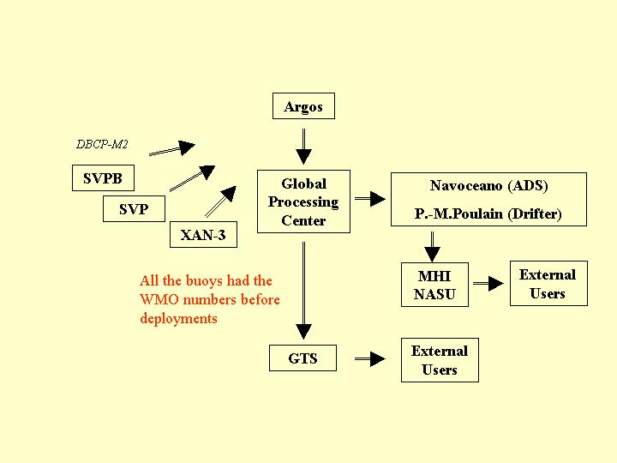

Figure 2. Ways for data acquisition, processing and distribution during the experiment

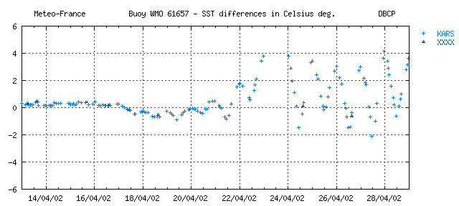
Quality control for air pressure (AP) and sea surface temperature (SST) was organized by usual way via Meteo-France QC system. All the SVPBs in operation hadn’t any problems with AP. The situation for SST was more complex. From time to time the model’s data for SST were too wrong scattered, as it presented on Fig.3, while the real SST data were calm. Thus, there is an area for updating of model for SST.

Figure 3. From time to time the model’s data for SST were too wrong scattered,

Drifter data is used also to study the characteristics of macro –and mesoscale Black Sea water dynamics. Although the data analysis is not finished yet, the preliminary results of this study are the follows:
- Drifter trajectories demonstrate us that the largescale currents in the BS are basically (but not always) contour - like.
- Potential vorticity gradient induced by steep topography is not a barrier for shelf-deep basin interactions and water exchange and pollution transport. The mesoscale eddy dynamics reveal to be a major factor of the shelf-deep basin interactions in the Black Sea
- Analysis of drifter trajectories together with structure and variability of the wind field above the Black Sea have shown that drifter pathway depends on the wind stress curl distribution at the sea surface integrated over the timescale about two-weeks -one month previous to observations
Some studies were done according to the plans of DBCP Evaluation Group. The reasons for this job were the further increasing of buoy's reliability and decreasing of its cost. The results are in the Table 3.

Table 3. Investigations according to the plans of DBCP Evaluation Group
Area | Way | Result
Operation of buoys with 20-bit and 28-bit IDs, equipped by the DBCP-M2 data format | Data reception and computation by Argos Processing Centers and MHI | There weren’t any problems as for the Argos, as for the MHI for data computation and distribution. Thus, DBCP-M2 data format is acceptable for practice
Plastic and metallic (nickel and brass) membranes for barometric port | AP data analysis via QC system, when buoys were in operation and ashore | Plastic membrane is working without any problem, when there is a dynamic self-cleaning by the pressed air during the submergence cycles  When buoy came ashore plastic membrane is being closed during 3-5 months. This phenomenon might be used for the automatic turning off the buoy after ashore problem.  Metallic membrane hadn’t any problem as in operation, as when ashore problem. This membrane might be used for utilization in the tropical areas, where there are the large biology activity and calm water during the long time
New “compact packing” system for connection of the tether line to the Holey Sock | Investigation of buoy extracted from water after the 5 months in operation | New system hasn’t the problems peculiar to the old system and it should provide minimum 2-years lifetime of buoy with attached drogue.
The data transfer when there are the 3 conditions:  - 90-s repetition period  - Randomization inside +/- 9 s  - Taking into account the Subm. sensor for data transfer, when buoy is at the surface exclusively | Comparison of contacts and locations numbers per pass for two buoys with and without taking into account the submergence data when messages transfer | 1. Mean number of contacts per pass was become more when level of submergence was increased.  2. There was the essential increasing of passes with locations regarding the total number of passes

The prolongation of pilot experiment will be in 2003, when 14-20 drifters of international SVPB standard should be deployed according to the project “Black Sea-2002/2003”. The following areas for investigation will be:
- Operational oceanography and hydrometeorology (SVPBs + + profiling buoys).
- Reliability of new “compact packing” connection of tether with drogue.
- Prolongation of testing of the submergence data application for control of messages transfer.
- Number of contacts and locations for new carry frequency 401.640 MHz (S6 channel) in comparison with central Argos-1 frequency - 401.650 MHz (S11 channel).

