The Performance of Minimet Wind Drifters in Hurricane Fabian

Peter Niiler and Bill Scuba
Scripps Institution of Oceanography
La Jolla, California, U.S.A.

1. Introduction

Since 1996 wind drifters have been deployed in tropical ocean areas where hurricanes tend to develop in strength or approach landfall. Projection of winds from NCEP reanalysis wind data on these drifters has revealed that the 133 wind drifters whose data appeared on the Global Telecommunication System (GTS) in 1999, 2001 and 2002, no wind drifter south of 30N in the Atlantic experienced winds in excess of 27m/sec (Niiler, 2003). Typically, drifters were deployed in the general hurricane development area at the start of the hurricane season and simply hurricanes missed these drifters. To deploy wind-drifters that would obtain hurricane data, operational air-deployment packages were developed and tested for Minimet wind-drifter deployments in front of targeted storms by operational “Hurricane Hunter “C-130-J aircraft. On September 3, 2003, 11 Minimet drifters (Milliff et al., 2003) were successfully deployed at a distance about 18 hours in front of the projected path of a category-4 hurricane, Fabian, in the vicinity of 25N, 65W.

This work describes the air deployment scheme used to drop 8 containers, containing 16 Minimets in the path of hurricane Fabian, in the tropical Atlantic Ocean, and examines the preliminary data received from these drifters. In total 8 Minimet drifters recorded, ambient noise (wind speed) and wind direction, SST, atmospheric pressure, and drifter positions throughout the passage of Fabian over the drifter array. Based on this unique, but limited data set, recommendations are made for continued research and operational deployments of drifters which sense into hurricanes from operational C-130-J, or other aircraft.

3. Drifter and Air Deployment Package

The drifters used in the experiment were ‘Digital Minimet’ drifters manufactured by Pacific Gyre, Inc. (Figure 1) that included a barometer, thermistor, submergence sensor, wind speed sensor - hydrophone/ambient noise sensor, and wind direction sensor - compass and wind vane.

The air deployment package consisted of a 100 cm x 100 cm x 100 cm cardboard container, in which 2 Minimets were stacked one on top of the other. Each Minimet was individually packaged in a cardboard container (Figure 2). A smaller cardboard box inside the drifter box contained the drogue. This smaller box had a hole cut in its top to allow room for a protrusion of the tether that attached the drogue to the surface float. An outer cardboard sleeve, or wrap, with 5 sides was used to cover the two Minimet boxes and served to hold them in place on a wooden pallet. A slit was cut down one corner of this outer box to allow for its rapid disintegration once the entire package was in the water. All of the cardboard boxes were held together with water-soluble paper tape, which dissolved in sea-water. The deployment package of three layers of cardboard was designed so the cardboard wrap came apart first, allowing the two inner boxes that each contained a float and the drogue to separate from each other before these dissolved. To keep the drogues from entangling, the boxes that contained the drogues were the last to dissolve.

The cardboard containers were placed on top of a specially designed wooden pallet (Figure 3). Blocks of wood around the corners of the top of the pallet kept the box secure during the air deployment, as during deployment into the air-stream there can be a large sideways force on the box. These wooden blocks and the straps running up all four sides of the box were designed to keep the box from coming off the pallet during its decent to the ocean.

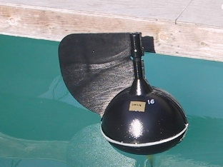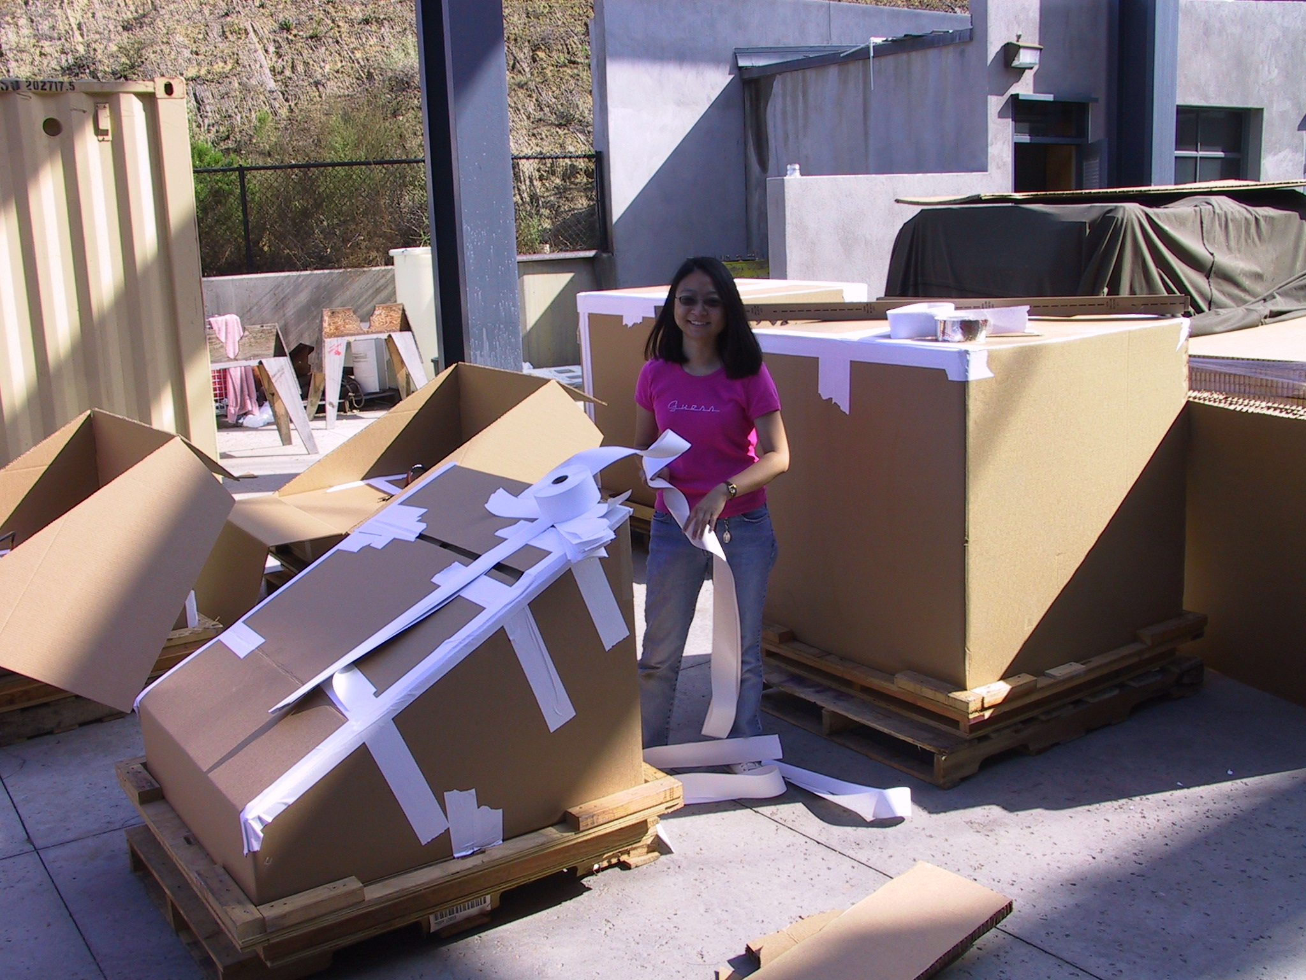

Figure 1: Minimet drifter float in SIO test tank, displaying the wind vane and barometer port.

Figure 2: Left side of picture - angled box containing 1 Minimet drifter. Right side of picture – 2 angled boxes one on top of each other covered by a cardboard sleeve.

One end of each strap was attached to a C-9 military personnel parachute on top of the box and the other end was secured to the pallet using salt blocks. On the salt block end of the straps were loops that passed through slots on all 4 sides of the pallet. A 7.5 cm x 1.75 cm x 1.75 cm salt block, cut with a banc saw from ‘horse-lick’ salt, was inserted through each loop and was then wrapped with water-soluble tape to secure it during deployment (Figure 4). The salt blocks prevent the straps from pulling back through the slots during the parachute decent to the ocean. Upon contact with the sea-water, the salt blocks dissolve, releasing the parachute from the pallet.

This deployment scheme of multiple cardboard containers, attached to a parachute rigging via a pallet, was tested in 15ºC, 1m high seas off the coast of San Diego with deployment from a small vessel. After the container with the parachute open was placed into the sea, the salt blocks dissolved in about 20 minutes. The individual drifters deployed successfully in about 40 minutes. More rapid disintegration is expected in higher waves.

The deployment scheme from C-130-J aircraft was tested with 8 separate drops over land during training missions for the crews of the US Air Force Reserve 53rd Weather Reconnaissance Squadron, “Hurricane Hunters”, stationed at Keesler Air Force Base, Mississippi. During these tests, two “dummy” drifters were placed into the containers that simulated the weight distributions of the Minimets. During these test flights, 6 of the 8 containers deployed correctly. One parachute ‘inverted’ during deployment, but the container landed safely. One cardboard container disintegrated during deployment because a weight that was used to simulate a drifter float came loose within the container and broke through the container walls, but the pallet with the parachute attached landed safely.

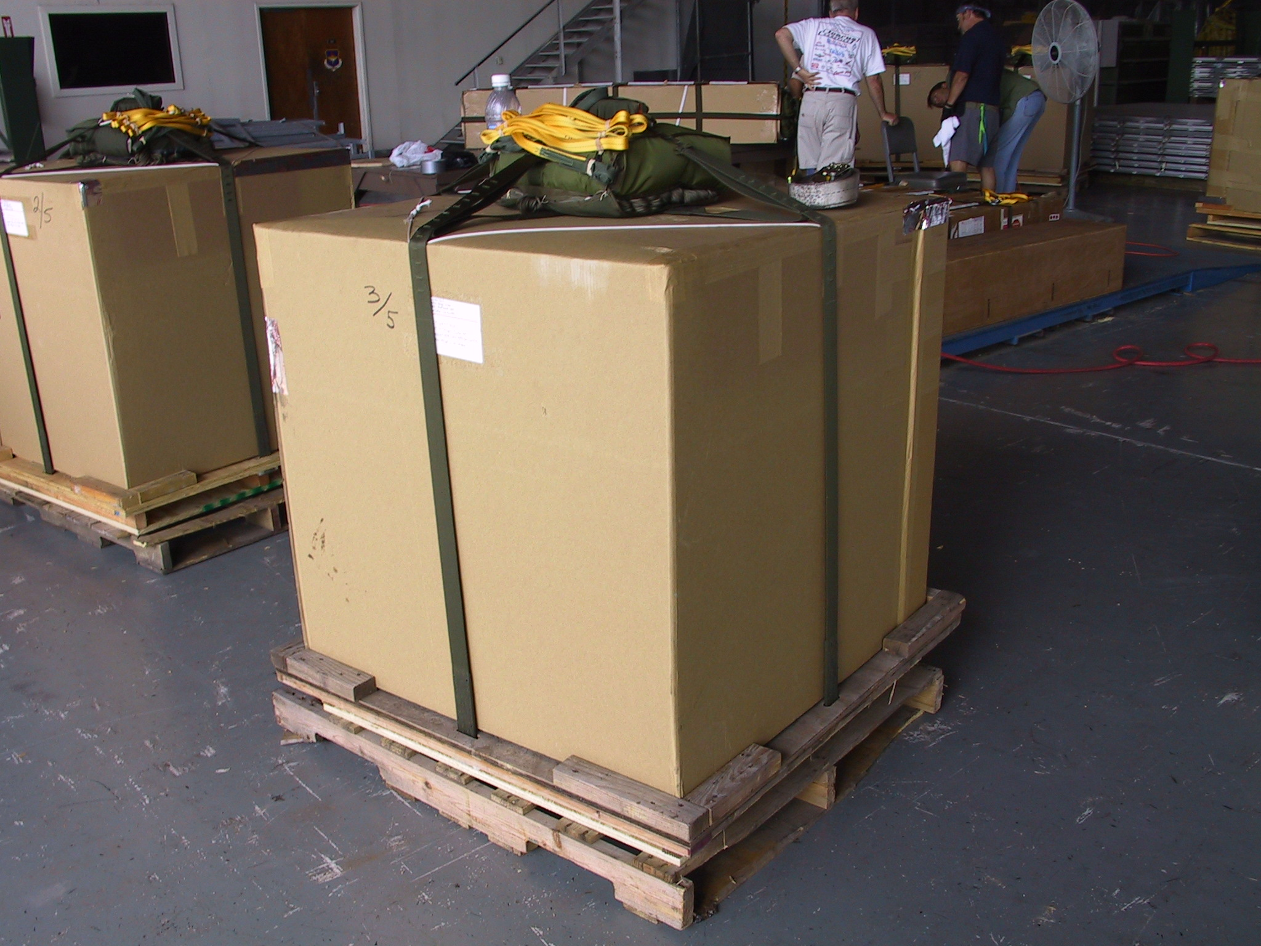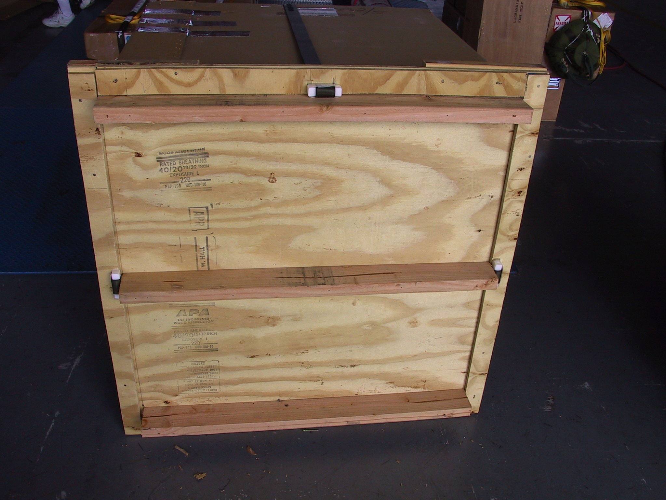

Figure 3: Box containing 2 Minimet drifters on top of pallet. Wooden deployment pallet is sitting on top of a shipping pallet that is removed before deployment.
Figure 4: Under side of deployment pallet with bottom plywood removed.

4. Hurricane Deployments

In early September, 2003 a Category 4 Hurricane, “Fabian”, was moving rapidly to the west-north west in the Atlantic north and east of Cuba. Eight fully rigged containers with 2 Minmets in each container were loaded aboard a C-130-J at Keesler Air Force Base and the deployment flight commenced on the afternoon of September 3rd. The 8 containers were deployed in a two-line array approximately 18 hours in front of the projected path of Fabian at an altitude between 300 m and 400 m and between 20:00 and 24:00 local time (Figure 5). The ground wind speed at the time of deployment was between 17 ms⁻¹ and 22 ms⁻¹ and the wave height was approximately 7 m.

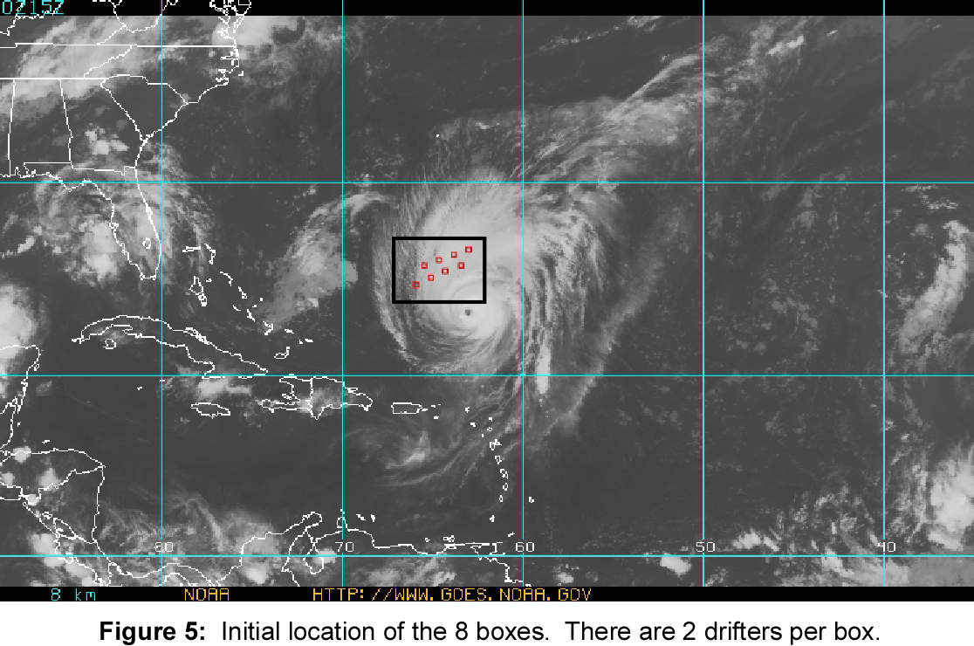

Five Minmets did not transmit any data after the air deployments. Three more stopped transmitting data before the complete passage of the hurricane (~36 hours). The remaining eight drifters provided data through Fabian passage (Figure 6). Two drifters came within 30 km of the hurricane center.

Less than 2 weeks later the 8 drifters that sampled Fabian were in the path of hurricane Isabel (Figure 7), for which data was also collected.

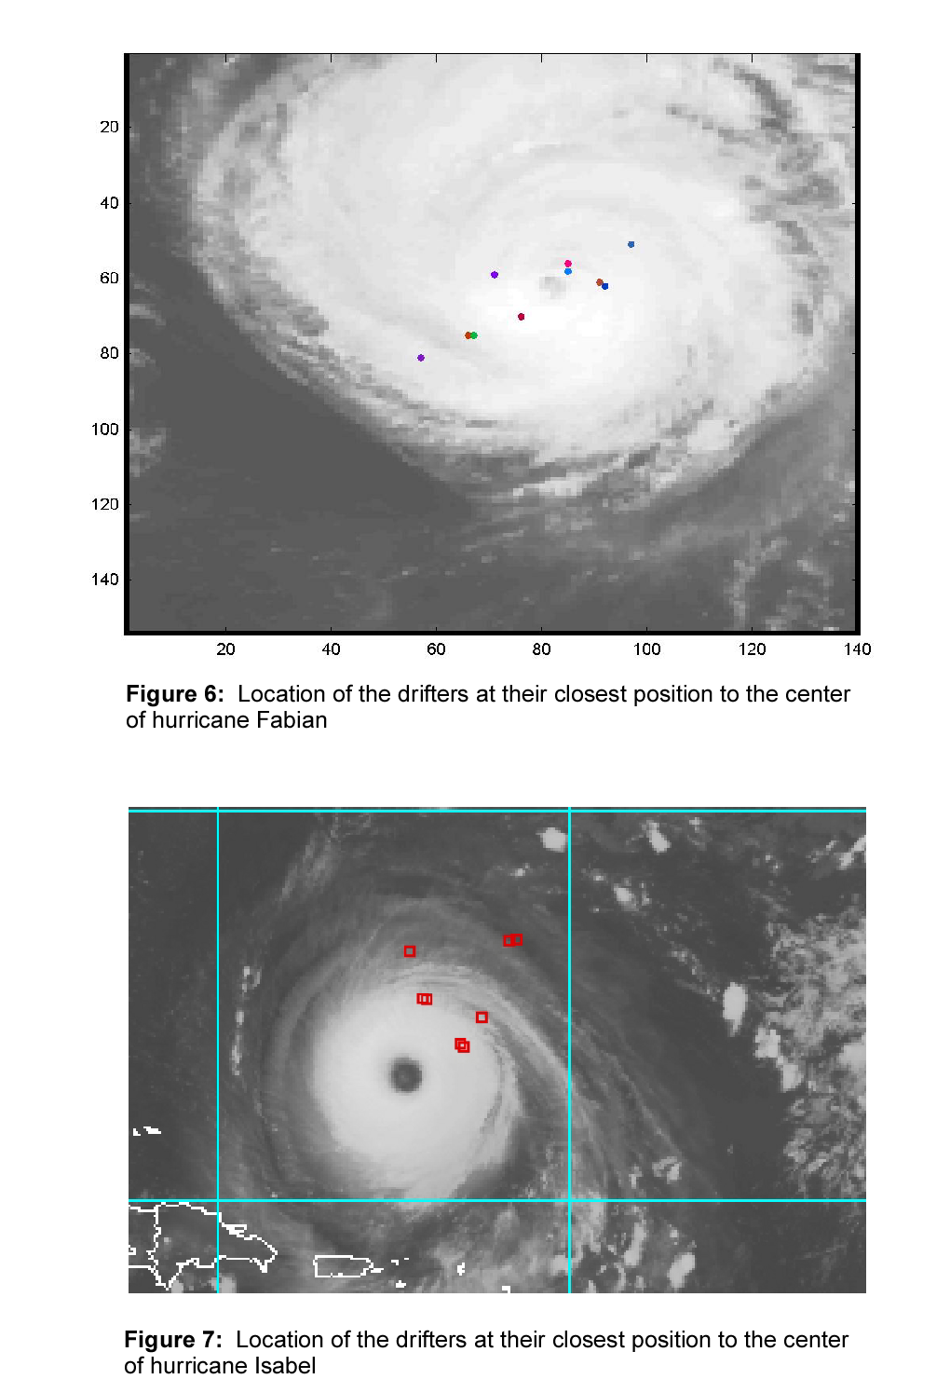

There are perhaps several explanations for the failure Minimets. One explanation is that in the high winds (20 m/sec.) and waves (7m) significant horizontal forces on the deployment container and the drifters can result as the container hits the water. During high winds the deployment container is moving horizontally at a large speed, as are waves that are breaking. The deceleration caused by the drifter package contacting the water can cause the two drifters to be forced into each other or into the wooden pallet with sufficient force to damage the electronics or their floats. A second explanation is that 4 containers were damaged during shipment to Keesler Air Force Base by being stacked on top of each other. These containers were repaired, but they still might not have had sufficient integrity to survive insertion from the C-130-J tailgate into the airstream. In the damaged containers only 3 out of the 8 Minimets survived the hurricane. In the undamaged containers, 5 out of the 8 Minimets survived the hurricane.

5. Preliminary Results

Analysis of the drifter wind direction data revealed the expected cyclonic motion of the hurricane winds (Figure 8). The radially averaged wind direction relative to the distance from the center of the hurricane (Figure 9) shows that between 100 km and 300 km the wind direction has a small component pointing toward the center of the hurricane. A much larger directional component is pointing toward the center of the hurricane for distances from 300 km to 500 km. For distances from 35 km to 100 km the wind direction has a component pointing away from the center of the hurricane.

The air pressure at sea level decreases with distance to the center of the hurricane (Figure 10). Measurements of the air pressure in the eye of the hurricane by dropsondes, suggested the air pressure at the eye on September 4, 2003 was between 939 mBar and 944 mBar. The lowest pressure measured by a Minimet was 943 mBar at 33 km from the hurricane center. From these data it appears that the ‘eye’ of Fabian crossed over at least one of the Minimet.

Fabian cooled the SST at its ‘center’ from 28.9ºC to 26.8 ºC (Figure 11). After the passage of Fabian, there was a 1.5ºC – 0.7C diurnal variation signal of the cooled area and SST warmed to between 27.5ºC and 28.5ºC in 7 days. It is interesting to note that the area that was most highly cooled with the passage of Fabian was also the area that had the largest diurnal signal of SST and the largest 7 day warming after the passage of Fabian.

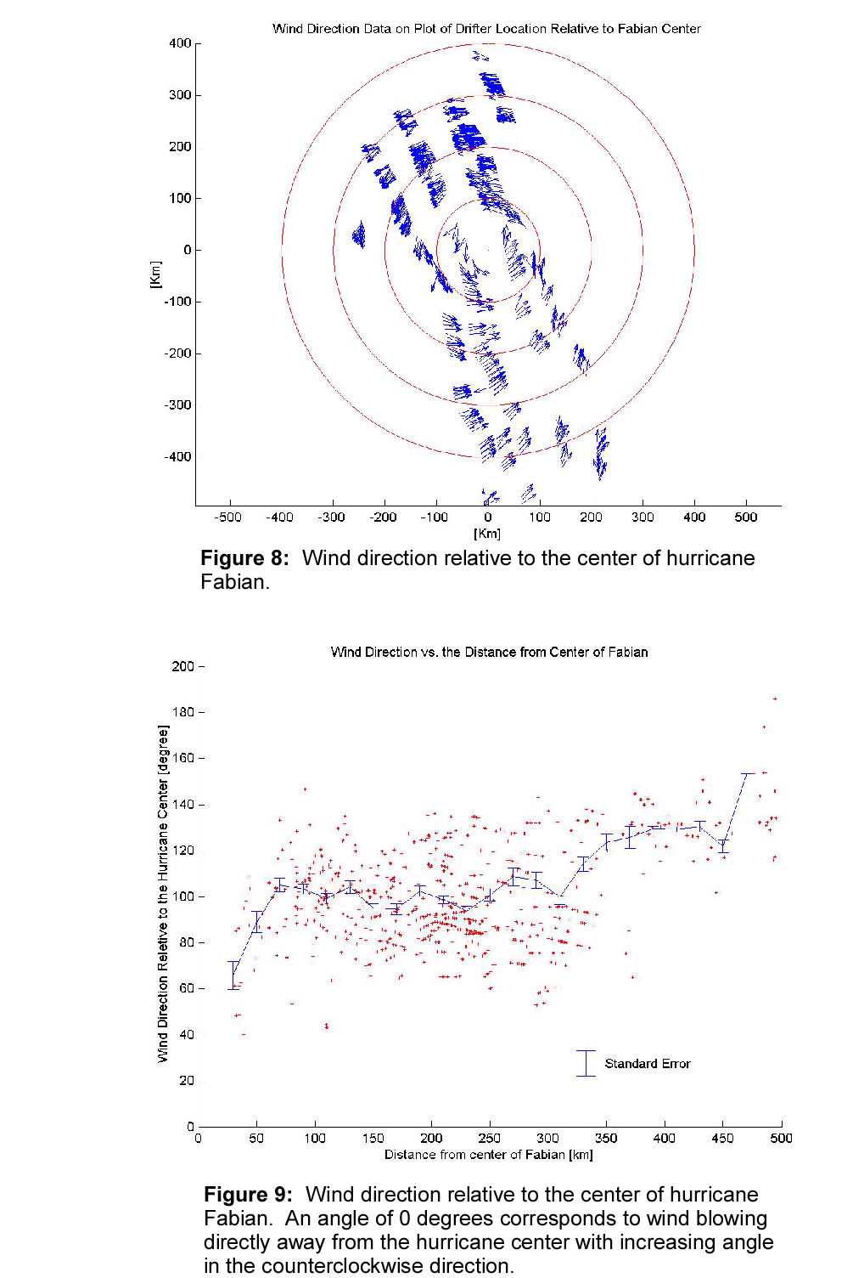
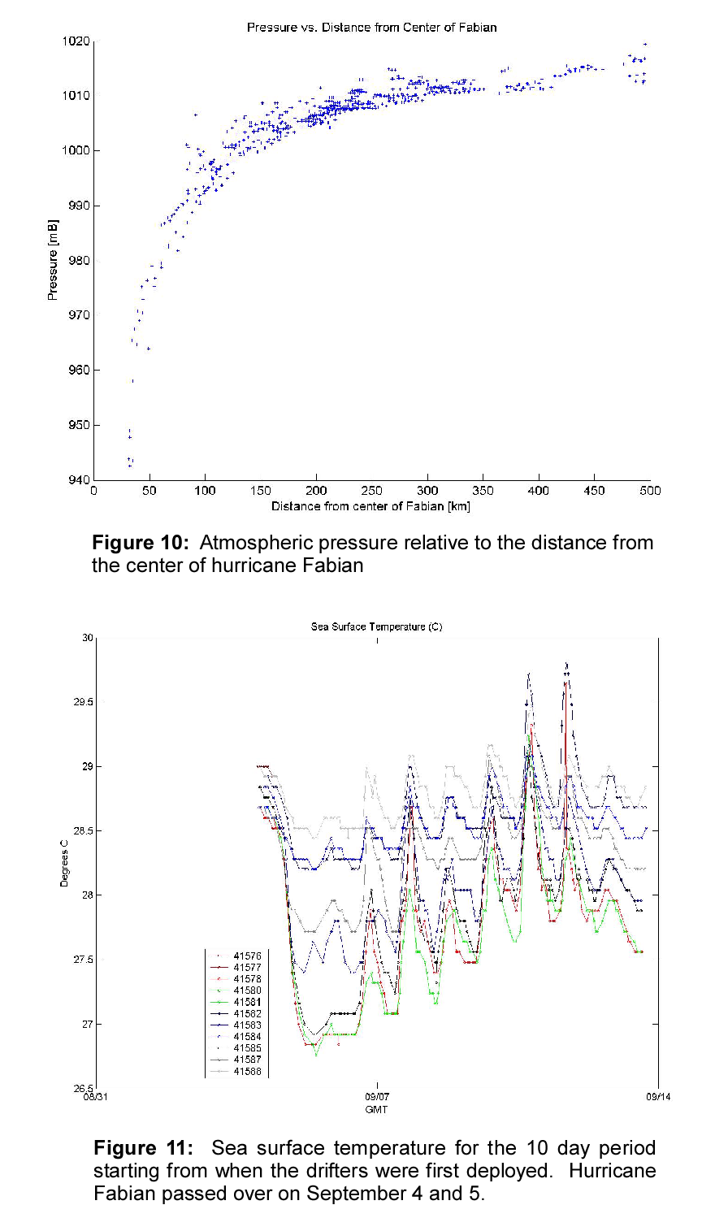

6. Conclusions

Measurements of hurricane wind direction, wind speed, SST, atmospheric pressure and surface currents were obtained by deploying 16 Minimet drifting buoys in front of hurricane Fabian. Eight of the 16 drifters transmitted data throughout the entire time they were in the hurricane. The data shows that:

1. The atmospheric pressure decreases from ~1018 mBar on the outside of the Fabian to ~940 mBar within 30 km of the center
2. SST is decreases by 2.1ºC in the hurricane ‘center’. After Fabian passage the cold wake recovers quickly with large diurnal variations of SST.
3. The expected cyclonic motion of the hurricane winds is measured well by the Minimets. At distances from 100 km to 500 km there is a component of the wind direction pointing toward the center of Fabian.

This experiment demonstrates that the air deployment of Minimet drifters in front of a hurricane provides an excellent means of obtaining meteorological and oceanographic data. It is recommended that at least 4 containers, with 8 Minimets be deployed in front of hurricanes. In the 2004 hurricane season, an array of 38 drifters that will return data also from below ocean surface will be deployed in an Atlantic hurricane with the methodology that was developed in this study.

To increase survivability of the instruments, the drifters should be deployed in wind condition of less than 13 ms⁻¹ and further steps should be taken to assure the containers are not stacked or damaged during shipping.

7. Acknowledgements

We acknowledge and thank Luca Centurioni, Euna Lee, Andy Sybrandy and Chris Martin for their help in putting together the Minimet drifters and packaging them. Luca Centurioni and Andy Sybrandy are further acknowledged for their insightful suggestions on analyzing and presenting the data.

8. References

Niiler, P.P., Evolution of the SVP Drifter Design and the Global Drifter Program Future, Presentation at DBCP Conference, Angra dos Reis, Brazil, 2003.

Milliff, R.F., P.P. Niiler, J. Morzel, A.E. Sybrandy, D. Nychka, W.G. Large. (2003). “Mesoscale correlation length scales from NSCAT and Minimet surface wind retrievals in the Labrador Sea.” Journal of Atmospheric & Oceanic Technology 20(4): 513-533.

