Practical Steps For “Storm Buoy” Project Realization

Motyzhev S.*, Brown J.**, Horton E.*, Lunev E.*, Tolstosheev A.*, Motyzhev V.*
* Marine Hydrophysical Institute NASU, Kapitanskaya,2, Sebastopol, Ukraine, 99011
** Naval Oceanographic Office, 1002 Balch Boulevard, Stennis Space Center, MS 39522-5001,USA

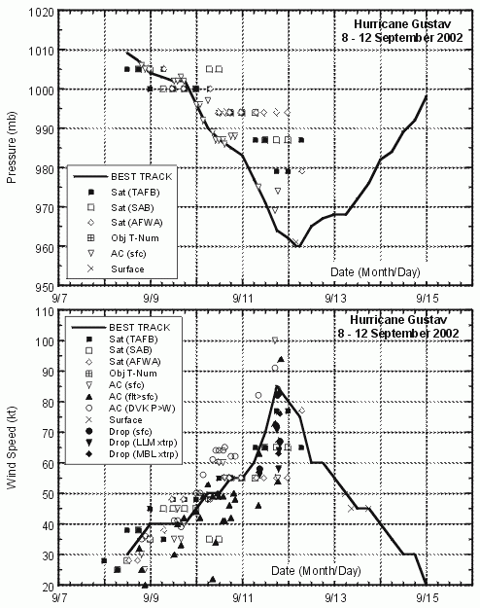
1. Introduction

Main idea of storm buoy is referred to the early warning about a typhoon determination by means of monitoring of Air Pressure (AP) depression. It is known that AP variability inside of the Tropical Convergence zone has small absolute variability and has 2 maximum and 2 minimum values inside the daily cycle. Amplitude of AP variability is within 3-4 hPa and there is some AP variation from day to day. On the other hand there is a good dependence between AP variability and wind speed as it is presented at Figure 1. This physical phenomenon takes usually place for many tropical storms.

Figure 1. Dependence of wind speed from air pressure variability for hurricane Gustav (8-12 September 2002)

Thus, the goal of storm buoy in general is that it could determine exactly the AP depression on background of AP daily and another variability and begin AP and SST data transfer with higher instrumental-temporary resolution to monitor the dynamics of a tropical storm. This problem is difficult enough because we don’t know where is a usual AP variation and what is the AP depression, which could be a preliminary indicator of possible tropical storm. Thus, the problem of storm buoy development has had many problems of instrumental and physical order.

2. Some positive things, which took place before and during storm buoy creation.

2.1. There has been achieved here in Marlin some positive technological experience to create the reliable and low-cost SVP-B drifters.

2.2. 3-satellite standard Argos Service.
This event has become very useful, because 3-d Japanese satellite has covered by passes the former 5-7 hours intervals (in the Tropical zone) been before without any contacts between buoy and satellite. Argos has tried to design the optimal constellation with minimum temporary interval between passes. Nevertheless the holes have taken place, but duration is less: 2-3 hours instead 5-7 as before.

2.3. DBCP-M2 data format.
This format was the compromise solution, which has been achieved after long discussing between Evaluation Group participants. It has an advantage connecting with flexibility for data transfer: because there are now possibilities for transfer the instantaneous data as well as the archived one. These both possibilities have been necessary to be used for storm buoys.

2.4. New electronic components with reduced power consumption.
Appearance of this hardware has become a good basis for storm buoy development. The following things have become possible:
- Increased resolution of AP and SST measurements
- Replacement of hourly samples by 15-min samples
- Continuous averaging of AP and SST data for 15-min temporary intervals
This is that AP and SST sensors of storm buoy have been operating during full buoy lifetime and nevertheless the buoy has 1-year duration of operation in situ in spite of this non-standard mode of using.

3. Entity of storm buoy

3.1. Reason of storm buoy creation
There are the following stages of tropical storm development:
- Tropical wave
- Tropical disturbance (trade wind)
- Tropical depression (wind velocity between 20 and 34 knots)
- Tropical storm (wind velocity between 35 and 64 knots)
- Hurricane or Typhoon (wind velocity more than 64 knots)
To monitor a tropical storm development the expensive enough wind drifters are being used now. This experiment has been an attempt to use economical “smart” drifter instead wind buoy to deploy and support the low-cost storm forecasting drifter networks with AP high resolution and data processing ability to predict the stages of storm development.

3.2. Modes of operation
Buoy has to have two modes of operation: standard and warning. When buoy has the standard mode it should operate under the DBCP-M2 data format with constant Rank=0 and usual for this format resolution and sensor dynamic ranges as for the AP and APT. When buoy has the warning mode it operates under DBCP-M2 data format with Rank=3 (0, 1, 2, 3) with increased resolution and reduced dynamic range as for the AP and APT. Technical files for both data formats are in the table below. After some discussing between co-authors this format has been approved to be used during the first experiment.

Being inside the DBCP-M2 data format the storm buoy had to have the following differences:
- Resolution of AP channel is increased up to 0.05 hPa
- New dynamic ranges must be from 930.00 hPa to 1032.35 hPa for AP, and from –12,75 hPa to +12.8 hPa for APT, that is acceptable for the North Tropical Atlantic
- Temporary interval between AP samples will be 15 minutes instead 60 minutes
- AP and SST sensors have to operate continuously
- Rank=3 is used for data transfer.
Updated Technical File (format DBCP-M2, 28 bits ID) is presented in Table 1:

Table 1
Technical File of Storm Buoy
Item |  | Bits No. | Bits Loc. | Min | Max | Res | Formula
CheckSum |  | 8 | 0-7 | 0 | 255 | - | Lower 8 bits
Rank | Standard  Warning | 4 | 8-11 | 0  0 | 0  3 | - | Rank=0, always  Rank=3 (0,1, 2, 3)
AgeB |  | 6 | 12-17 | 0 | 63 | - | Age (minutes)
Barometric Pressure | Standard  Warning | 11 | 18-28 | 850.0  930.0 | 1054.7  1032.35 | 0.1  0.05 | BP(hPa) = 0.1n + 850  BP(hPa) = 0.05n + 930
SST |  | 9 | 29-37 | -5.0 | 35.88 | 0.08 | SST(°C) = 0.08n – 5
Air Pressure Tenden. | Standard  Warning | 9 | 38-46 | -25.5  -12.75 | 25.6  12.8 | 0.1  0.05 | APT(hPa) = 0.1n – 25.5  APT(hPa) = 0.05n – 12.75
Submergence |  | 6 | 47-52 | 0 | 100 | - | Percent = 100n/63
Battery Volt. |  | 3 | 53-55 | 7 | 14 | - | BV = n + 7
Total |  | 56

3.3. Determination of limit values for AP, APT, SST
Thus, buoy operates in standard mode through Argos. At the same time buoy provides continuously inside itself the data processing in warning mode. When AP, APT, SST (together or separately) have reached some limit values the buoy should change format for data transfer and should begin the operation in warning mode.

3.4. Returning to the standard mode
When sensor data has got values below some limit the buoy has to operate in standard mode again.

4. Development of storm buoy

4.1. Standard or warning mode
One of main problems has been the lack of knowledge about limiting values as for the AP, APT and SST variability to be sure that storm is closely. Thus, it has been accepted the solution that first cluster of storm buoys had to operate in warning mode continuously. In this case we can get some statistic materials for future analysis and real-time data with increased resolution according to the operational goals.

4.2. In fact we had to develop the new experimental buoy and there were small time and limited financial possibilities to do this job. Main problem was a choice of AP (APT) sensor, which could provide the necessary resolution and accuracy. Former variants (Motorola-MPX2100A and Infineon-KPY53AK) cannot be used due to their limited possibilities. The Infineon Technologies – KP203-A pressure sensor was chosen, because specification for this device has allowed a creation of AP channel of necessary quality.

4.3. SST sensor
SST sensor was chosen some time ago and we didn’t see any ideas to replace it by another kind.

4.4. Sensor sampling
To sense a small variability of AP, APT, SST and decrease the random fluctuation of samples, the AP and SST data are sampled continuously with a 15-minute repeat cycle. SST data processing completely corresponds to standard algorithm for SVP-B drifter. AP data is the averaged result of 10 samples each of them is prepared according to the standard algorithm. Technology of this computation is presented in Table 2 below.
Table 2
Technology of AP data computation
SVP-B Standard algorithm  40 AP samples (40 s).  Median of the lowest 3 points.  Median within 1 hPa | SVB-B Storm Buoy algorithm  40 AP samples (40 s).  Median of the lowest 3 points.  Median within 1 hPa  10 standard measurements (according to SVP-B standard algorithm) within 15 minutes with 90 sec interval.  Average of 10 medians

5. Preliminary results of storm buoys testing in situ

5.1. Storm buoys were deployed in the following order:
No | ID | WMO | Progr. | Date | Way | Lat. | Lon.
1 | 40429 | 41502 | 00721 | 09.07.03 | Air | 10.00 | -55.00
2 | 40430 | 41504 | 00721 | 09.07.03 | Air | 10.00 | -50.00
3 | 40431 | 41505 | 00721 | 09.07.03 | Air | 15.00 | -50.00
4 | 40432 | 41506 | 00721 | 09.07.03 | Air | 15.00 | -55.00
5 | 40433 | 41520 | 00721 | 10.07.03 | Air | 10.00 | -45.00
6 | 40434 | 41521 | 00721 | 10.07.03 | Air | 15.00 | -45.00
Tracks of buoys from dates of deployments to December 2, 2003 are presented on Figure 2.

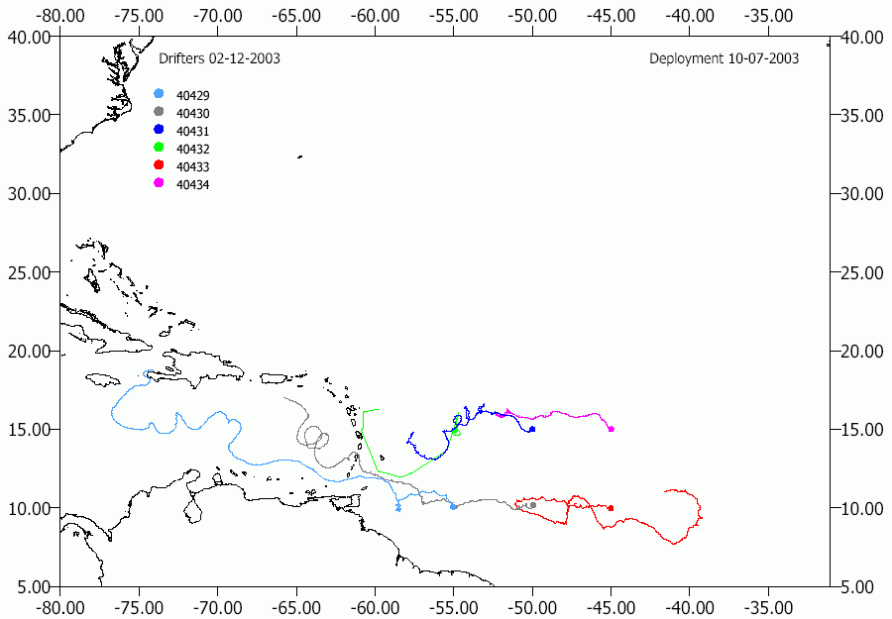

Figure 2. Tracks of buoys from dates of deployments to December 2, 2003

5.2. Buoy data computation
Dedicated software has been developed for computation of buoy data. This software has transformed the data received though ADS in hex format into the data in physical format connecting with universal-time scale. To have data connected to universal-time scale the time of buoy contact with satellite, age of observation and rank of observation were taken into account.

5.3. Some results
Figure 3 demonstrates AP variability for ID40434/WMO41521 from 09.07.03 (date of buoy deployment) to 24.09.03.
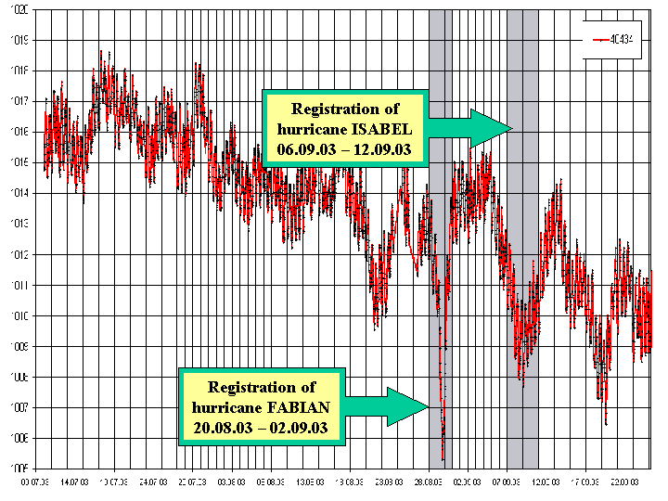
Figure 3. AP variability AP variability for ID40434/WMO41521

Despite the fact that hurricane Isabel was more powerful than hurricane Fabian the air pressure variability for both events had a different matter. It is explained by different distance from center of the tropical storm and location of the buoy when minimum Air pressure took place. The distance between the drifter and the hurricane Fabian’s eye was approximately 85 miles, as it is presented at Figure 4.
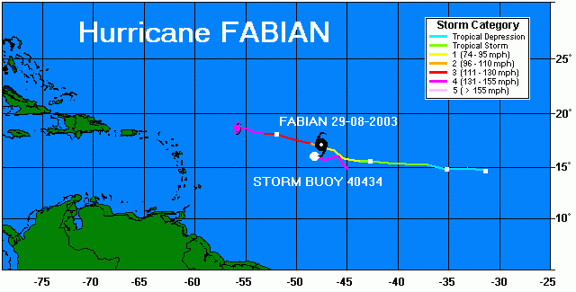
Figure 4. Positional relationship of drifter and hurricane FABIAN when minimum AP took place
AP variability before, during and after “contact” of buoy with hurricane FABIAN is presented at the Figure 5. It is clear that velocity of AP variability was faster than velocity of semi-day cycles.

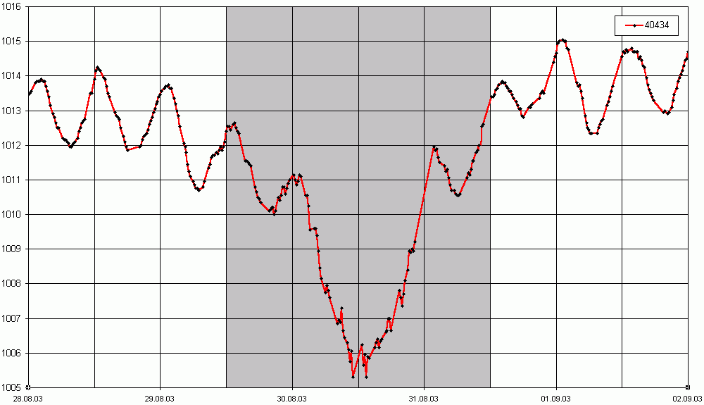

Figure 5. AP variability before, during and after “contact” of buoy with hurricane FABIAN

In comparison with hurricane Fabian the distance between the hurricane Isabel’s eye and the drifter, when minimum air pressure took place, was 265 miles approximately as it is presented at Figure 6.
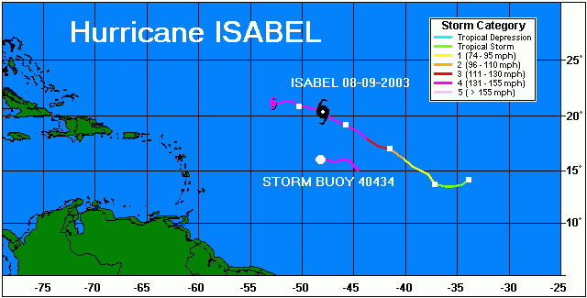

Figure 6. Positional relationship of drifter and hurricane ISABEL when minimum AP took place

The longer distance between a hurricane’s eye and a drifter, the less AP variability fixed by drifter AP sensor. This fact explains a small AP fall, fixed by ID40434, as it is presented at Figure 7. The semi-day cycles continue be visible against a background of AP variability due to hurricane Isabel.
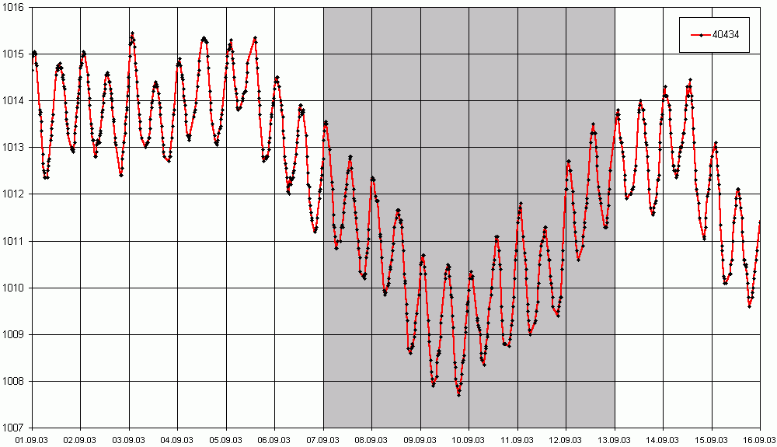

Figure 7. AP variability before, during and after “contact” of buoy with hurricane ISABEL

6. Conclusion
Positive results of experiment
- Storm buoy has been developed and being in operation it has demonstrated that higher instrumental-temporary AP resolution provides more careful investigation of AP and SST variability
- Developed algorithms of AP data computation and chosen configuration of buoy’s barometric port have demonstrated the buoy ability to AP measure with high resolution in rough seas without AP spikes
- Buoy network has been deployed and long-time observation of AP and SST variability has been provided
- Registration of hurricane different stages was done in September-October 2003
- Accumulation of data for the future analysis was being provided.

Negative result
- Main of problems had been that some specimens of chosen low-cost AP sensor (KP203A - Surface Mount Piezoresistive Silicon Absolute Pressure Sensor) have had a systematic shift of AP data
- Due to this reason new AP channel for the storm buoy has been developed and tested in Marlin

Possible further activity
- Current status of storm buoy data utilization has statistical matter and it isn’t possible to do any completed recommendation now about warning possibilities of this buoy
- It is necessary more close cooperation between expert-physicists who investigate, understand and feel typhoons and buoy creators who have possibility to produce buoys with necessary parameters and can make these buoys within the short temporary interval
It seems that to monitor tropical storm development the assess of energy, accumulated inside the ocean upper layer, the SVP-B drifter should be equipped by additional temperature sensor on the lower part of tether line.

